Rhythmic Gymnastics Promotion Centre
---------------------------------------------------------------------------------------------------------------------------------------------------------------------------------------------------------------------------------------------------------------------------

International Rhythmic Gymnastics Tournament

NOVOGORSK STARLETS ‘2018

Novogorsk, Khimki, Moscow Region, Russia
25 – 27 May 2018

D I R E C T I V E S & O F F I C I A L I N V I T A T I O N

Our International Rhythmic Gymnastics Tournament with the participation of Russian, CIS and foreign gymnasts will possibly help select gifted gymnasts for further participation in a number of training camps. Such training programs and classes are to be offered to young gymnasts by Rhythmic Gymnastics Centre in order to achieve top results in the future.

Goals & Objectives

- Promotion of international sport exchange
- Rhythmic gymnastics progress
- Healthy lifestyle
- Competitive experience to be gained by young gymnasts
- Selection of talented and promising gymnasts
- Upgrading judges

Schedule

Friday, 25 May 2018 – arrival, trainings
– competitions commission 15.00 – 18.00
– judges & delegations meeting 18.00
Saturday, 26 May 2018 – 1st competition day, Opening Ceremony
Sunday, 27 May 2018 – 2nd competition day, departure after 21.00

Venue

Irina Viner-Usmanova’s Rhythmic Gymnastics Centre
28 Olympiyskaya Str., Novogorsk, Moscow Region, Russia

Organizing Committee

Rhythmic Gymnastics Promotion Centre: organization & judging

Management

Elena O. Smirnova, Tournament Administrator

Note: the Organizers reserve the right to reduce the competitions program and the number of entries before the resp. deadline.
All gymnast, coaches and judges must have a pair of soft shoes to change before entering the gym (no high heels!).

Delegations

Gymnasts representing Russia, CIS and foreign countries are welcome to our Tournament!

• individual program – 8 gymnasts
• 1 coach
• 1 judge w./resp. ID & record book

• groups – 6 gymnasts per group
• 1 coach
• 1 judge w./resp. ID & record book

Each team must bring at least 1 judge in order to be allowed to the competitions. Unaccompanied children cannot be accommodated! All gymnasts must have resp. documents confirming their qualification/category.

DOB | Group А | Group B
2013 | - w/a
2012 | - w/a | - w/a
2011 | - w/a | - w/a
2010 | - w/a  - 1 apparatus by choice | - w/a
2009 | - w/a  - 2 apparatus by choice | - w/a  - 1 apparatus by choice
2008 | - w/a  2. 2 apparatus by choice | - w/a  - 1 apparatus by choice
2007 | - w/a  2. 2 apparatus by choice | - w/a  - 1 apparatus by choice
2006 | - w/a  2. 2 apparatus by choice | - w/a  - 1 apparatus by choice
2005 | FIG Program | 2 apparatus by choice, FIG Program
2004 | FIG Program | 2 apparatus by choice, FIG Program

2003
2002 and older | FIG Program
Competitions Program
Individual Gymnasts

Exercises without apparatus must meet the following requirements:

2013 Group A – 2012 Group B: D max. = 6.0, 5 – 7 Body Difficulties (1 jump/leap, 1 balance, 1 rotation, the remaining Difficulties groups by choice)

2012 – 2006 Group A: D max. = 8,0, 7 – 9 Body Difficulties (min. 2 jumps/leaps, min. 2 balances, min. 2 rotations, the remaining Difficulties groups by choice)

Three Difficulties must be performed on non-dominant leg: 1 jump/leap, 1 balance, 1 rotation.

Each gymnast is invited to present one Show Exercise (max. 2 min.).

Group Exercises
D.O.B. | Apparatus
2003 – 2005 | 10 clubs; 5 ribbons
2006 – 2007 | 5 hoops; 10 clubs
2007 – 2008 | w/a; 5 balls
2008 – 2009 | w/a; 5 hoops
2009 – 2010 | w/a
2010 and younger | w/a

Awards

- Winners and 2 runners-up in individual all-around per each age category will be awarded with medals, diplomas and souvenirs.

- All participants will be awarded with memorable gifts.

Safety & Security

All sport events are to be held at sport venues meeting latest requirements specified in resp. regulatory legal acts valid on the territory of the Russian Federation and are purposed to ensure public order, safety and security of participants and spectators. All sport facilities are prepared for organizing sport events and approved in the established order. Medical services are to be provided in accordance with the Order of the Health and Social Ministry of the Russian Federation No. 613 N, dated 09.08.2010, ‘Approved Medical Services at Sport & Mass Events’.

Insurance Terms

Each participant must present a valid medical insurance policy (an original of life & health insurance policy).

Financial Terms

All organizational expenses related to the preparation and holding of the tournament are to be covered by the Organizing Committee.

All delegations are to cover the resp. expenses of their participants, i.e. travel costs, accommodations, meals, insurance, etc.

Entry fees:

• 3000 Rubles per individual gymnast
• 9000 Rubles per each group

The above entry fees are to compensate organizational costs and prize money.

Music

Music for all exercises should be recorded on CDs. Each gymnast should present 2 CDs per each routine.

Accommodations

The Organizing Committee offers accommodations at the Hotel of the Gymnastics Centre (2nd level of the building). The hotel rates are as follows:

Room Category | Rubles,  Per Person Per Night
Double Standard | 9000
Triple Standard | 12000

Please note that the number of the hotel rooms is limited. Therefore, only participants who have paid their entries can be accommodated.

If case that you need a Russian visa, please send your passport copy (data page only) to the Organizing Committee not later than 01 May 2018. Late inscriptions will not be accepted.

Nominative Entries Deadline: 08 May 2018 :
https://www.sportvokrug.ru/competitions/4071/

Each gymnast is obliged to present a valid Passport and/or original Birth Certificate and an insurance policy. Each entry must be approved and signed by a physician which will mean that the resp. gymnast is allowed to compete.

E-mail: fsk-novogorsk@mail.ru

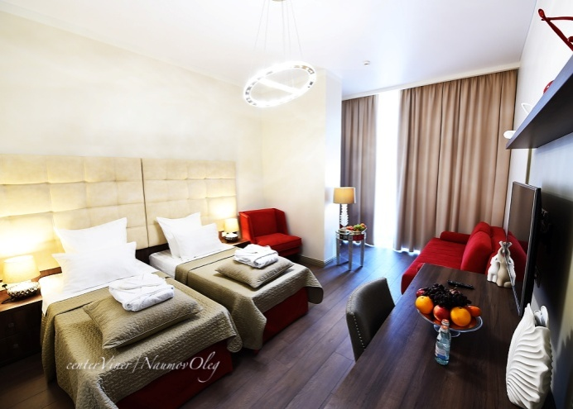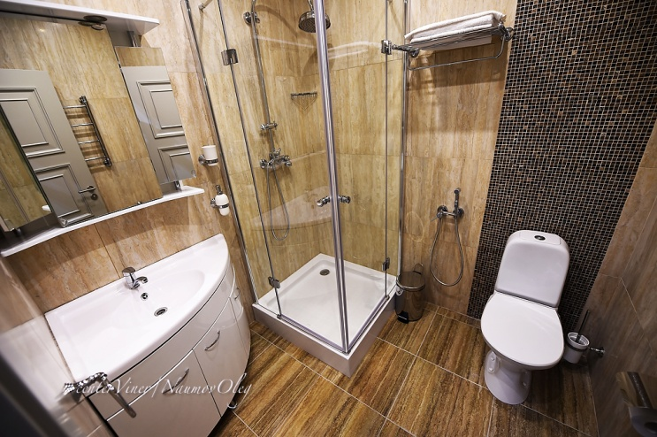
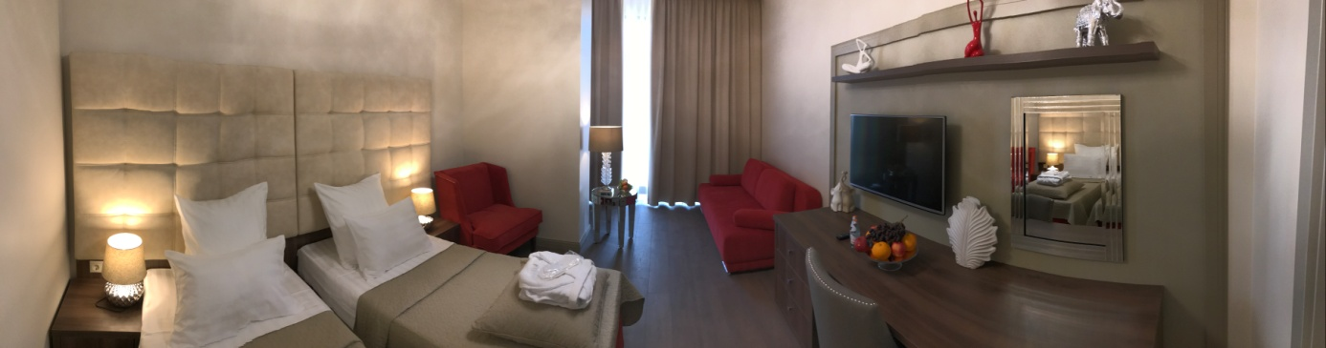

ENTRY FORM

Team: ______________________ City:____________________

# | Surname & Name | DOB | Cat. |  | Coach’s Surname & Name | Doctor’s Signature
 | Individual All-around
1
2
3
4
5
6
7
8
 | Groups All-around
1
2
3
4
5
6

Allowed to compete: _______________________________________________________________

Doctor:___________________________________________________________________________

Team’s Representative: Surname, Name, contact phone___________________________________
Judge’s Surname, Name & Cat. _____________________________/________________________/

Director/Organization ______________________________________/______________________/

Contact phone ___________________________________________________________________

