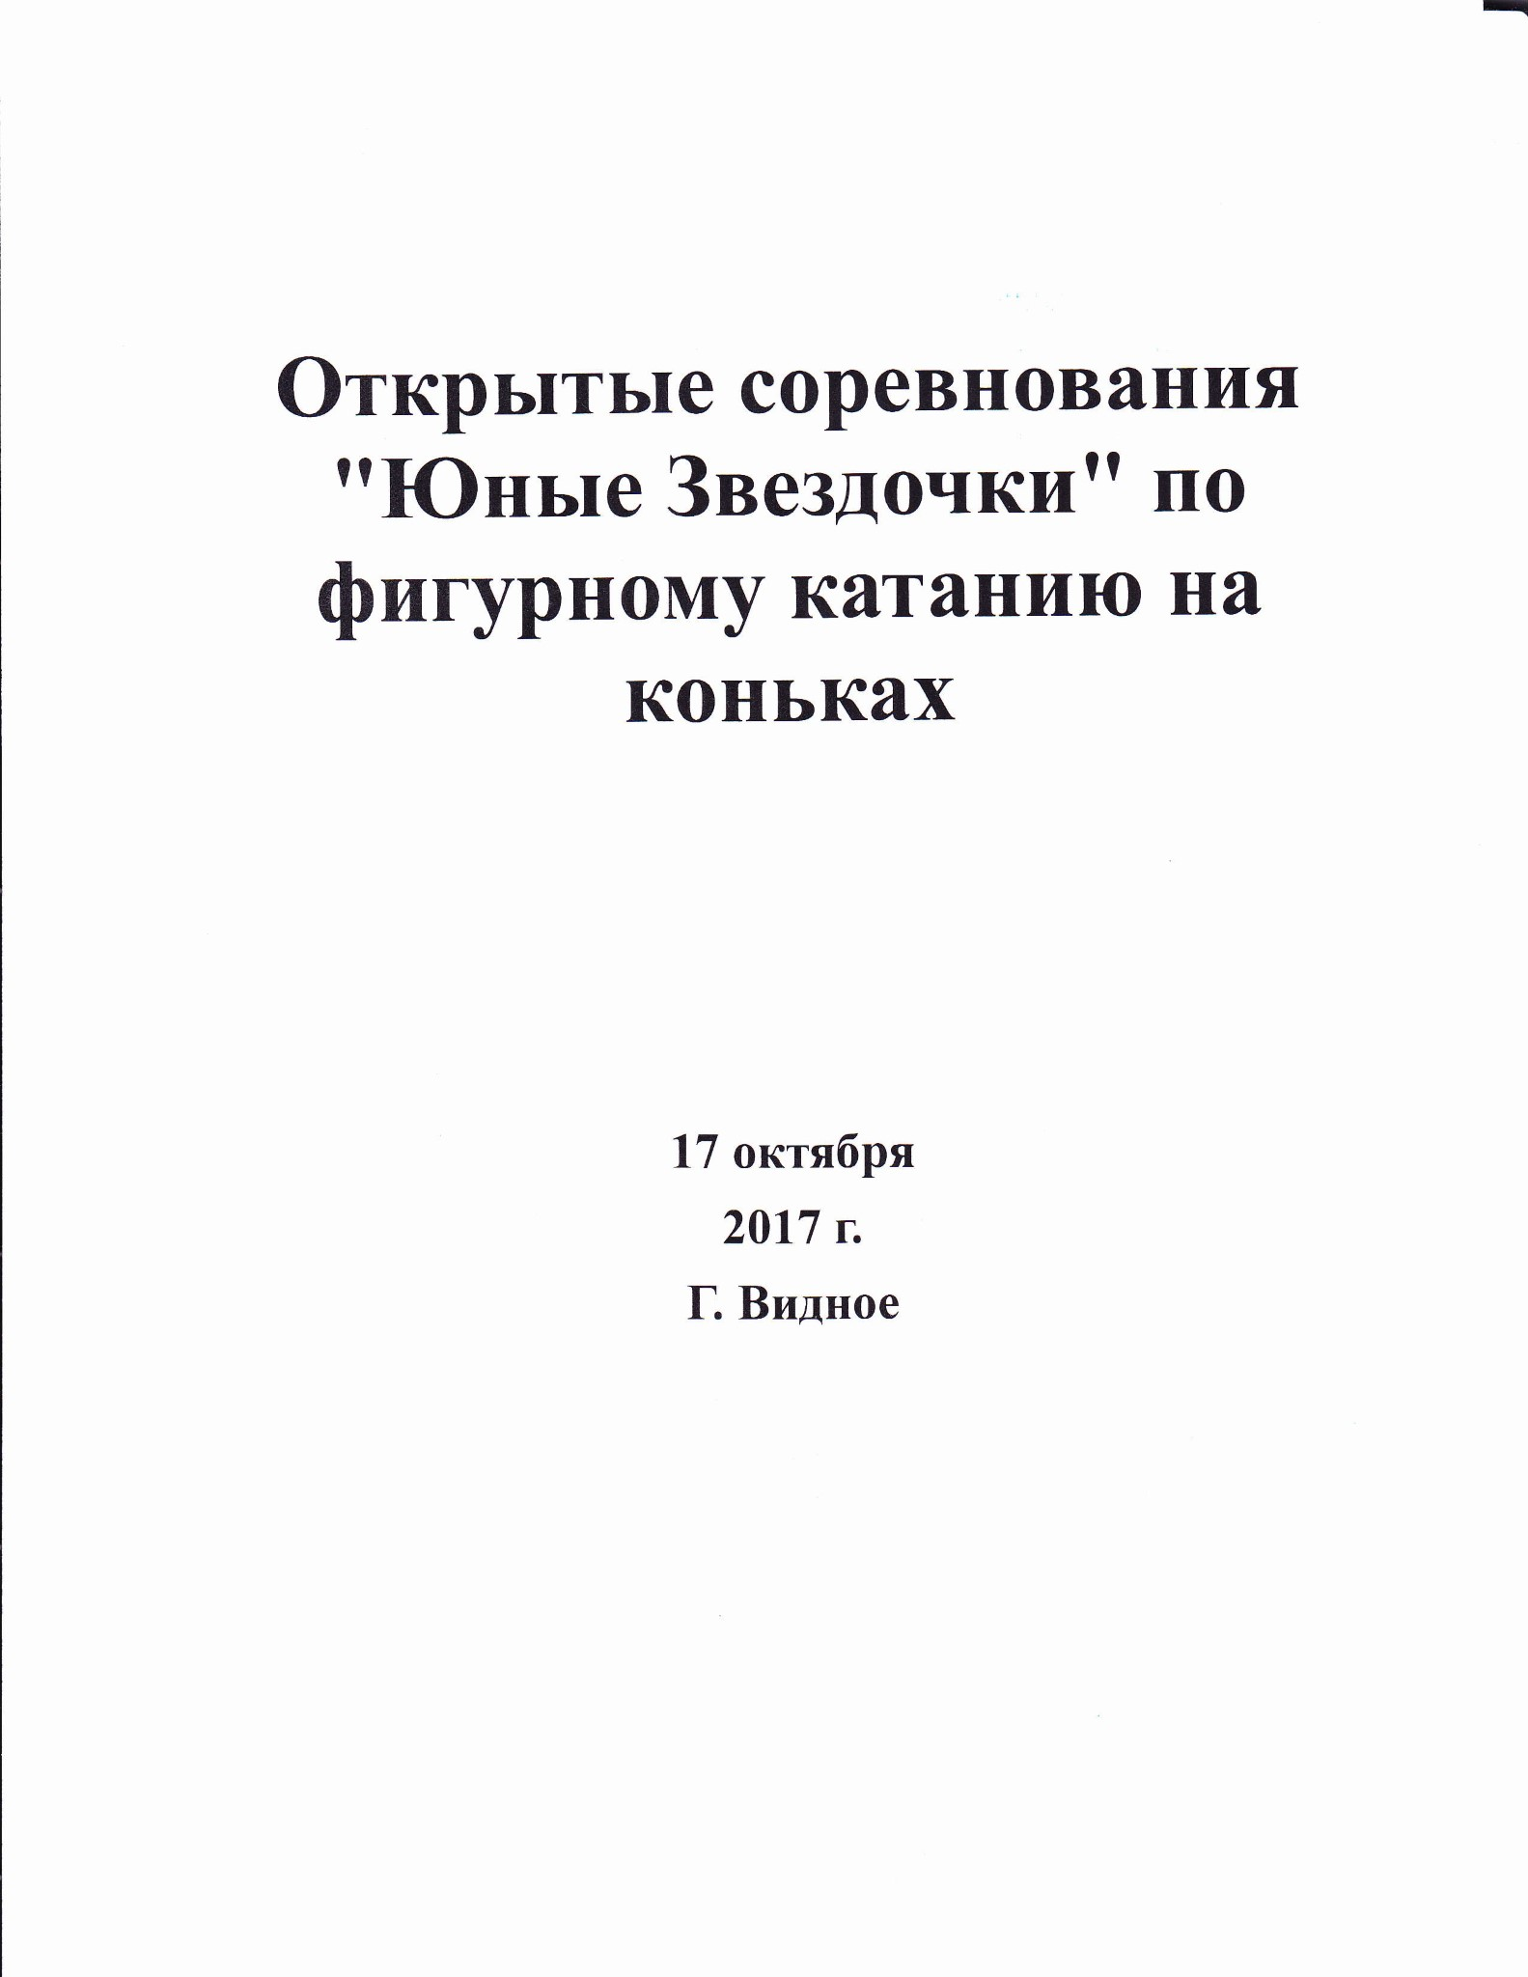
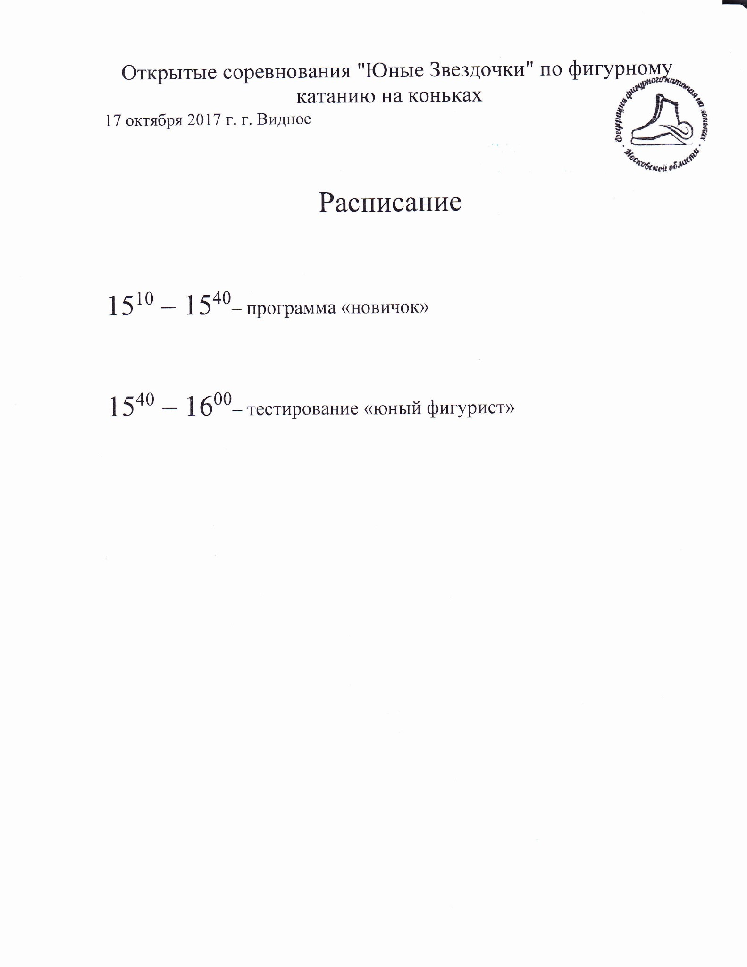
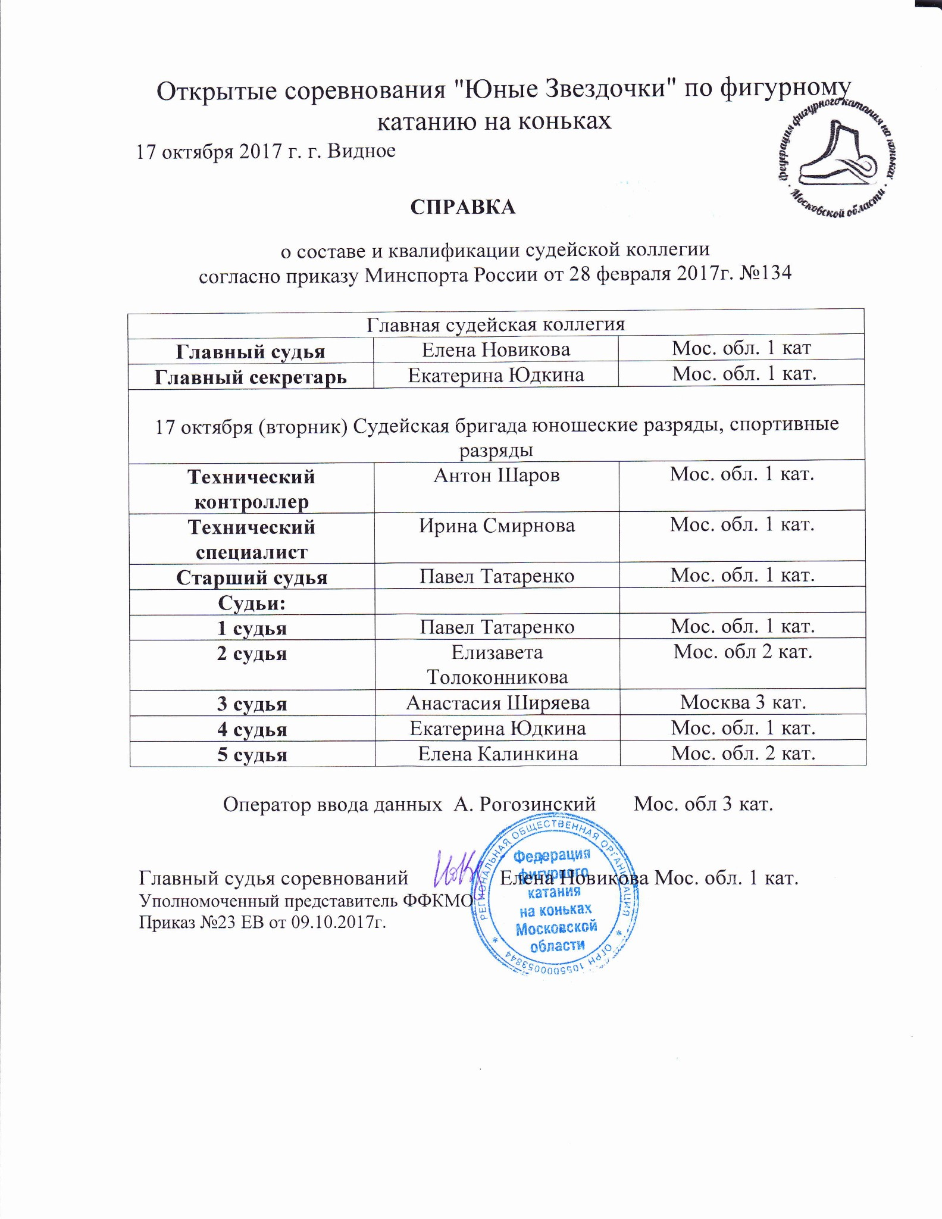
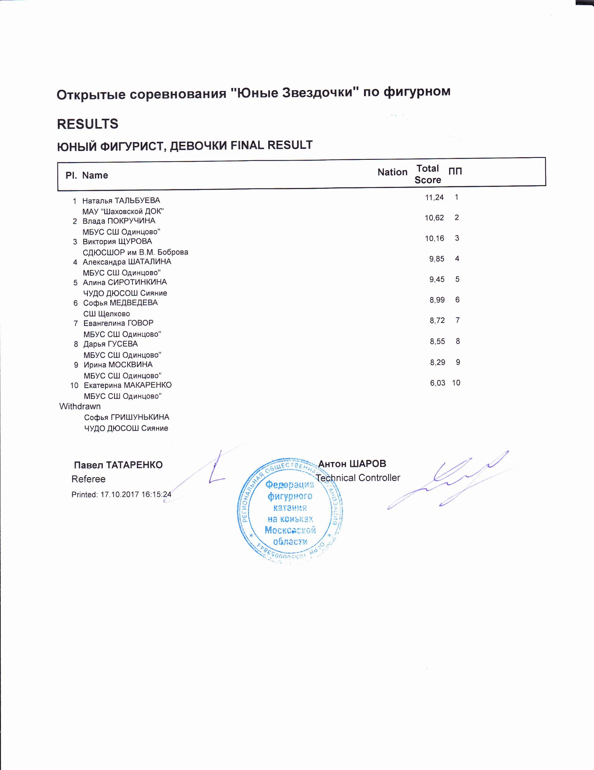

ЮНЫЙ ФИГУРИСТ, ДЕВОЧКИ
RESULT DETAILS ПРОИЗВОЛЬНАЯ ПРОГРАММА
 | Pl. | Name |  |  |  | Nation | Total  Segment  Score  = |  | Total  Element  Score  + |  | Tot. Prog.  Comp.  Score *  + |  | SS |  |  |  | PE |  |  |  |  |  | Deduct.  -
1 Наталья ТАЛЬБУЕВА |  |  |  |  | 11.24 |  |  | 5.24 |  | 6.00 |  | 2.50 |  | 0.00 |  | 2.50 |  | 0.00 |  | 0.00 |  | 0.00
2 Влада ПОКРУЧИНА |  |  |  |  | 10.62 |  |  | 5.22 |  | 5.40 |  | 2.17 |  | 0.00 |  | 2.33 |  | 0.00 |  | 0.00 |  | 0.00
3 Виктория ЩУРОВА |  |  |  |  | 10.16 |  |  | 4.76 |  | 5.40 |  | 2.25 |  | 0.00 |  | 2.25 |  | 0.00 |  | 0.00 |  | 0.00
4 Александра ШАТАЛИНА |  |  |  |  | 9.85 |  |  | 4.75 |  | 5.10 |  | 2.00 |  | 0.00 |  | 2.25 |  | 0.00 |  | 0.00 |  | 0.00
5 Алина СИРОТИНКИНА |  |  |  |  | 9.45 |  |  | 4.85 |  | 5.10 |  | 2.25 |  | 0.00 |  | 2.00 |  | 0.00 |  | 0.00 |  | 0.50
6 Софья МЕДВЕДЕВА |  |  |  |  | 8.99 |  |  | 3.69 |  | 5.30 |  | 2.33 |  | 0.00 |  | 2.08 |  | 0.00 |  | 0.00 |  | 0.00
7 Евангелина ГОВОР |  |  |  |  | 8.72 |  |  | 3.82 |  | 4.90 |  | 2.00 |  | 0.00 |  | 2.08 |  | 0.00 |  | 0.00 |  | 0.00
8 Дарья ГУСЕВА |  |  |  |  | 8.55 |  |  | 3.45 |  | 5.60 |  | 2.33 |  | 0.00 |  | 2.33 |  | 0.00 |  | 0.00 |  | 0.50
9 Ирина МОСКВИНА |  |  |  |  | 8.29 |  |  | 3.29 |  | 5.00 |  | 1.92 |  | 0.00 |  | 2.25 |  | 0.00 |  | 0.00 |  | 0.00
10 Екатерина МАКАРЕНКО |  |  |  |  | 6.03 |  |  | 1.53 |  | 5.00 |  | 2.00 |  | 0.00 |  | 2.17 |  | 0.00 |  | 0.00 |  | 0.50
SS = Навыки скольжения |  |  |  |  | PE = Представление
- = factored score
Printed: 17.10.2017 16:16:59

Deductions
0.00
- Invalid element x Credit for highlight distribution, base value multiplied by 1.1
Rank | Name |  |  | Nation |  | Starting  Number |  | Total  Segment Score |  | Total  Element Score |  | Total  Program Component  Score (factored) |  |  | Total  Deductions
2 | Влада ПОКРУЧИНА |  |  |  |  | 3 |  | 10.62 |  | 5.22 |  | 5.40 |  |  | 0.00
#  1 | Executed  Elements  1F | Base  Info  Value  0.50 | GOE  0.00 | J1  0 | J2  0 | J3  0 | J4  0 |  | J5  0 | J6 | J7 | J8 | J9 | Ref | Scores of Panel  0.50
2 | 1Lo | 0.50 | 0.00 | 0 | 0 | 0 | 0 |  | 0 |  |  |  |  |  | 0.50
3 | ChSq1 | 2.00 | 0.70 | 1 | 1 | 1 | 1 |  | 1 |  |  |  |  |  | 2.70
4 | 1W | 0.22 | x 0.03 | 2 | 1 | 0 | 0 |  | 0 |  |  |  |  |  | 0.25
5 | SSpB | 1.10 | 0.17 | 1 | 1 | 0 | 0 |  | 0 |  |  |  |  |  | 1.27
 |  | 4.32 |  |  |  |  |  |  |  |  |  |  |  |  | 5.22
 | Program Components  Навыки скольжения |  | Factor  1.20 | 2,50 | 2,25 | 2,00 | 2,00 |  | 2,25 |  |  |  |  |  | 2.17
 | Представление |  | 1.20 | 2,75 | 2,50 | 2,25 | 2,00 |  | 2,25 |  |  |  |  |  | 2.33
 | Judges Total Program Component Score (factored) |  |  |  |  |  |  |  |  |  |  |  |  |  | 5.40
Deductions
0.00
#  1 | Executed  Elements  1W | Base  Info  Value  0.20 | GOE  0.00 |  | J1  1 | J2  0 | J3  0 | J4  0 | J5  0 | J6 | J7 | J8 | J9 | Ref | Scores of Panel  0.20
2 | ChSq1 | 2.00 |  | 0.70 | 1 | 1 | 1 | 1 | 1 |  |  |  |  |  | 2.70
3 | 1T | 0.40 |  | 0.00 | 0 | 0 | 0 | 0 | 0 |  |  |  |  |  | 0.40
4 | USpB | 1.00 |  | 0.50 | 1 | 1 | 1 | 1 | 1 |  |  |  |  |  | 1.50
5 | USpB* | * 0.00 |  | 0.00 | - | - | - | - | - |  |  |  |  |  | 0.00
6 | 1S | 0.44 x |  | 0.00 | 0 | 0 | 0 | 0 | 0 |  |  |  |  |  | 0.44
 |  | 4.04 |  |  |  |  |  |  |  |  |  |  |  |  | 5.24
 | Program Components  Навыки скольжения |  |  | Factor  1.20 | 2,75 | 2,50 | 2,25 | 2,50 | 2,50 |  |  |  |  |  | 2.50
 | Представление |  |  | 1.20 | 2,50 | 2,25 | 2,50 | 2,50 | 2,50 |  |  |  |  |  | 2.50
 | Judges Total Program Component Score (factored) |  |  |  |  |  |  |  |  |  |  |  |  |  | 6.00
Rank | Name |  |  | Nation | Starting  Number | Total  Segment Score | Total  Element Score | Total  Program Component  Score (factored) | Total  Deductions
1 | Наталья ТАЛЬБУЕВА |  |  |  | 4 | 11.24 | 5.24 | 6.00 | 0.00
x Credit for highlight distribution, base value multiplied by 1.1
Rank | Name |  |  |  | Nation |  | Starting  Number |  | Total  Segment Score |  | Total  Element Score |  | Total  Program Component  Score (factored) |  |  | Total  Deductions
3 | Виктория ЩУРОВА |  |  |  |  |  | 10 |  | 10.16 |  | 4.76 |  | 5.40 |  |  | 0.00
#  1 | Executed  Elements  1W | Base  Info  Value  0.20 | GOE  0.10 |  | J1  1 | J2  1 | J3  0 | J4  1 |  | J5  1 | J6 | J7 | J8 | J9 | Ref | Scores of Panel  0.30
2 | ChSq1 | 2.00 |  | 0.23 | 0 | 1 | 1 | 0 |  | 0 |  |  |  |  |  | 2.23
3 | SSpB | 1.10 |  | 0.00 | 0 | 0 | 0 | 0 |  | 0 |  |  |  |  |  | 1.10
4 | 1Lo | 0.55 | x | 0.13 | 1 | 1 | 1 | 0 |  | 0 |  |  |  |  |  | 0.68
5 | 1F | 0.55 | x | -0.10 | -1 | -1 | -1 | -1 |  | -1 |  |  |  |  |  | 0.45
 |  | 4.40 |  |  |  |  |  |  |  |  |  |  |  |  |  | 4.76
 | Program Components  Навыки скольжения |  |  | Factor  1.20 | 2,25 | 2,25 | 2,00 | 2,25 |  | 2,25 |  |  |  |  |  | 2.25
 | Представление |  |  | 1.20 | 2,00 | 2,25 | 2,25 | 2,25 |  | 2,25 |  |  |  |  |  | 2.25
 | Judges Total Program Component Score (factored) |  |  |  |  |  |  |  |  |  |  |  |  |  |  | 5.40
Deductions |  |  |  |  |  |  |  |  |  |  |  |  |  |  |  | 0.00
x Credit for highlight distribution, base value multiplied by 1.1
#  1 | Executed  Elements  1F | Base  Info  Value  0.50 | GOE  -0.10 | J1  -1 | J2  -1 | J3  -1 | J4  -1 | J5  -1 | J6 | J7 | J8 | J9 | Ref | Scores of Panel  0.40
2 | 1W | 0.20 | 0.00 | 1 | 0 | 0 | 0 | 0 |  |  |  |  |  | 0.20
3 | ChSq1 | 2.00 | 0.70 | 1 | 1 | 1 | 1 | 1 |  |  |  |  |  | 2.70
4 | 1Lo | 0.55 | x -0.10 | -1 | -1 | -1 | -1 | 0 |  |  |  |  |  | 0.45
5 | SSpB | 1.10 | -0.10 | -1 | -1 | 0 | 0 | 0 |  |  |  |  |  | 1.00
 |  | 4.35 |  |  |  |  |  |  |  |  |  |  |  | 4.75
 | Program Components  Навыки скольжения |  | Factor  1.20 | 2,25 | 2,00 | 2,00 | 2,00 | 2,00 |  |  |  |  |  | 2.00
 | Представление |  | 1.20 | 2,50 | 2,25 | 2,25 | 2,25 | 2,25 |  |  |  |  |  | 2.25
 | Judges Total Program Component Score (factored) |  |  |  |  |  |  |  |  |  |  |  |  | 5.10
Rank | Name |  |  | Nation | Starting  Number | Total  Segment Score | Total  Element Score | Total  Program Component  Score (factored) | Total  Deductions
4 | Александра ШАТАЛИНА |  |  |  | 1 | 9.85 | 4.75 | 5.10 | 0.00
x Credit for highlight distribution, base value multiplied by 1.1
Deductions
0.00
Rank | Name |  |  |  |  | Nation |  | Starting  Number |  | Total  Segment Score |  | Total  Element Score |  | Total  Program Component  Score (factored) |  |  | Total  Deductions
5 | Алина СИРОТИНКИНА |  |  |  |  |  |  | 2 |  | 9.45 |  | 4.85 |  | 5.10 |  |  | 0.50
#  1 | Executed  Elements USpB | Base  Info  Value  1.00 |  | GOE  0.17 |  | J1  1 | J2  1 | J3  0 | J4  0 |  | J5  0 | J6 | J7 | J8 | J9 | Ref | Scores of Panel  1.17
2 | ChSq1 | 2.00 |  |  | 0.70 | 1 | 1 | 1 | 1 |  | 1 |  |  |  |  |  | 2.70
3 | 1T | 0.44 |  | x | 0.00 | 1 | 0 | 0 | 0 |  | 0 |  |  |  |  |  | 0.44
4 | 1Lo | 0.55 |  | x | -0.30 | -3 | -3 | -3 | -3 |  | -3 |  |  |  |  |  | 0.25
5 | 1W | 0.22 |  | x | 0.07 | 1 | 1 | 1 | 0 |  | 0 |  |  |  |  |  | 0.29
 |  | 4.21 |  |  |  |  |  |  |  |  |  |  |  |  |  |  | 4.85
 | Program Components  Навыки скольжения |  |  |  | Factor  1.20 | 2,50 | 2,25 | 2,25 | 2,25 |  | 2,25 |  |  |  |  |  | 2.25
 | Представление |  |  |  | 1.20 | 2,00 | 2,00 | 2,00 | 2,00 |  | 2,00 |  |  |  |  |  | 2.00
 | Judges Total Program Component Score (factored) |  |  |  |  |  |  |  |  |  |  |  |  |  |  |  | 5.10
Deductions |  |  | Falls: |  | -0.50 |  |  |  |  |  |  |  |  |  |  |  | -0.50
x Credit for highlight distribution, base value multiplied by 1.1
Rank | Name |  |  |  | Nation |  | Starting  Number |  | Total  Segment Score |  | Total  Element Score |  | Total  Program Component  Score (factored) |  |  | Total  Deductions
6 | Софья МЕДВЕДЕВА |  |  |  |  |  | 8 |  | 8.99 |  | 3.69 |  | 5.30 |  |  | 0.00
#  1 | Executed  Elements  1W | Base  Info  Value  0.20 | GOE  0.07 |  | J1  0 | J2  1 | J3  1 | J4  1 |  | J5  0 | J6 | J7 | J8 | J9 | Ref | Scores of Panel  0.27
2 | SSpB | 1.10 | -0.20 |  | -1 | -1 | -1 | 0 |  | 0 |  |  |  |  |  | 0.90
3 | ChSq1 | 2.00 | 0.00 |  | 1 | 0 | 0 | 0 |  | 0 |  |  |  |  |  | 2.00
4 | 1F | 0.55 | x -0.03 |  | -1 | -1 | 0 | 0 |  | 0 |  |  |  |  |  | 0.52
 |  | 3.85 |  |  |  |  |  |  |  |  |  |  |  |  |  | 3.69
 | Program Components  Навыки скольжения |  | Factor  1.20 |  | 2,50 | 2,50 | 2,25 | 2,25 |  | 2,25 |  |  |  |  |  | 2.33
 | Представление |  | 1.20 |  | 2,00 | 2,00 | 2,00 | 2,25 |  | 2,25 |  |  |  |  |  | 2.08
 | Judges Total Program Component Score (factored) |  |  |  |  |  |  |  |  |  |  |  |  |  |  | 5.30
Deductions |  |  |  |  |  |  |  |  |  |  |  |  |  |  |  | 0.00
x Credit for highlight distribution, base value multiplied by 1.1 x Credit for highlight distribution, base value multiplied by 1.1
Rank | Name |  |  |  |  | Nation |  | Starting  Number |  | Total  Segment Score |  | Total  Element Score |  | Total  Program Component  Score (factored) |  |  | Total  Deductions
8 | Дарья ГУСЕВА |  |  |  |  |  |  | 5 |  | 8.55 |  | 3.45 |  | 5.60 |  |  | 0.50
#  1 | Executed  Elements  1T | Base  Info  Value  0.40 |  | GOE  -0.17 |  | J1  -2 | J2  -2 | J3  -2 | J4  -1 |  | J5  -1 | J6 | J7 | J8 | J9 | Ref | Scores of Panel  0.23
2 | 1S | 0.40 |  | 0.00 |  | 0 | -1 | 0 | 0 |  | 0 |  |  |  |  |  | 0.40
3 | ChSq1 | 2.00 |  | -1.00 |  | -2 | -2 | -2 | -2 |  | -2 |  |  |  |  |  | 1.00
4 | 1W | 0.22 |  | x 0.00 |  | 1 | 0 | 0 | 0 |  | 0 |  |  |  |  |  | 0.22
5 | SSpB | 1.10 |  | 0.50 |  | 1 | 1 | 1 | 1 |  | 0 |  |  |  |  |  | 1.60
 |  | 4.12 |  |  |  |  |  |  |  |  |  |  |  |  |  |  | 3.45
 | Program Components  Навыки скольжения |  |  | Factor  1.20 |  | 2,50 | 2,50 | 2,25 | 2,25 |  | 2,25 |  |  |  |  |  | 2.33
 | Представление |  |  | 1.20 |  | 2,25 | 2,25 | 2,50 | 2,50 |  | 2,25 |  |  |  |  |  | 2.33
 | Judges Total Program Component Score (factored) |  |  |  |  |  |  |  |  |  |  |  |  |  |  |  | 5.60
Deductions |  |  | Falls: |  | -0.50 |  |  |  |  |  |  |  |  |  |  |  | -0.50
#  1 | Executed  Elements  1T | Base  Info  Value  0.40 | GOE  -0.13 | J1  -2 | J2  -2 | J3  -1 | J4  -1 | J5  -1 | J6 | J7 | J8 | J9 | Ref | Scores of Panel  0.27
2 | 1S | 0.40 | -0.20 | -3 | -2 | -2 | -2 | -2 |  |  |  |  |  | 0.20
3 | ChSq1 | 2.00 | 0.23 | 1 | 0 | 0 | 0 | 1 |  |  |  |  |  | 2.23
4 | 1W | 0.22 | x 0.00 | 1 | 0 | 0 | 0 | 0 |  |  |  |  |  | 0.22
5 | SSpB | 1.10 | -0.20 | -2 | -1 | -1 | 0 | 0 |  |  |  |  |  | 0.90
 |  | 4.12 |  |  |  |  |  |  |  |  |  |  |  | 3.82
 | Program Components  Навыки скольжения |  | Factor  1.20 | 2,25 | 2,00 | 2,00 | 1,75 | 2,00 |  |  |  |  |  | 2.00
 | Представление |  | 1.20 | 2,50 | 2,25 | 1,75 | 2,00 | 2,00 |  |  |  |  |  | 2.08
 | Judges Total Program Component Score (factored) |  |  |  |  |  |  |  |  |  |  |  |  | 4.90
Rank | Name |  |  | Nation | Starting  Number | Total  Segment Score | Total  Element Score | Total  Program Component  Score (factored) | Total  Deductions
7 | Евангелина ГОВОР |  |  |  | 9 | 8.72 | 3.82 | 4.90 | 0.00
x Credit for highlight distribution, base value multiplied by 1.1
Deductions
0.00
Rank | Name |  |  |  | Nation |  | Starting  Number |  | Total  Segment Score |  | Total  Element Score |  | Total  Program Component  Score (factored) |  |  | Total  Deductions
9 | Ирина МОСКВИНА |  |  |  |  |  | 11 |  | 8.29 |  | 3.29 |  | 5.00 |  |  | 0.00
#  1 | Executed  Elements  1F | Base  Info  Value  0.50 | GOE  -0.20 |  | J1  -2 | J2  -2 | J3  -2 | J4  -2 |  | J5  -2 | J6 | J7 | J8 | J9 | Ref | Scores of Panel  0.30
2 | 1Lo<< | << 0.00 | 0.00 |  | - | - | - | - |  | - |  |  |  |  |  | 0.00
3 | ChSq1 | 2.00 | 0.70 |  | 2 | 1 | 1 | 0 |  | 1 |  |  |  |  |  | 2.70
4 | 1W | 0.22 | x 0.07 |  | 1 | 1 | 1 | 0 |  | 0 |  |  |  |  |  | 0.29
5 | SSp | 0.00 | 0.00 |  | - | - | - | - |  | - |  |  |  |  |  | 0.00
 |  | 2.72 |  |  |  |  |  |  |  |  |  |  |  |  |  | 3.29
 | Program Components  Навыки скольжения |  | Factor  1.20 |  | 2,25 | 2,00 | 2,00 | 1,75 |  | 1,75 |  |  |  |  |  | 1.92
 | Представление |  | 1.20 |  | 2,75 | 2,50 | 2,25 | 2,00 |  | 2,00 |  |  |  |  |  | 2.25
 | Judges Total Program Component Score (factored) |  |  |  |  |  |  |  |  |  |  |  |  |  |  | 5.00
Deductions |  |  |  |  |  |  |  |  |  |  |  |  |  |  |  | 0.00
<< Downgraded jump x Credit for highlight distribution, base value multiplied by 1.1
#  1 | Executed  Elements  1T | Base  Info  Value  0.40 | GOE  0.00 |  | J1  -1 | J2  0 | J3  0 | J4  0 | J5  0 | J6 | J7 | J8 | J9 | Ref | Scores of Panel  0.40
2 | ChSq1 | 2.00 |  | -1.50 | -3 | -3 | -3 | -3 | -3 |  |  |  |  |  | 0.50
3 | 1W | 0.22 | x | 0.00 | 0 | 0 | 0 | 0 | 0 |  |  |  |  |  | 0.22
4 | 1S | 0.44 | x | -0.03 | -1 | -1 | 0 | 0 | 0 |  |  |  |  |  | 0.41
5 | SSp | 0.00 |  | 0.00 | - | - | - | - | - |  |  |  |  |  | 0.00
 |  | 3.06 |  |  |  |  |  |  |  |  |  |  |  |  | 1.53
 | Program Components  Навыки скольжения |  |  | Factor  1.20 | 2,25 | 2,00 | 2,00 | 2,00 | 1,75 |  |  |  |  |  | 2.00
 | Представление |  |  | 1.20 | 2,50 | 2,25 | 2,25 | 2,00 | 2,00 |  |  |  |  |  | 2.17
 | Judges Total Program Component Score (factored) |  |  |  |  |  |  |  |  |  |  |  |  |  | 5.00
Rank | Name |  |  | Nation | Starting  Number | Total  Segment Score | Total  Element Score | Total  Program Component  Score (factored) | Total  Deductions
10 | Екатерина МАКАРЕНКО |  |  |  | 7 | 6.03 | 1.53 | 5.00 | 0.50
Deductions | Falls: | -0.50 |  |  |  |  |  |  |  |  |  |  | -0.50
x Credit for highlight distribution, base value multiplied by 1.1 printed: 17.10.2017 16:17:05

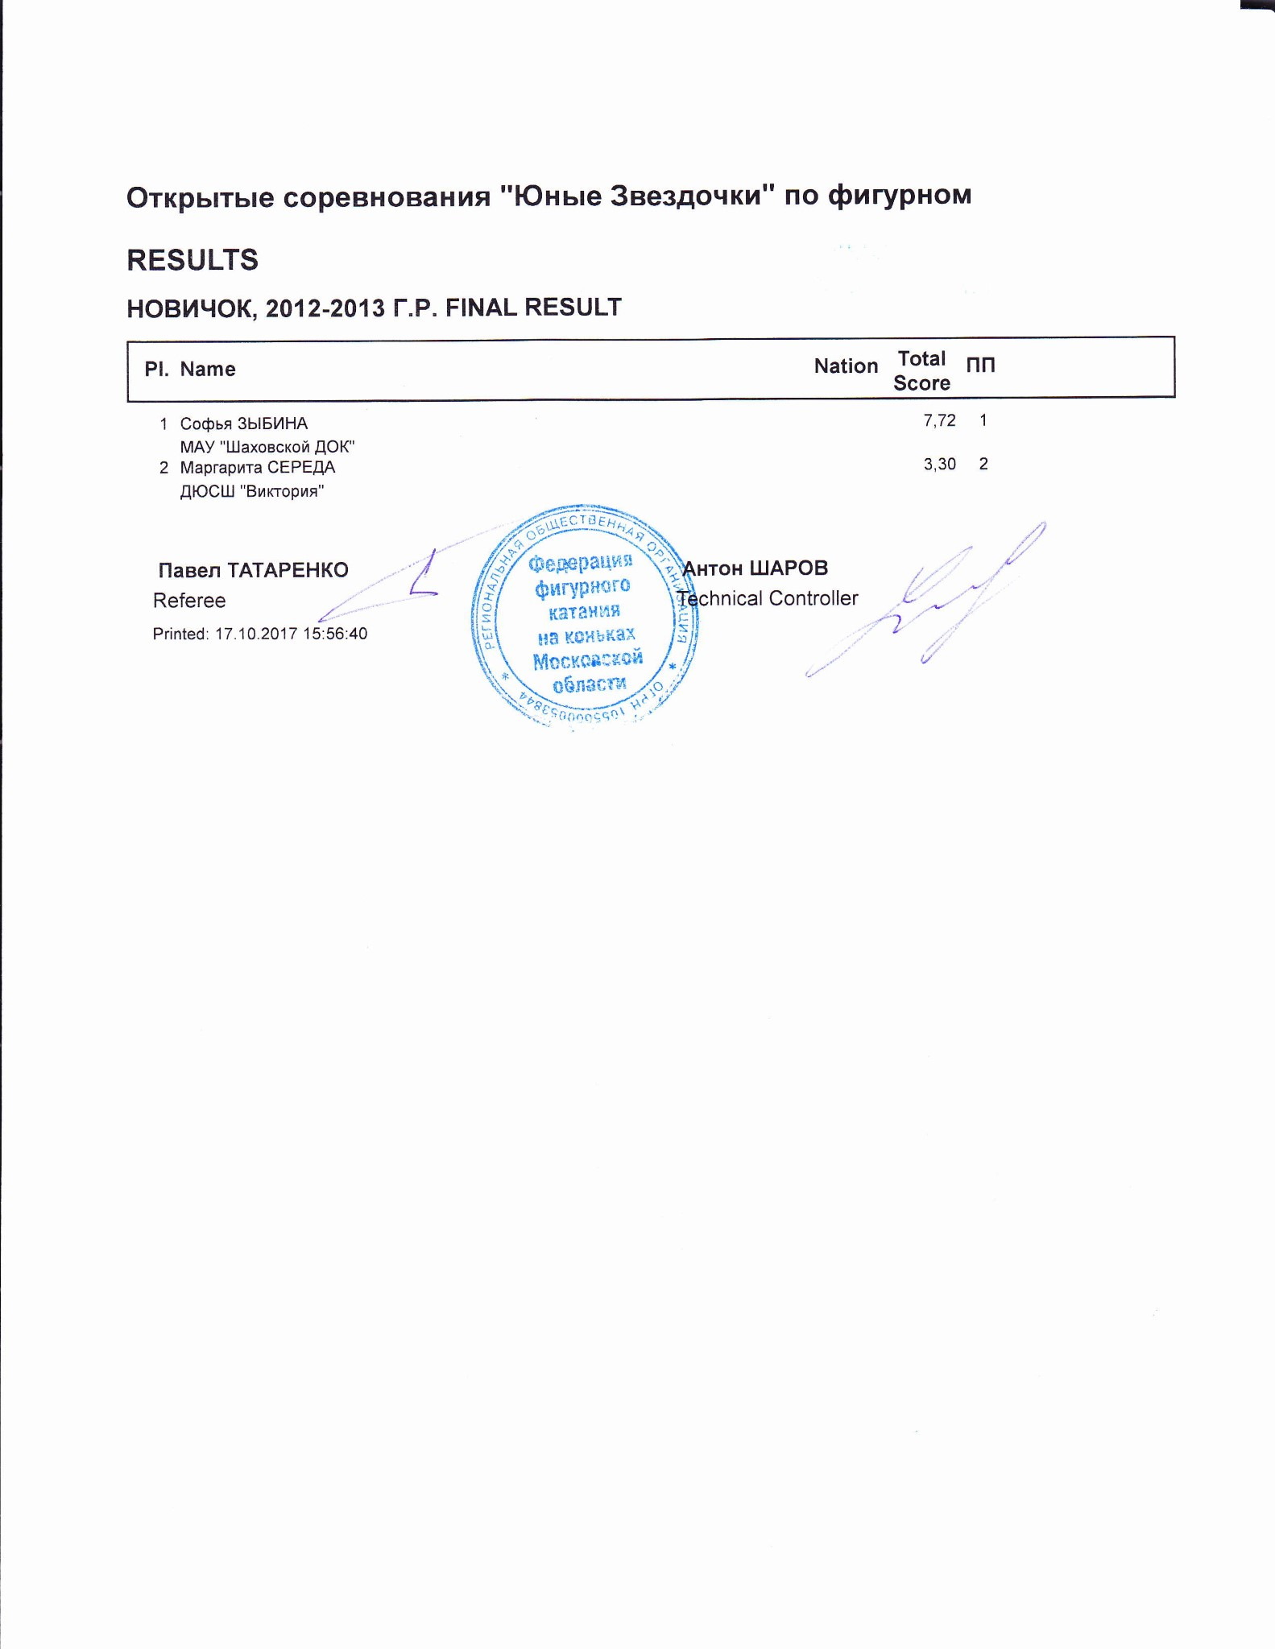

НОВИЧОК, 2012-2013 Г.Р.
RESULT DETAILS ПРОИЗВОЛЬНАЯ ПРОГРАММА
Pl. | Name |  | Nation | Total  Segment  Score  = | Total  Element  Score  + | Tot. Prog.  Comp.  Score *  + | SS |  | PE |  |  | Deduct.  -
- Софья ЗЫБИНА 7.72 3.22 4.50 1.75 0.00 2.00 0.00 0.00 0.00
- Маргарита СЕРЕДА 3.30 0.80 3.50 1.50 0.00 1.42 0.00 0.00 1.00
SS = Навыки скольжения PE = Представление
- = factored score
Printed: 17.10.2017 15:58:09

Открытые соревнования "Юные Звездочки" по фигурном
НОВИЧОК, 2012-2013 Г.Р. ПРОИЗВОЛЬНАЯ ПРОГРАММА JUDGES DETAILS PER SKATER
Rank | Name |  |  |  | Nation |  | Starting  Number |  | Total  Segment Score |  | Total  Element Score |  | Total  Program Component  Score (factored) |  |  | Total  Deductions
1 | Софья ЗЫБИНА |  |  |  |  |  | 2 |  | 7.72 |  | 3.22 |  | 4.50 |  |  | 0.00
#  1 | Executed  Elements ChSq1 |  | Base  Info  Value  2.00 | GOE  0.00 | J1  0 | J2  0 | J3  0 | J4  0 |  | J5  0 | J6 | J7 | J8 | J9 | Ref | Scores of Panel  2.00
2 | USpB |  | 1.00 | 0.00 | 0 | 0 | 0 | 0 |  | 0 |  |  |  |  |  | 1.00
3 | 1W |  | 0.22 | x 0.00 | 0 | 0 | 0 | 0 |  | 0 |  |  |  |  |  | 0.22
4 | 1W* |  | * 0.00 | x 0.00 | - | - | - | - |  | - |  |  |  |  |  | 0.00
 |  |  | 3.22 |  |  |  |  |  |  |  |  |  |  |  |  | 3.22
 | Program Components  Навыки скольжения |  | Factor  1.20 |  | 1,75 | 1,75 | 1,75 | 1,75 |  | 1,75 |  |  |  |  |  | 1.75
 | Представление |  | 1.20 |  | 1,50 | 2,00 | 2,25 | 2,00 |  | 2,00 |  |  |  |  |  | 2.00
 | Judges Total Program Component Score (factored) |  |  |  |  |  |  |  |  |  |  |  |  |  |  | 4.50
Deductions
0.00
- Invalid element x Credit for highlight distribution, base value multiplied by 1.1
Rank | Name |  |  |  |  | Nation |  | Starting  Number |  | Total  Segment Score |  | Total  Element Score |  | Total  Program Component  Score (factored) |  |  | Total  Deductions
2 | Маргарита СЕРЕДА |  |  |  |  |  |  | 1 |  | 3.30 |  | 0.80 |  | 3.50 |  |  | 1.00
#  1 | Executed  Elements  1W | Base  Info  Value  0.20 |  | GOE  0.00 |  | J1  -1 | J2  0 | J3  0 | J4  0 |  | J5  0 | J6 | J7 | J8 | J9 | Ref | Scores of Panel  0.20
2 | ChSq1 | 2.00 |  | -1.50 |  | -3 | -3 | -3 | -3 |  | -3 |  |  |  |  |  | 0.50
3 | USpB | 1.00 |  | -0.90 |  | -3 | -3 | -3 | -3 |  | -3 |  |  |  |  |  | 0.10
 |  | 3.20 |  |  |  |  |  |  |  |  |  |  |  |  |  |  | 0.80
 | Program Components  Навыки скольжения |  |  | Factor  1.20 |  | 1,25 | 1,50 | 1,50 | 1,50 |  | 1,50 |  |  |  |  |  | 1.50
 | Представление |  |  | 1.20 |  | 1,00 | 1,25 | 1,75 | 1,50 |  | 1,50 |  |  |  |  |  | 1.42
 | Judges Total Program Component Score (factored) |  |  |  |  |  |  |  |  |  |  |  |  |  |  |  | 3.50
Deductions |  |  | Falls: |  | -1.00 |  |  |  |  |  |  |  |  |  |  |  | -1.00
printed: 17.10.2017 15:58:13

