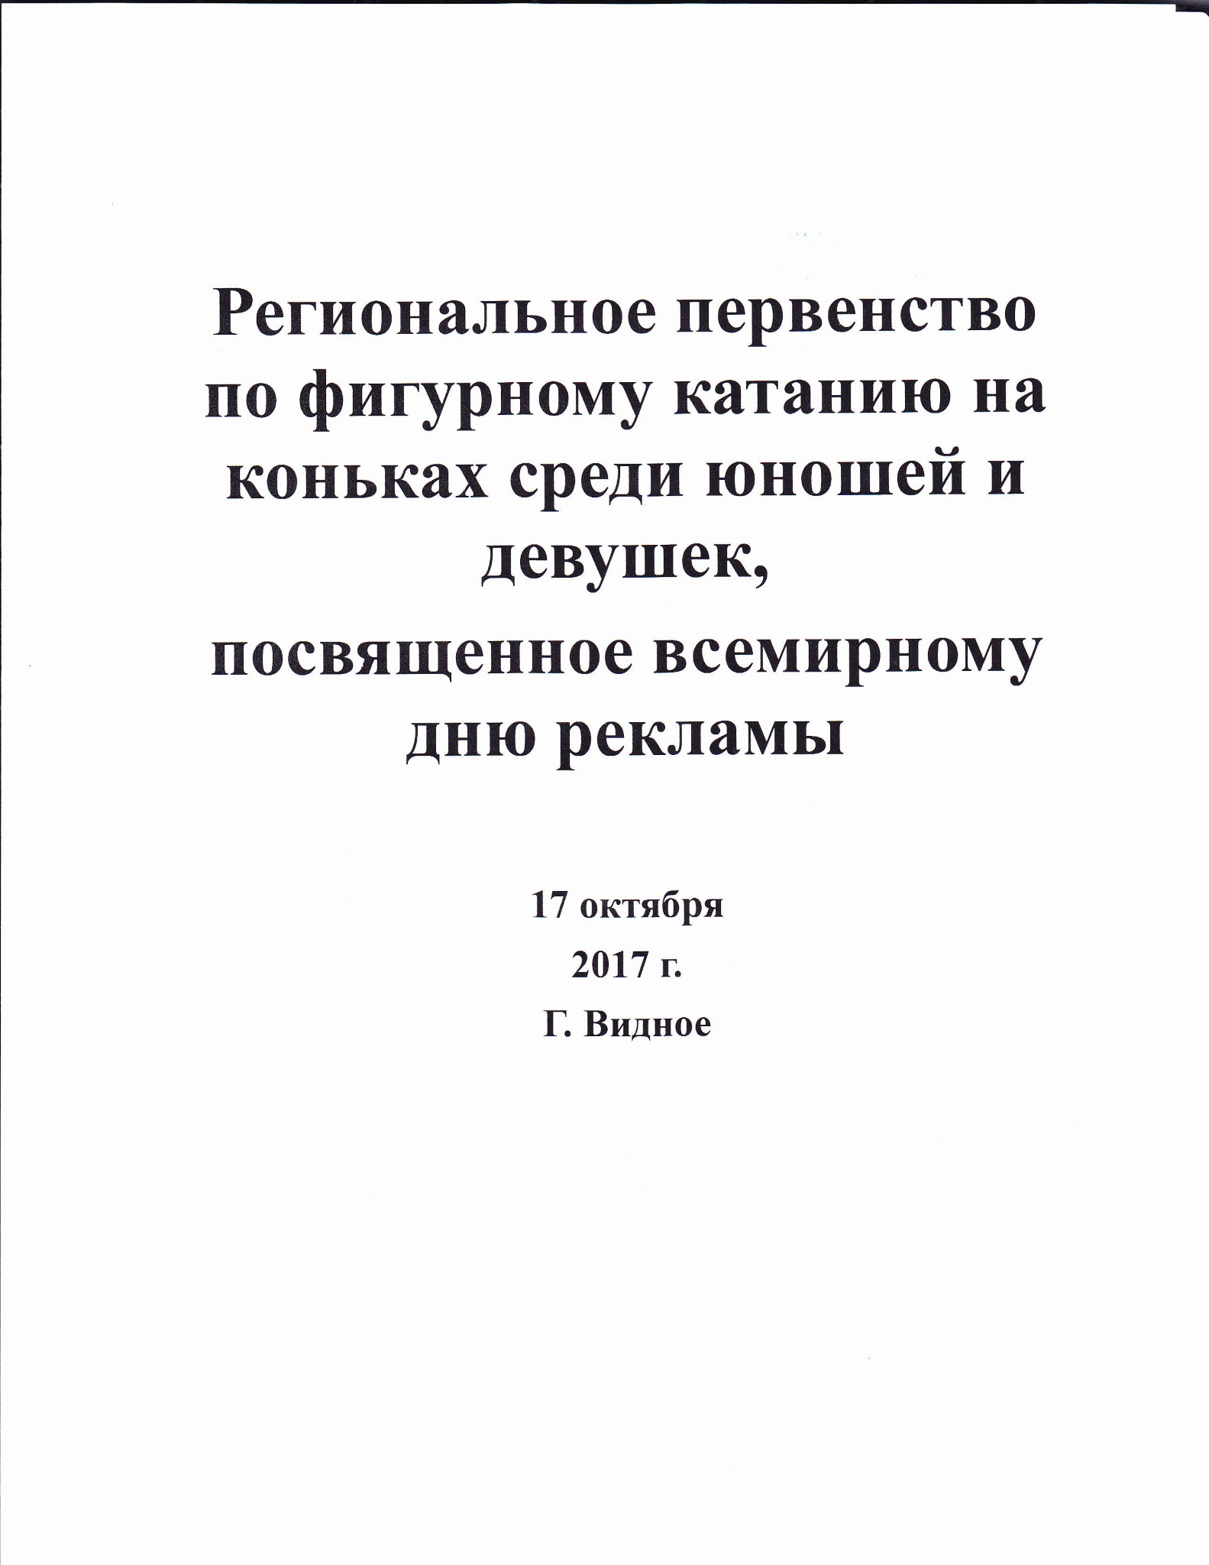
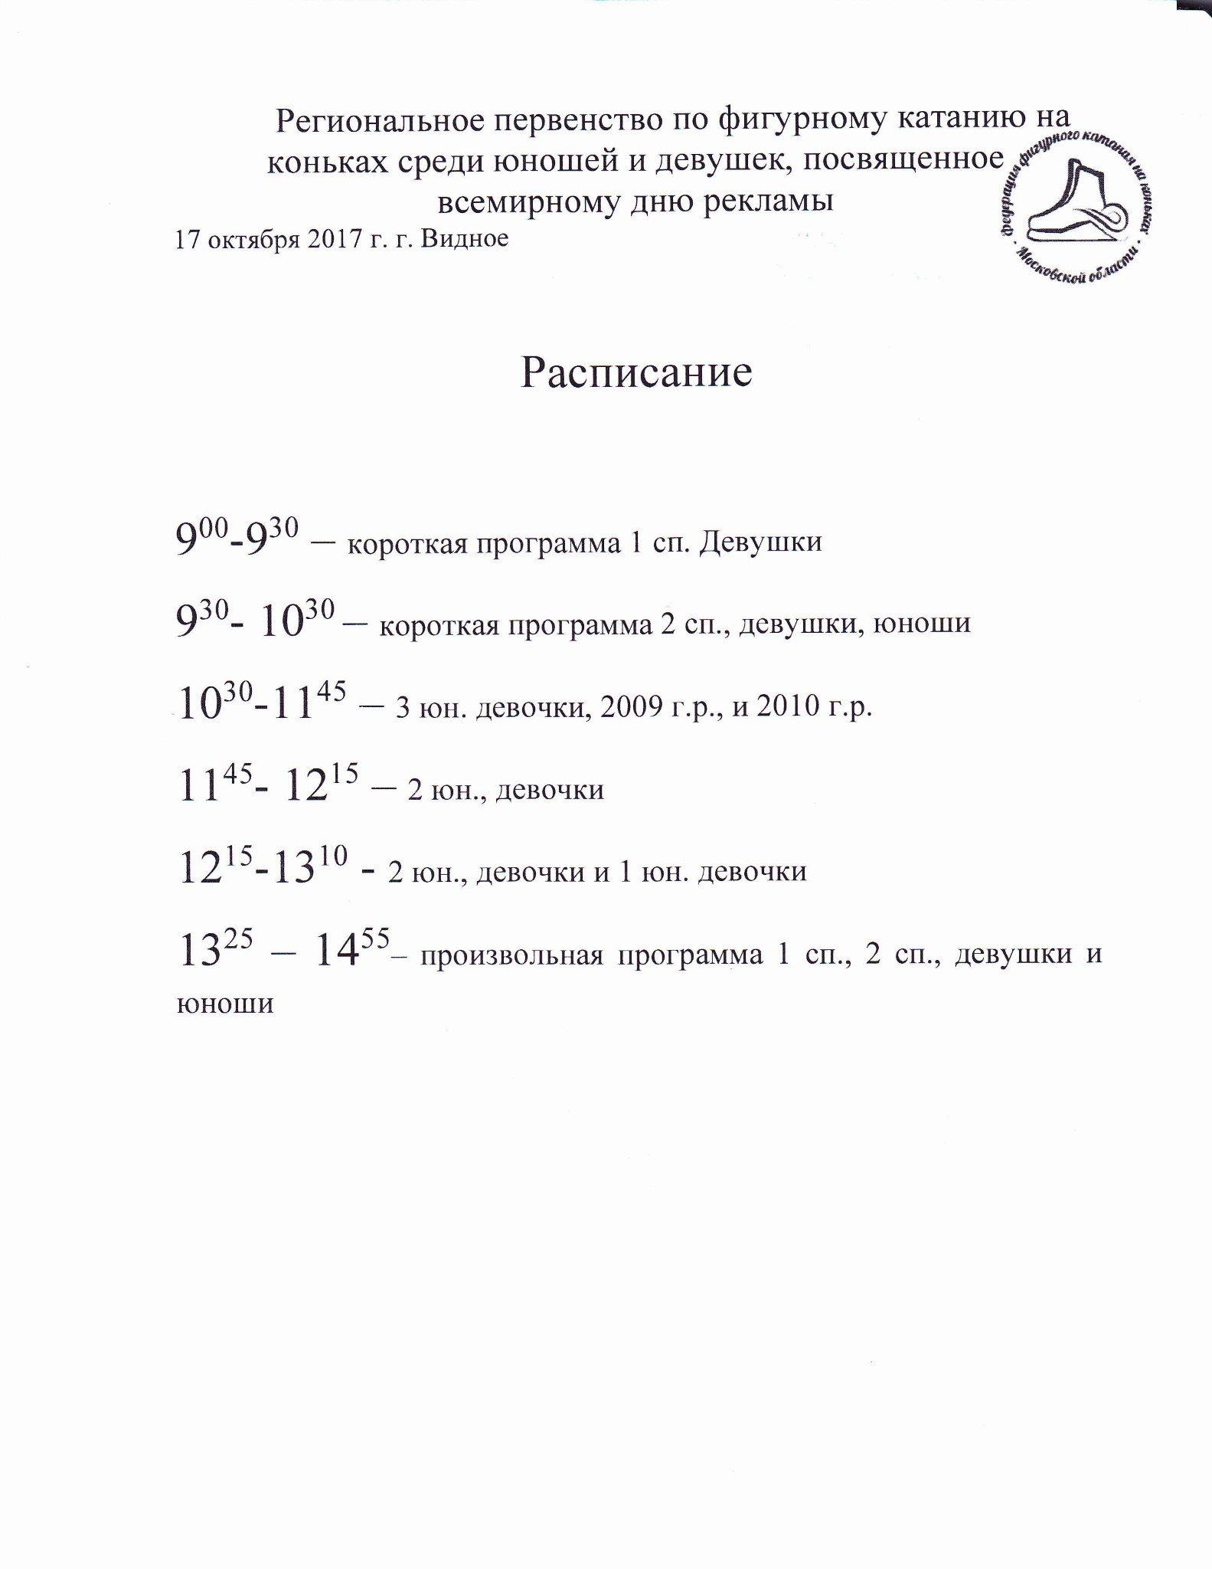
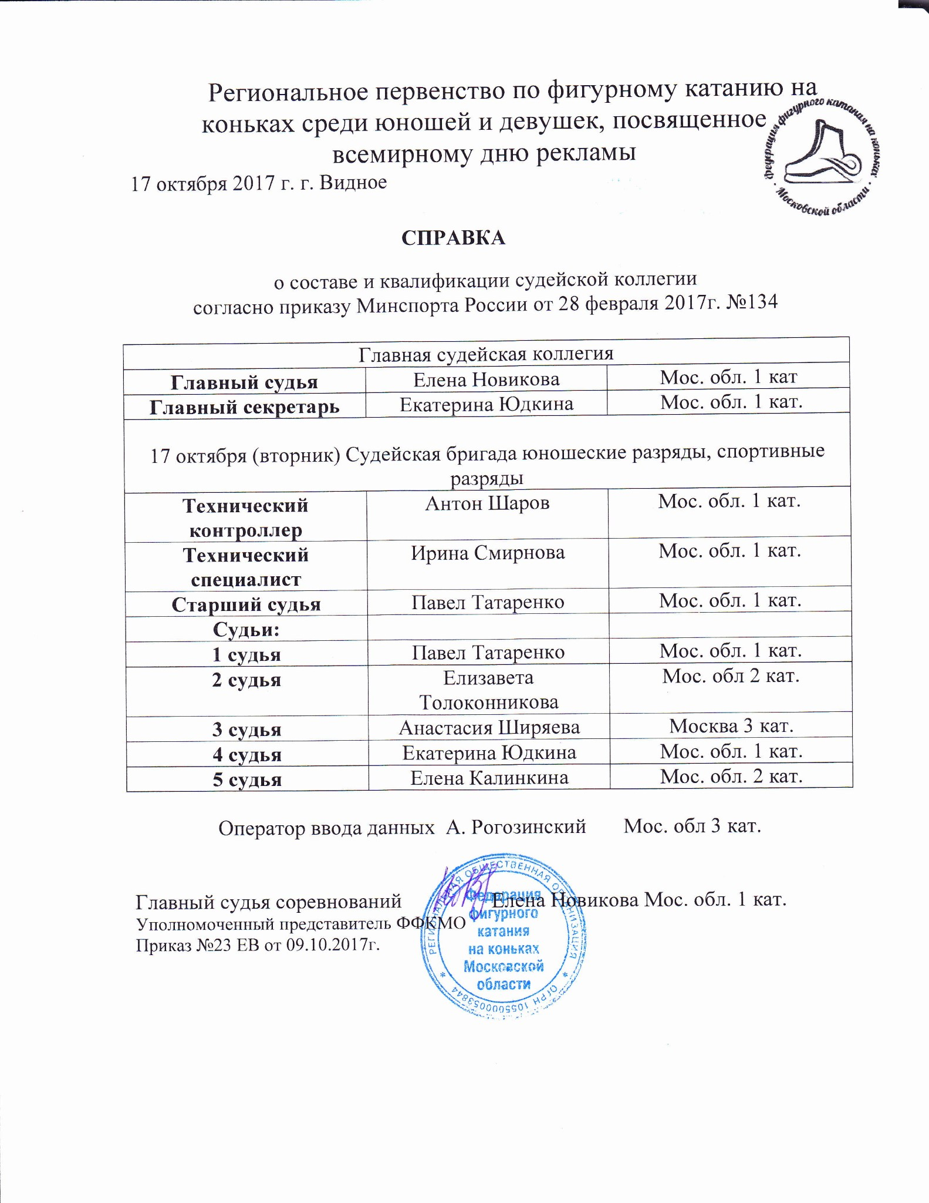
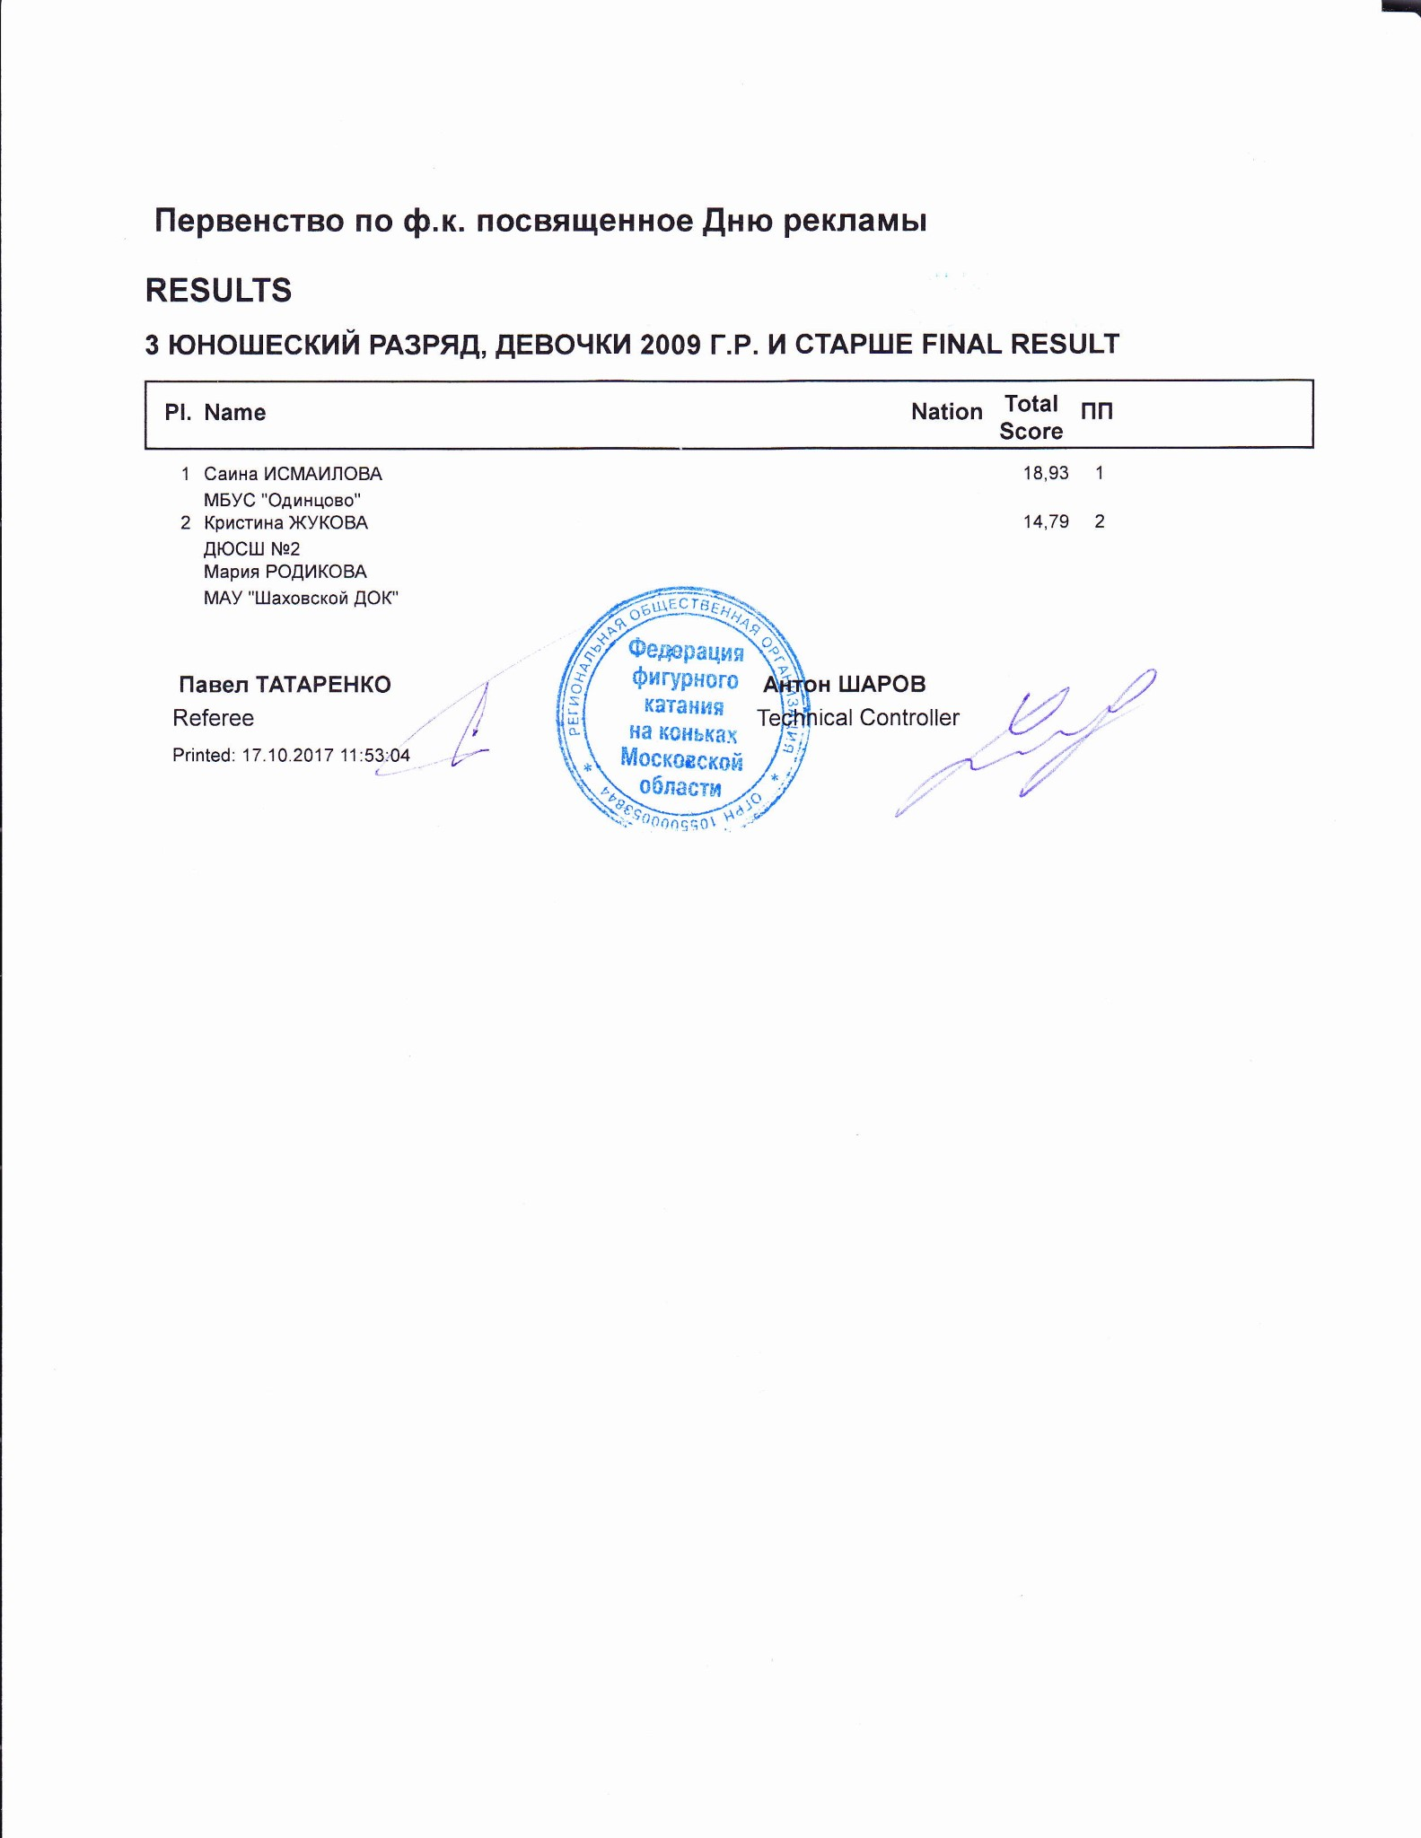

3 ЮНОШЕСКИЙ РАЗРЯД, ДЕВОЧКИ 2009 Г.Р. И СТАРШЕ
RESULT DETAILS ПРОИЗВОЛЬНАЯ ПРОГРАММА
Pl. | Name |  | Nation | Total  Segment  Score  = | Total  Element  Score  + | Tot. Prog.  Comp.  Score *  + | SS |  | PE |  | IN | Deduct.  -
- Саина ИСМАИЛОВА 18.93 7.41 12.52 2.92 0.00 2.67 0.00 2.75 1.00
- Кристина ЖУКОВА 14.79 4.55 11.24 2.58 0.00 2.33 0.00 2.58 1.00
SS = Навыки скольжения PE = Представление IN = Интерпретация
* = factored score
Printed: 17.10.2017 11:56:14

Первенство по ф.к. посвященное Дню рекламы
3 ЮНОШЕСКИЙ РАЗРЯД, ДЕВОЧКИ 2009 Г.Р. И СТАРШЕ ПРОИЗВОЛЬНАЯ ПРОГРАММА JUDGE
Rank | Name |  |  |  |  | Nation |  | Starting  Number |  | Total  Segment Score |  | Total  Element Score |  | Total  Program Component  Score (factored) |  |  | Total  Deductions
1 | Саина ИСМАИЛОВА |  |  |  |  |  |  | 3 |  | 18.93 |  | 7.41 |  | 12.52 |  |  | 1.00
#  1 | Executed  Elements  1F | Base  Info  Value  0.50 |  | GOE  0.07 |  | J1  1 | J2  1 | J3  0 | J4  0 |  | J5  0 | J6 | J7 | J8 | J9 | Ref | Scores of Panel  0.57
2 | 1A+SEQ+1T | 1.20 |  | -0.60 |  | -3 | -3 | -3 | -3 |  | -3 |  |  |  |  |  | 0.60
3 | CCoSpB | 1.70 |  | 0.00 |  | 1 | 0 | 0 | 0 |  | 0 |  |  |  |  |  | 1.70
4 | ChSq1 | 2.00 |  | 0.23 |  | 1 | 1 | 0 | 0 |  | 0 |  |  |  |  |  | 2.23
5 | 1A | 1.21 |  | x 0.00 |  | 0 | 0 | 1 | 0 |  | 0 |  |  |  |  |  | 1.21
6 | SSpB | 1.10 |  | 0.00 |  | 0 | 0 | 0 | 0 |  | 0 |  |  |  |  |  | 1.10
 |  | 7.71 |  |  |  |  |  |  |  |  |  |  |  |  |  |  | 7.41
 | Program Components  Навыки скольжения |  |  | Factor  1.50 |  | 3,25 | 3,25 | 2,75 | 2,75 |  | 2,75 |  |  |  |  |  | 2.92
 | Представление |  |  | 1.50 |  | 2,75 | 2,50 | 2,75 | 2,75 |  | 2,50 |  |  |  |  |  | 2.67
 | Интерпретация |  |  | 1.50 |  | 2,50 | 2,75 | 3,00 | 2,75 |  | 2,75 |  |  |  |  |  | 2.75
 | Judges Total Program Component Score (factored) |  |  |  |  |  |  |  |  |  |  |  |  |  |  |  | 12.52
Deductions |  |  | Falls: |  | -1.00 |  |  |  |  |  |  |  |  |  |  |  | -1.00
x Credit for highlight distribution, base value multiplied by 1.1
Rank | Name |  |  |  |  |  | Nation |  | Starting  Number |  | Total  Segment Score |  | Total  Element Score |  | Total  Program Component  Score (factored) |  |  | Total  Deductions
2 | Кристина ЖУКОВА |  |  |  |  |  |  |  | 2 |  | 14.79 |  | 4.55 |  | 11.24 |  |  | 1.00
#  1 | Executed  Elements CoSpB | Base  Info  Value  1.50 |  |  | GOE  0.00 |  | J1  1 | J2  0 | J3  0 | J4  0 |  | J5  0 | J6 | J7 | J8 | J9 | Ref | Scores of Panel  1.50
2 | 1Lo |  | 0.50 |  |  | -0.03 | -1 | -1 | 0 | 0 |  | 0 |  |  |  |  |  | 0.47
3 | ChSq1 |  | 2.00 |  |  | -1.50 | -3 | -3 | -3 | -3 |  | -3 |  |  |  |  |  | 0.50
4 | 1A |  | 1.21 |  | x | -0.47 | -2 | -3 | -3 | -2 |  | -2 |  |  |  |  |  | 0.74
5 | 1S+1Lo<< | << | 0.44 |  | x | -0.20 | -2 | -2 | -2 | -2 |  | -2 |  |  |  |  |  | 0.24
6 | SSpB |  | 1.10 |  |  | 0.00 | 0 | 0 | 0 | 0 |  | 0 |  |  |  |  |  | 1.10
 |  |  | 6.75 |  |  |  |  |  |  |  |  |  |  |  |  |  |  | 4.55
 | Program Components  Навыки скольжения |  |  |  |  | Factor  1.50 | 2,75 | 2,75 | 2,50 | 2,50 |  | 2,50 |  |  |  |  |  | 2.58
 | Представление |  |  |  |  | 1.50 | 2,25 | 2,50 | 2,50 | 2,25 |  | 2,25 |  |  |  |  |  | 2.33
 | Интерпретация |  |  |  |  | 1.50 | 2,25 | 3,00 | 2,75 | 2,50 |  | 2,50 |  |  |  |  |  | 2.58
 | Judges Total Program Component Score (factored) |  |  |  |  |  |  |  |  |  |  |  |  |  |  |  |  | 11.24
Deductions |  |  |  | Falls: |  | -1.00 |  |  |  |  |  |  |  |  |  |  |  | -1.00
<< Downgraded jump x Credit for highlight distribution, base value multiplied by 1.1 printed: 17.10.2017 11:56:19

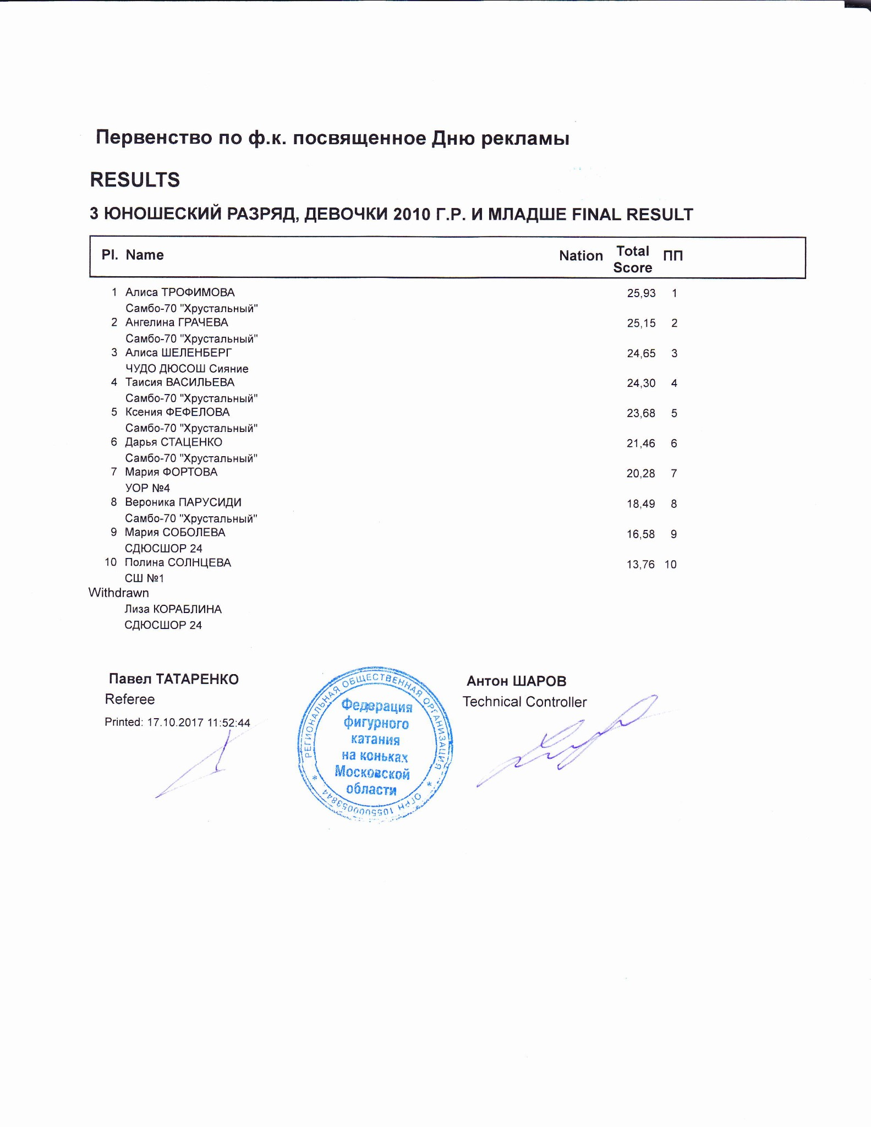

3 ЮНОШЕСКИЙ РАЗРЯД, ДЕВОЧКИ 2010 Г.Р. И МЛАДШЕ
RESULT DETAILS ПРОИЗВОЛЬНАЯ ПРОГРАММА
 | Pl. | Name |  |  | Nation | Total  Segment  Score  = |  | Total  Element  Score  + |  | Tot. Prog.  Comp.  Score *  + |  | SS |  |  |  | PE |  |  |  | IN |  | Deduct.  -
1 Алиса ТРОФИМОВА |  |  |  | 25.93 |  |  | 10.55 |  | 15.38 |  | 3.42 |  | 0.00 |  | 3.33 |  | 0.00 |  | 3.50 |  | 0.00
2 Ангелина ГРАЧЕВА |  |  |  | 25.15 |  |  | 10.13 |  | 15.02 |  | 3.17 |  | 0.00 |  | 3.42 |  | 0.00 |  | 3.42 |  | 0.00
3 Алиса ШЕЛЕНБЕРГ |  |  |  | 24.65 |  |  | 10.01 |  | 14.64 |  | 3.25 |  | 0.00 |  | 3.17 |  | 0.00 |  | 3.33 |  | 0.00
4 Таисия ВАСИЛЬЕВА |  |  |  | 24.30 |  |  | 10.04 |  | 14.26 |  | 3.17 |  | 0.00 |  | 3.08 |  | 0.00 |  | 3.25 |  | 0.00
5 Ксения ФЕФЕЛОВА |  |  |  | 23.68 |  |  | 9.80 |  | 13.88 |  | 3.25 |  | 0.00 |  | 2.92 |  | 0.00 |  | 3.08 |  | 0.00
6 Дарья СТАЦЕНКО |  |  |  | 21.46 |  |  | 8.33 |  | 15.13 |  | 3.25 |  | 0.00 |  | 3.33 |  | 0.00 |  | 3.50 |  | 2.00
7 Мария ФОРТОВА |  |  |  | 20.28 |  |  | 8.03 |  | 13.25 |  | 2.75 |  | 0.00 |  | 3.00 |  | 0.00 |  | 3.08 |  | 1.00
8 Вероника ПАРУСИДИ |  |  |  | 18.49 |  |  | 7.34 |  | 12.15 |  | 2.67 |  | 0.00 |  | 2.67 |  | 0.00 |  | 2.75 |  | 1.00
9 Мария СОБОЛЕВА |  |  |  | 16.58 |  |  | 5.21 |  | 11.37 |  | 2.58 |  | 0.00 |  | 2.50 |  | 0.00 |  | 2.50 |  | 0.00
10 Полина СОЛНЦЕВА |  |  |  | 13.76 |  |  | 6.76 |  | 10.00 |  | 2.33 |  | 0.00 |  | 2.08 |  | 0.00 |  | 2.25 |  | 3.00
SS = Навыки скольжения |  |  |  | PE = Представление |  |  |  |  |  |  |  |  |  |  |  |  |  |  | IN = Интерпретация
* = factored score
Printed: 17.10.2017 11:55:51

x Credit for highlight distribution, base value multiplied by 1.1 ! Not clear edge
Rank | Name |  |  |  | Nation |  | Starting  Number |  | Total  Segment Score |  | Total  Element Score |  | Total  Program Component  Score (factored) |  |  | Total  Deductions
2 | Ангелина ГРАЧЕВА |  |  |  |  |  | 3 |  | 25.15 |  | 10.13 |  | 15.02 |  |  | 0.00
#  1 | Executed  Elements ChSq1 | Base  Info  Value  2.00 | GOE  0.93 |  | J1  2 | J2  2 | J3  1 | J4  1 |  | J5  1 | J6 | J7 | J8 | J9 | Ref | Scores of Panel  2.93
2 | 1A | 1.10 |  | 0.00 | 1 | 0 | 0 | 0 |  | 0 |  |  |  |  |  | 1.10
3 | SSp1 | 1.30 |  | 0.50 | 1 | 2 | 1 | 1 |  | 1 |  |  |  |  |  | 1.80
4 | 1A+1T | 1.65 | x | -0.20 | -2 | -1 | -1 | -1 |  | -1 |  |  |  |  |  | 1.45
5 | 1F | 0.55 | x | 0.13 | 2 | 1 | 0 | 0 |  | 1 |  |  |  |  |  | 0.68
6 | CCoSp1 | 2.00 |  | 0.17 | -1 | 0 | 0 | 1 |  | 1 |  |  |  |  |  | 2.17
 |  | 8.60 |  |  |  |  |  |  |  |  |  |  |  |  |  | 10.13
 | Program Components  Навыки скольжения |  |  | Factor  1.50 | 3,50 | 3,25 | 2,75 | 3,25 |  | 3,00 |  |  |  |  |  | 3.17
 | Представление |  |  | 1.50 | 3,75 | 3,75 | 3,00 | 3,25 |  | 3,25 |  |  |  |  |  | 3.42
 | Интерпретация |  |  | 1.50 | 4,00 | 3,75 | 3,00 | 3,25 |  | 3,25 |  |  |  |  |  | 3.42
 | Judges Total Program Component Score (factored) |  |  |  |  |  |  |  |  |  |  |  |  |  |  | 15.02
Deductions
0.00
#  1 | Executed  Elements CCoSp1 | Base  Info  Value  2.00 |  | GOE  0.00 |  | J1  -1 | J2  0 | J3  0 | J4  0 | J5  1 | J6 | J7 | J8 | J9 | Ref | Scores of Panel  2.00
2 | ChSq1 |  | 2.00 |  | 0.93 | 2 | 2 | 1 | 1 | 0 |  |  |  |  |  | 2.93
3 | 1A+1Lo |  | 1.76 | x | 0.13 | 1 | 1 | 1 | 0 | 0 |  |  |  |  |  | 1.89
4 | 1F | ! | 0.55 | x | 0.00 | 0 | 0 | 0 | 0 | 0 |  |  |  |  |  | 0.55
5 | SSp1 |  | 1.30 |  | 0.67 | 2 | 2 | 1 | 1 | 1 |  |  |  |  |  | 1.97
6 | 1A |  | 1.21 | x | 0.00 | 0 | 0 | 0 | 0 | 0 |  |  |  |  |  | 1.21
 |  |  | 8.82 |  |  |  |  |  |  |  |  |  |  |  |  | 10.55
 | Program Components  Навыки скольжения |  |  |  | Factor  1.50 | 3,75 | 3,75 | 3,00 | 3,25 | 3,25 |  |  |  |  |  | 3.42
 | Представление |  |  |  | 1.50 | 3,75 | 3,50 | 3,00 | 3,25 | 3,25 |  |  |  |  |  | 3.33
 | Интерпретация |  |  |  | 1.50 | 4,00 | 4,00 | 3,25 | 3,25 | 3,25 |  |  |  |  |  | 3.50
 | Judges Total Program Component Score (factored) |  |  |  |  |  |  |  |  |  |  |  |  |  |  | 15.38
Rank | Name |  |  | Nation | Starting  Number | Total  Segment Score | Total  Element Score | Total  Program Component  Score (factored) | Total  Deductions
1 | Алиса ТРОФИМОВА |  |  |  | 6 | 25.93 | 10.55 | 15.38 | 0.00
x Credit for highlight distribution, base value multiplied by 1.1
Deductions
0.00
Rank | Name |  |  |  | Nation |  | Starting  Number |  | Total  Segment Score |  | Total  Element Score |  | Total  Program Component  Score (factored) |  |  | Total  Deductions
3 | Алиса ШЕЛЕНБЕРГ |  |  |  |  |  | 9 |  | 24.65 |  | 10.01 |  | 14.64 |  |  | 0.00
#  1 | Executed  Elements SSp1 | Base  Info  Value  1.30 | GOE  0.67 |  | J1  2 | J2  2 | J3  1 | J4  1 |  | J5  0 | J6 | J7 | J8 | J9 | Ref | Scores of Panel  1.97
2 | 1Lz | 0.60 |  | 0.07 | 1 | 1 | 0 | 0 |  | 0 |  |  |  |  |  | 0.67
3 | ChSq1 | 2.00 |  | 0.70 | 1 | 1 | 1 | 1 |  | 0 |  |  |  |  |  | 2.70
4 | 1A+1Lo | 1.76 | x | 0.00 | 1 | 0 | 0 | 0 |  | 0 |  |  |  |  |  | 1.76
5 | 1A | 1.21 | x | 0.00 | 0 | 0 | 0 | 0 |  | 0 |  |  |  |  |  | 1.21
6 | CoSp1 | 1.70 |  | 0.00 | 1 | 0 | 0 | 0 |  | 0 |  |  |  |  |  | 1.70
 |  | 8.57 |  |  |  |  |  |  |  |  |  |  |  |  |  | 10.01
 | Program Components  Навыки скольжения |  |  | Factor  1.50 | 3,50 | 3,25 | 3,25 | 3,25 |  | 2,75 |  |  |  |  |  | 3.25
 | Представление |  |  | 1.50 | 3,50 | 3,25 | 3,00 | 3,25 |  | 3,00 |  |  |  |  |  | 3.17
 | Интерпретация |  |  | 1.50 | 3,50 | 3,50 | 3,25 | 3,25 |  | 3,00 |  |  |  |  |  | 3.33
 | Judges Total Program Component Score (factored) |  |  |  |  |  |  |  |  |  |  |  |  |  |  | 14.64
Deductions |  |  |  |  |  |  |  |  |  |  |  |  |  |  |  | 0.00
x Credit for highlight distribution, base value multiplied by 1.1
x Credit for highlight distribution, base value multiplied by 1.1
Rank | Name |  |  |  | Nation |  | Starting  Number |  | Total  Segment Score |  | Total  Element Score |  | Total  Program Component  Score (factored) |  |  | Total  Deductions
5 | Ксения ФЕФЕЛОВА |  |  |  |  |  | 5 |  | 23.68 |  | 9.80 |  | 13.88 |  |  | 0.00
#  1 | Executed  Elements  1A+1Lo | Base  Info  Value  1.60 | GOE  0.13 |  | J1  1 | J2  1 | J3  1 | J4  0 |  | J5  0 | J6 | J7 | J8 | J9 | Ref | Scores of Panel  1.73
2 | ChSq1 | 2.00 |  | 0.70 | 1 | 1 | 1 | 0 |  | 1 |  |  |  |  |  | 2.70
3 | 1A | 1.21 | x | 0.00 | 0 | 0 | 0 | 0 |  | 0 |  |  |  |  |  | 1.21
4 | SSp1 | 1.30 |  | 0.50 | 1 | 1 | 0 | 1 |  | 1 |  |  |  |  |  | 1.80
5 | 1Lz | 0.66 | x | -0.10 | -1 | -1 | -1 | -1 |  | 0 |  |  |  |  |  | 0.56
6 | CCoSp1 | 2.00 |  | -0.20 | -1 | -1 | -1 | 0 |  | 0 |  |  |  |  |  | 1.80
 |  | 8.77 |  |  |  |  |  |  |  |  |  |  |  |  |  | 9.80
 | Program Components  Навыки скольжения |  |  | Factor  1.50 | 3,50 | 3,25 | 3,00 | 3,25 |  | 3,25 |  |  |  |  |  | 3.25
 | Представление |  |  | 1.50 | 3,00 | 2,75 | 2,75 | 3,00 |  | 3,25 |  |  |  |  |  | 2.92
 | Интерпретация |  |  | 1.50 | 3,25 | 3,00 | 3,25 | 3,00 |  | 3,00 |  |  |  |  |  | 3.08
 | Judges Total Program Component Score (factored) |  |  |  |  |  |  |  |  |  |  |  |  |  |  | 13.88
Deductions
0.00
#  1 | Executed  Elements CCoSp1 | Base  Info  Value  2.00 | GOE  -0.10 |  | J1  0 | J2  -1 | J3  -1 | J4  0 | J5  0 | J6 | J7 | J8 | J9 | Ref | Scores of Panel  1.90
2 | 1F | 0.50 |  | 0.07 | 1 | 1 | 0 | 0 | 0 |  |  |  |  |  | 0.57
3 | SSp1 | 1.30 |  | 0.50 | 1 | 2 | 0 | 1 | 1 |  |  |  |  |  | 1.80
4 | ChSq1 | 2.00 |  | 0.93 | 2 | 2 | 1 | 1 | 1 |  |  |  |  |  | 2.93
5 | 1A | 1.21 | x | 0.00 | 0 | 0 | 0 | 0 | 0 |  |  |  |  |  | 1.21
6 | 1A+1Lo | 1.76 | x | -0.13 | -1 | 0 | -1 | -1 | 0 |  |  |  |  |  | 1.63
 |  | 8.77 |  |  |  |  |  |  |  |  |  |  |  |  | 10.04
 | Program Components  Навыки скольжения |  |  | Factor  1.50 | 3,25 | 3,50 | 3,00 | 3,00 | 3,25 |  |  |  |  |  | 3.17
 | Представление |  |  | 1.50 | 3,00 | 3,75 | 3,00 | 3,00 | 3,25 |  |  |  |  |  | 3.08
 | Интерпретация |  |  | 1.50 | 3,50 | 3,50 | 2,75 | 3,00 | 3,25 |  |  |  |  |  | 3.25
 | Judges Total Program Component Score (factored) |  |  |  |  |  |  |  |  |  |  |  |  |  | 14.26
Rank | Name |  |  | Nation | Starting  Number | Total  Segment Score | Total  Element Score | Total  Program Component  Score (factored) | Total  Deductions
4 | Таисия ВАСИЛЬЕВА |  |  |  | 4 | 24.30 | 10.04 | 14.26 | 0.00
x Credit for highlight distribution, base value multiplied by 1.1
Deductions
0.00
Rank | Name |  |  |  |  | Nation |  | Starting  Number |  | Total  Segment Score |  | Total  Element Score |  | Total  Program Component  Score (factored) |  |  | Total  Deductions
6 | Дарья СТАЦЕНКО |  |  |  |  |  |  | 11 |  | 21.46 |  | 8.33 |  | 15.13 |  |  | 2.00
#  1 | Executed  Elements  1A | Base  Info  Value  1.10 |  | GOE  -0.60 |  | J1  -3 | J2  -3 | J3  -3 | J4  -3 |  | J5  -3 | J6 | J7 | J8 | J9 | Ref | Scores of Panel  0.50
2 | SSp1 | 1.30 |  |  | 0.50 | 1 | 2 | 1 | 1 |  | 1 |  |  |  |  |  | 1.80
3 | ChSq1 | 2.00 |  |  | 0.93 | 2 | 2 | 1 | 1 |  | 1 |  |  |  |  |  | 2.93
4 | 1A+REP | 0.85 |  | x | 0.20 | 1 | 1 | 1 | 1 |  | 1 |  |  |  |  |  | 1.05
5 | 1Lze | e 0.55 |  | x | -0.20 | -2 | -2 | -2 | -2 |  | -2 |  |  |  |  |  | 0.35
6 | CoSp1 | 1.70 |  |  | 0.00 | -1 | 0 | 0 | 0 |  | 0 |  |  |  |  |  | 1.70
 |  | 7.50 |  |  |  |  |  |  |  |  |  |  |  |  |  |  | 8.33
 | Program Components  Навыки скольжения |  |  |  | Factor  1.50 | 3,50 | 3,50 | 3,00 | 3,00 |  | 3,25 |  |  |  |  |  | 3.25
 | Представление |  |  |  | 1.50 | 3,75 | 3,75 | 3,25 | 3,00 |  | 3,00 |  |  |  |  |  | 3.33
 | Интерпретация |  |  |  | 1.50 | 4,00 | 4,00 | 3,25 | 3,25 |  | 3,25 |  |  |  |  |  | 3.50
 | Judges Total Program Component Score (factored) |  |  |  |  |  |  |  |  |  |  |  |  |  |  |  | 15.13
Deductions |  |  | Time violation: |  | -1.00 |  |  |  | Falls: |  | -1.00 |  |  |  |  |  | -2.00
x Credit for highlight distribution, base value multiplied by 1.1 e Wrong edge REP Jump repetition * Invalid element x Credit for highlight distribution, base value multiplied by 1.1
Rank | Name |  |  |  |  | Nation |  | Starting  Number |  | Total  Segment Score |  | Total  Element Score |  | Total  Program Component  Score (factored) |  |  | Total  Deductions
8 | Вероника ПАРУСИДИ |  |  |  |  |  |  | 10 |  | 18.49 |  | 7.34 |  | 12.15 |  |  | 1.00
#  1 | Executed  Elements  1Lo | Base  Info  Value  0.50 |  | GOE  0.00 |  | J1  1 | J2  0 | J3  0 | J4  0 |  | J5  0 | J6 | J7 | J8 | J9 | Ref | Scores of Panel  0.50
2 | ChSq1 | 2.00 |  |  | 0.23 | 1 | 1 | 0 | 0 |  | 0 |  |  |  |  |  | 2.23
3 | SSp1 | 1.30 |  |  | -0.10 | 0 | -1 | 0 | 0 |  | -1 |  |  |  |  |  | 1.20
4 | 1F+1Lo | 1.10 |  | x | 0.00 | -1 | 0 | 0 | 0 |  | 0 |  |  |  |  |  | 1.10
5 | CoSp1 | 1.70 |  |  | 0.00 | 0 | 0 | 0 | 0 |  | 0 |  |  |  |  |  | 1.70
6 | 1A | 1.21 |  | x | -0.60 | -3 | -3 | -3 | -3 |  | -3 |  |  |  |  |  | 0.61
 |  | 7.81 |  |  |  |  |  |  |  |  |  |  |  |  |  |  | 7.34
 | Program Components  Навыки скольжения |  |  |  | Factor  1.50 | 3,00 | 2,75 | 2,50 | 2,75 |  | 2,50 |  |  |  |  |  | 2.67
 | Представление |  |  |  | 1.50 | 2,50 | 2,75 | 2,75 | 2,50 |  | 2,75 |  |  |  |  |  | 2.67
 | Интерпретация |  |  |  | 1.50 | 2,75 | 3,25 | 2,75 | 2,75 |  | 2,50 |  |  |  |  |  | 2.75
 | Judges Total Program Component Score (factored) |  |  |  |  |  |  |  |  |  |  |  |  |  |  |  | 12.15
Deductions |  |  | Falls: |  | -1.00 |  |  |  |  |  |  |  |  |  |  |  | -1.00
#  1 | Executed  Elements CoSpB | Base  Info  Value  1.50 | GOE  0.50 |  | J1  1 | J2  1 | J3  1 | J4  1 | J5  0 | J6 | J7 | J8 | J9 | Ref | Scores of Panel  2.00
2 | ChSq1 | 2.00 |  | 0.70 | 1 | 1 | 1 | 1 | 0 |  |  |  |  |  | 2.70
3 | SSp1 | 1.30 |  | 0.50 | 1 | 1 | 1 | 1 | 1 |  |  |  |  |  | 1.80
4 | 1A+SEQ+1Lo* | 0.97 | x | -0.60 | -3 | -3 | -3 | -3 | -3 |  |  |  |  |  | 0.37
5 | 1F | 0.55 | x | 0.00 | 0 | 0 | 0 | 0 | 0 |  |  |  |  |  | 0.55
6 | 1A | 1.21 | x | -0.60 | -3 | -3 | -3 | -3 | -3 |  |  |  |  |  | 0.61
 |  | 7.53 |  |  |  |  |  |  |  |  |  |  |  |  | 8.03
 | Program Components  Навыки скольжения |  |  | Factor  1.50 | 3,00 | 2,75 | 2,75 | 2,75 | 2,75 |  |  |  |  |  | 2.75
 | Представление |  |  | 1.50 | 3,00 | 3,25 | 3,00 | 3,00 | 2,50 |  |  |  |  |  | 3.00
 | Интерпретация |  |  | 1.50 | 3,50 | 3,00 | 3,25 | 3,00 | 2,75 |  |  |  |  |  | 3.08
 | Judges Total Program Component Score (factored) |  |  |  |  |  |  |  |  |  |  |  |  |  | 13.25
Rank | Name |  |  | Nation | Starting  Number | Total  Segment Score | Total  Element Score | Total  Program Component  Score (factored) | Total  Deductions
7 | Мария ФОРТОВА |  |  |  | 8 | 20.28 | 8.03 | 13.25 | 1.00
Deductions | Falls: | -1.00 |  |  |  |  |  |  |  |  |  |  |  | -1.00
x Credit for highlight distribution, base value multiplied by 1.1
Rank | Name |  |  |  | Nation |  | Starting  Number |  | Total  Segment Score |  | Total  Element Score |  | Total  Program Component  Score (factored) |  |  | Total  Deductions
9 | Мария СОБОЛЕВА |  |  |  |  |  | 1 |  | 16.58 |  | 5.21 |  | 11.37 |  |  | 0.00
#  1 | Executed  Elements SSpB | Base  Info  Value  1.10 | GOE  0.00 |  | J1  0 | J2  0 | J3  -1 | J4  0 |  | J5  0 | J6 | J7 | J8 | J9 | Ref | Scores of Panel  1.10
2 | ChSq1 | 2.00 |  | 0.00 | 0 | 0 | 0 | 0 |  | 0 |  |  |  |  |  | 2.00
3 | 1Lz | 0.66 | x | -0.10 | -1 | -1 | -1 | -1 |  | 0 |  |  |  |  |  | 0.56
4 | 1F | 0.55 | x | 0.00 | 0 | 0 | 0 | 0 |  | 0 |  |  |  |  |  | 0.55
5 | 1F+1Lo | 1.10 | x | -0.10 | -1 | -1 | -1 | -1 |  | -1 |  |  |  |  |  | 1.00
6 | CoSp | 0.00 |  | 0.00 | - | - | - | - |  | - |  |  |  |  |  | 0.00
 |  | 5.41 |  |  |  |  |  |  |  |  |  |  |  |  |  | 5.21
 | Program Components  Навыки скольжения |  |  | Factor  1.50 | 2,75 | 2,75 | 2,50 | 2,50 |  | 2,50 |  |  |  |  |  | 2.58
 | Представление |  |  | 1.50 | 2,50 | 2,75 | 2,50 | 2,50 |  | 2,50 |  |  |  |  |  | 2.50
 | Интерпретация |  |  | 1.50 | 2,25 | 2,50 | 2,75 | 2,50 |  | 2,50 |  |  |  |  |  | 2.50
 | Judges Total Program Component Score (factored) |  |  |  |  |  |  |  |  |  |  |  |  |  |  | 11.37
Deductions |  |  |  |  |  |  |  |  |  |  |  |  |  |  |  | 0.00
x Credit for highlight distribution, base value multiplied by 1.1
#  1 | Executed  Elements  1F | Base  Info  Value  0.50 | GOE  0.00 |  | J1  0 | J2  0 | J3  0 | J4  0 | J5  0 | J6 | J7 | J8 | J9 | Ref | Scores of Panel  0.50
2 | ChSq1 | 2.00 |  | 0.00 | 0 | 0 | 0 | 0 | 0 |  |  |  |  |  | 2.00
3 | CoSpB | 1.50 |  | 0.00 | 0 | 0 | 0 | 0 | 0 |  |  |  |  |  | 1.50
4 | 1Lz+1Lo | 1.21 | x | -0.10 | -1 | -1 | -1 | -1 | 0 |  |  |  |  |  | 1.11
5 | 1Lo | 0.55 | x | 0.00 | 0 | 0 | 0 | 0 | 0 |  |  |  |  |  | 0.55
6 | SSpB | 1.10 |  | 0.00 | 0 | 0 | 0 | 0 | 0 |  |  |  |  |  | 1.10
 |  | 6.86 |  |  |  |  |  |  |  |  |  |  |  |  | 6.76
 | Program Components  Навыки скольжения |  |  | Factor  1.50 | 2,50 | 2,50 | 2,25 | 2,25 | 2,25 |  |  |  |  |  | 2.33
 | Представление |  |  | 1.50 | 2,00 | 2,00 | 2,25 | 2,00 | 2,50 |  |  |  |  |  | 2.08
 | Интерпретация |  |  | 1.50 | 2,25 | 2,25 | 2,50 | 2,25 | 2,25 |  |  |  |  |  | 2.25
 | Judges Total Program Component Score (factored) |  |  |  |  |  |  |  |  |  |  |  |  |  | 10.00
Rank | Name |  |  | Nation | Starting  Number | Total  Segment Score | Total  Element Score | Total  Program Component  Score (factored) | Total  Deductions
10 | Полина СОЛНЦЕВА |  |  |  | 2 | 13.76 | 6.76 | 10.00 | 3.00
Deductions | Time violation: | -1.00 |  |  |  | Falls: | -2.00 |  |  |  |  |  | -3.00
x Credit for highlight distribution, base value multiplied by 1.1 printed: 17.10.2017 11:55:57

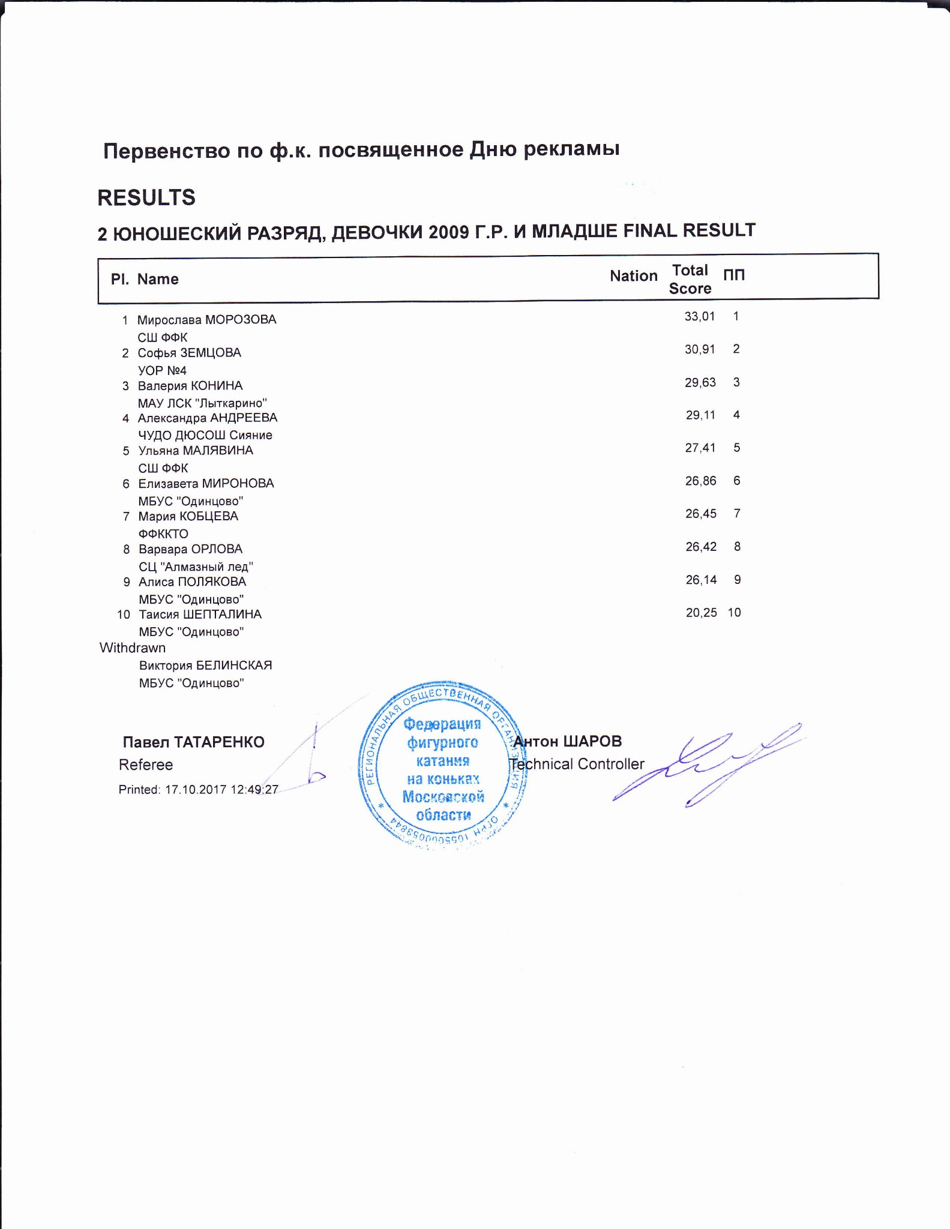

2 ЮНОШЕСКИЙ РАЗРЯД, ДЕВОЧКИ 2009 Г.Р. И МЛАДШЕ
RESULT DETAILS ПРОИЗВОЛЬНАЯ ПРОГРАММА
 | Pl. | Name |  |  | Nation | Total  Segment  Score  = |  | Total  Element  Score  + |  | Tot. Prog.  Comp.  Score *  + |  | SS |  |  |  | PE |  |  |  | IN |  | Deduct.  -
1 Мирослава МОРОЗОВА |  |  |  | 33.01 |  |  | 15.28 |  | 17.73 |  | 3.58 |  | 0.00 |  | 3.75 |  | 0.00 |  | 3.75 |  | 0.00
2 Софья ЗЕМЦОВА |  |  |  | 30.91 |  |  | 14.05 |  | 17.86 |  | 3.75 |  | 0.00 |  | 3.58 |  | 0.00 |  | 3.83 |  | 1.00
3 Валерия КОНИНА |  |  |  | 29.63 |  |  | 11.63 |  | 18.00 |  | 3.75 |  | 0.00 |  | 3.67 |  | 0.00 |  | 3.83 |  | 0.00
4 Александра АНДРЕЕВА |  |  |  | 29.11 |  |  | 12.38 |  | 17.73 |  | 3.75 |  | 0.00 |  | 3.58 |  | 0.00 |  | 3.75 |  | 1.00
5 Ульяна МАЛЯВИНА |  |  |  | 27.41 |  |  | 12.48 |  | 16.93 |  | 3.75 |  | 0.00 |  | 3.33 |  | 0.00 |  | 3.50 |  | 2.00
6 Елизавета МИРОНОВА |  |  |  | 26.86 |  |  | 10.60 |  | 16.26 |  | 3.25 |  | 0.00 |  | 3.33 |  | 0.00 |  | 3.58 |  | 0.00
7 Мария КОБЦЕВА |  |  |  | 26.45 |  |  | 12.25 |  | 15.20 |  | 3.25 |  | 0.00 |  | 3.00 |  | 0.00 |  | 3.25 |  | 1.00
8 Варвара ОРЛОВА |  |  |  | 26.42 |  |  | 10.02 |  | 16.40 |  | 3.50 |  | 0.00 |  | 3.33 |  | 0.00 |  | 3.42 |  | 0.00
9 Алиса ПОЛЯКОВА |  |  |  | 26.14 |  |  | 10.00 |  | 16.14 |  | 3.25 |  | 0.00 |  | 3.42 |  | 0.00 |  | 3.42 |  | 0.00
10 Таисия ШЕПТАЛИНА |  |  |  | 20.25 |  |  | 7.85 |  | 14.40 |  | 3.00 |  | 0.00 |  | 2.83 |  | 0.00 |  | 3.17 |  | 2.00
SS = Навыки скольжения |  |  |  | PE = Представление |  |  |  |  |  |  |  |  |  |  |  |  |  |  | IN = Интерпретация
* = factored score
Printed: 17.10.2017 12:51:28

Rank | Name |  |  |  | Nation |  | Starting  Number |  | Total  Segment Score |  | Total  Element Score |  | Total  Program Component  Score (factored) |  |  | Total  Deductions
1 | Мирослава МОРОЗОВА |  |  |  |  |  | 10 |  | 33.01 |  | 15.28 |  | 17.73 |  |  | 0.00
#  1 | Executed  Elements CSSp2 | Base  Info  Value  2.30 | GOE  0.50 |  | J1  2 | J2  2 | J3  0 | J4  0 |  | J5  1 | J6 | J7 | J8 | J9 | Ref | Scores of Panel  2.80
2 | ChSq1 | 2.00 |  | 0.23 | 1 | 1 | 0 | 0 |  | 0 |  |  |  |  |  | 2.23
3 | 2Lo | 1.98 | x | 0.10 | 0 | 1 | 0 | 0 |  | 1 |  |  |  |  |  | 2.08
4 | 2Lo+1Lo | 2.53 | x | 0.00 | 1 | 0 | 0 | 0 |  | 0 |  |  |  |  |  | 2.53
5 | 2S | 1.43 | x | 0.13 | 1 | 0 | 1 | 0 |  | 1 |  |  |  |  |  | 1.56
6 | 1A | 1.21 | x | 0.20 | 2 | 1 | 1 | 0 |  | 1 |  |  |  |  |  | 1.41
7 | CCoSp2 | 2.50 |  | 0.17 | 0 | 0 | 0 | 1 |  | 1 |  |  |  |  |  | 2.67
 |  | 13.95 |  |  |  |  |  |  |  |  |  |  |  |  |  | 15.28
 | Program Components  Навыки скольжения |  |  | Factor  1.60 | 3,50 | 3,50 | 3,50 | 3,75 |  | 3,75 |  |  |  |  |  | 3.58
 | Представление |  |  | 1.60 | 3,75 | 3,50 | 3,75 | 3,75 |  | 3,75 |  |  |  |  |  | 3.75
 | Интерпретация |  |  | 1.60 | 3,75 | 3,75 | 3,75 | 3,75 |  | 4,00 |  |  |  |  |  | 3.75
 | Judges Total Program Component Score (factored) |  |  |  |  |  |  |  |  |  |  |  |  |  |  | 17.73
Deductions
0.00
x Credit for highlight distribution, base value multiplied by 1.1
Rank | Name |  |  |  |  |  | Nation |  | Starting  Number |  | Total  Segment Score |  | Total  Element Score |  | Total  Program Component  Score (factored) |  |  | Total  Deductions
2 | Софья ЗЕМЦОВА |  |  |  |  |  |  |  | 6 |  | 30.91 |  | 14.05 |  | 17.86 |  |  | 1.00
#  1 | Executed  Elements  2Lz+1A+SEQ | Base  Info  Value  2.56 |  |  | GOE  -0.30 |  | J1  0 | J2  -1 | J3  -1 | J4  -1 |  | J5  -1 | J6 | J7 | J8 | J9 | Ref | Scores of Panel  2.26
2 | CSSp1 |  | 1.90 |  |  | 0.67 | 2 | 2 | 1 | 1 |  | 1 |  |  |  |  |  | 2.57
3 | ChSq1 |  | 2.00 |  |  | 0.70 | 1 | 2 | 1 | 1 |  | 1 |  |  |  |  |  | 2.70
4 | 2F | ! | 2.09 |  | x | -0.90 | -3 | -3 | -3 | -3 |  | -3 |  |  |  |  |  | 1.19
5 | 2Lo |  | 1.98 |  | x | -0.40 | -2 | -2 | -1 | -1 |  | -1 |  |  |  |  |  | 1.58
6 | 2Lz< | < | 1.65 |  | x | -0.90 | -3 | -3 | -3 | -3 |  | -3 |  |  |  |  |  | 0.75
7 | CCoSp2 |  | 2.50 |  |  | 0.50 | 1 | 1 | 0 | 1 |  | 1 |  |  |  |  |  | 3.00
 |  |  | 14.68 |  |  |  |  |  |  |  |  |  |  |  |  |  |  | 14.05
 | Program Components  Навыки скольжения |  |  |  |  | Factor  1.60 | 3,75 | 3,75 | 3,75 | 3,75 |  | 3,75 |  |  |  |  |  | 3.75
 | Представление |  |  |  |  | 1.60 | 3,50 | 3,75 | 3,25 | 3,50 |  | 3,75 |  |  |  |  |  | 3.58
 | Интерпретация |  |  |  |  | 1.60 | 3,50 | 4,00 | 3,75 | 3,75 |  | 4,00 |  |  |  |  |  | 3.83
 | Judges Total Program Component Score (factored) |  |  |  |  |  |  |  |  |  |  |  |  |  |  |  |  | 17.86
Deductions |  |  |  | Falls: |  | -1.00 |  |  |  |  |  |  |  |  |  |  |  | -1.00
< Under-rotated jump x Credit for highlight distribution, base value multiplied by 1.1 ! Not clear edge
Rank | Name |  |  |  |  | Nation |  | Starting  Number |  | Total  Segment Score |  | Total  Element Score |  | Total  Program Component  Score (factored) |  |  | Total  Deductions
3 | Валерия КОНИНА |  |  |  |  |  |  | 11 |  | 29.63 |  | 11.63 |  | 18.00 |  |  | 0.00
#  1 | Executed  Elements ChSq1 | Base  Info  Value  2.00 |  | GOE  0.70 |  | J1  1 | J2  1 | J3  1 | J4  1 |  | J5  0 | J6 | J7 | J8 | J9 | Ref | Scores of Panel  2.70
2 | 2S |  | 1.30 |  | 0.07 | 0 | 1 | 0 | 0 |  | 1 |  |  |  |  |  | 1.37
3 | CCoSp2 |  | 2.50 |  | 0.00 | -1 | 0 | 0 | 0 |  | 1 |  |  |  |  |  | 2.50
4 | 2Lo<<+1A+SEQ | << | 1.41 | x | -0.40 | -2 | -2 | -2 | -2 |  | -2 |  |  |  |  |  | 1.01
5 | CSSp2 |  | 2.30 |  | 0.67 | 2 | 2 | 1 | 1 |  | 1 |  |  |  |  |  | 2.97
6 | 1Lz |  | 0.66 | x | 0.07 | 1 | 1 | 0 | 0 |  | 0 |  |  |  |  |  | 0.73
7 | 2Lo<< | << | 0.55 | x | -0.20 | -2 | -2 | -2 | -2 |  | -2 |  |  |  |  |  | 0.35
 |  |  | 10.72 |  |  |  |  |  |  |  |  |  |  |  |  |  | 11.63
 | Program Components  Навыки скольжения |  |  |  | Factor  1.60 | 4,00 | 3,75 | 3,75 | 3,75 |  | 3,75 |  |  |  |  |  | 3.75
 | Представление |  |  |  | 1.60 | 3,50 | 3,50 | 3,75 | 3,75 |  | 3,75 |  |  |  |  |  | 3.67
 | Интерпретация |  |  |  | 1.60 | 3,25 | 4,00 | 4,00 | 3,75 |  | 3,75 |  |  |  |  |  | 3.83
 | Judges Total Program Component Score (factored) |  |  |  |  |  |  |  |  |  |  |  |  |  |  |  | 18.00
Deductions
0.00
<< Downgraded jump x Credit for highlight distribution, base value multiplied by 1.1
Rank | Name |  |  |  |  |  | Nation |  | Starting  Number |  | Total  Segment Score |  | Total  Element Score |  | Total  Program Component  Score (factored) |  |  | Total  Deductions
4 | Александра АНДРЕЕВА |  |  |  |  |  |  |  | 8 |  | 29.11 |  | 12.38 |  | 17.73 |  |  | 1.00
#  1 | Executed  Elements  2Lo+2Lo | Base  Info  Value  3.60 |  |  | GOE  -0.20 |  | J1  -1 | J2  -1 | J3  -1 | J4  0 |  | J5  0 | J6 | J7 | J8 | J9 | Ref | Scores of Panel  3.40
2 | CCoSp2V | nC | 2.00 |  |  | 0.00 | 0 | 0 | 0 | 0 |  | 0 |  |  |  |  |  | 2.00
3 | ChSq1 |  | 2.00 |  |  | 0.70 | 1 | 2 | 1 | 1 |  | 1 |  |  |  |  |  | 2.70
4 | 2F |  | 2.09 |  | x | -0.50 | -2 | -2 | -2 | -1 |  | -1 |  |  |  |  |  | 1.59
5 | 2Lz |  | 2.31 |  | x | -0.90 | -3 | -3 | -3 | -3 |  | -3 |  |  |  |  |  | 1.41
6 | 1A |  | 1.21 |  | x | 0.07 | 0 | 0 | 1 | 0 |  | 1 |  |  |  |  |  | 1.28
7 | CSSp |  | 0.00 |  |  | 0.00 | - | - | - | - |  | - |  |  |  |  |  | 0.00
 |  |  | 13.21 |  |  |  |  |  |  |  |  |  |  |  |  |  |  | 12.38
 | Program Components  Навыки скольжения |  |  |  |  | Factor  1.60 | 3,75 | 4,00 | 3,75 | 3,75 |  | 3,75 |  |  |  |  |  | 3.75
 | Представление |  |  |  |  | 1.60 | 3,50 | 3,75 | 3,50 | 3,50 |  | 3,75 |  |  |  |  |  | 3.58
 | Интерпретация |  |  |  |  | 1.60 | 3,75 | 3,75 | 3,75 | 3,75 |  | 3,75 |  |  |  |  |  | 3.75
 | Judges Total Program Component Score (factored) |  |  |  |  |  |  |  |  |  |  |  |  |  |  |  |  | 17.73
Deductions |  |  |  | Falls: |  | -1.00 |  |  |  |  |  |  |  |  |  |  |  | -1.00
x Credit for highlight distribution, base value multiplied by 1.1
Rank | Name |  |  |  |  | Nation |  | Starting  Number |  | Total  Segment Score |  | Total  Element Score |  | Total  Program Component  Score (factored) |  |  | Total  Deductions
5 | Ульяна МАЛЯВИНА |  |  |  |  |  |  | 7 |  | 27.41 |  | 12.48 |  | 16.93 |  |  | 2.00
#  1 | Executed  Elements ChSq1 | Base  Info  Value  2.00 |  | GOE  -0.50 |  | J1  -1 | J2  -1 | J3  -1 | J4  -1 |  | J5  -1 | J6 | J7 | J8 | J9 | Ref | Scores of Panel  1.50
2 | CCoSp2 | 2.50 |  |  | 0.17 | 0 | 0 | 0 | 1 |  | 1 |  |  |  |  |  | 2.67
3 | 2S+1Lo | 1.98 |  | x | -0.20 | -1 | -1 | -1 | -1 |  | -1 |  |  |  |  |  | 1.78
4 | 2T | 1.43 |  | x | -0.60 | -3 | -3 | -3 | -3 |  | -3 |  |  |  |  |  | 0.83
5 | 1A | 1.21 |  | x | 0.07 | 1 | 1 | 0 | 0 |  | 0 |  |  |  |  |  | 1.28
6 | 2F | 2.09 |  | x | -0.30 | -1 | -1 | -1 | -1 |  | -1 |  |  |  |  |  | 1.79
7 | CSSp2 | 2.30 |  |  | 0.33 | 2 | 1 | 0 | 0 |  | 1 |  |  |  |  |  | 2.63
 |  | 13.51 |  |  |  |  |  |  |  |  |  |  |  |  |  |  | 12.48
 | Program Components  Навыки скольжения |  |  |  | Factor  1.60 | 4,00 | 4,00 | 3,25 | 3,50 |  | 3,75 |  |  |  |  |  | 3.75
 | Представление |  |  |  | 1.60 | 3,25 | 3,50 | 3,25 | 3,25 |  | 3,50 |  |  |  |  |  | 3.33
 | Интерпретация |  |  |  | 1.60 | 3,50 | 3,50 | 3,50 | 3,25 |  | 3,75 |  |  |  |  |  | 3.50
 | Judges Total Program Component Score (factored) |  |  |  |  |  |  |  |  |  |  |  |  |  |  |  | 16.93
Deductions |  |  | Time violation: |  | -1.00 |  |  |  | Falls: |  | -1.00 |  |  |  |  |  | -2.00
x Credit for highlight distribution, base value multiplied by 1.1
Rank | Name |  |  |  | Nation |  | Starting  Number |  | Total  Segment Score |  | Total  Element Score |  | Total  Program Component  Score (factored) |  |  | Total  Deductions
6 | Елизавета МИРОНОВА |  |  |  |  |  | 2 |  | 26.86 |  | 10.60 |  | 16.26 |  |  | 0.00
#  1 | Executed  Elements  2Lo | Base  Info  Value  1.80 | GOE  -0.60 |  | J1  -2 | J2  -2 | J3  -2 | J4  -2 |  | J5  -2 | J6 | J7 | J8 | J9 | Ref | Scores of Panel  1.20
2 | 2S | 1.30 |  | 0.00 | 1 | 0 | 0 | 0 |  | 0 |  |  |  |  |  | 1.30
3 | CCoSp2 | 2.50 |  | 0.00 | 1 | 0 | 0 | 0 |  | 0 |  |  |  |  |  | 2.50
4 | ChSq1 | 2.00 |  | 0.47 | 1 | 0 | 1 | 1 |  | 0 |  |  |  |  |  | 2.47
5 | 1A+1T | 1.65 | x | 0.07 | 1 | 1 | 0 | 0 |  | 0 |  |  |  |  |  | 1.72
6 | 1A | 1.21 | x | 0.20 | 1 | 1 | 1 | 1 |  | 0 |  |  |  |  |  | 1.41
7 | CSSp | 0.00 |  | 0.00 | - | - | - | - |  | - |  |  |  |  |  | 0.00
 |  | 10.46 |  |  |  |  |  |  |  |  |  |  |  |  |  | 10.60
 | Program Components  Навыки скольжения |  |  | Factor  1.60 | 3,25 | 3,50 | 3,25 | 3,25 |  | 3,25 |  |  |  |  |  | 3.25
 | Представление |  |  | 1.60 | 3,75 | 3,50 | 3,25 | 3,25 |  | 3,25 |  |  |  |  |  | 3.33
 | Интерпретация |  |  | 1.60 | 4,00 | 3,75 | 3,50 | 3,50 |  | 3,25 |  |  |  |  |  | 3.58
 | Judges Total Program Component Score (factored) |  |  |  |  |  |  |  |  |  |  |  |  |  |  | 16.26
Deductions |  |  |  |  |  |  |  |  |  |  |  |  |  |  |  | 0.00
x Credit for highlight distribution, base value multiplied by 1.1
Rank | Name |  |  |  |  | Nation |  | Starting  Number |  | Total  Segment Score |  | Total  Element Score |  | Total  Program Component  Score (factored) |  |  | Total  Deductions
7 | Мария КОБЦЕВА |  |  |  |  |  |  | 9 |  | 26.45 |  | 12.25 |  | 15.20 |  |  | 1.00
#  1 | Executed  Elements CSSp2 | Base  Info  Value  2.30 |  | GOE  -0.10 |  | J1  0 | J2  0 | J3  -1 | J4  -1 |  | J5  0 | J6 | J7 | J8 | J9 | Ref | Scores of Panel  2.20
2 | ChSq1 | 2.00 |  |  | 0.00 | 0 | 0 | 0 | 0 |  | 0 |  |  |  |  |  | 2.00
3 | CoSp2 | 2.00 |  |  | -0.60 | -2 | -2 | -2 | -2 |  | -2 |  |  |  |  |  | 1.40
4 | 2S | 1.43 |  | x | 0.00 | 0 | 1 | 0 | 0 |  | 0 |  |  |  |  |  | 1.43
5 | 2Lo | 1.98 |  | x | -0.90 | -3 | -3 | -3 | -3 |  | -3 |  |  |  |  |  | 1.08
6 | 1A+2T | 2.64 |  | x | 0.07 | 1 | 1 | 0 | 0 |  | 0 |  |  |  |  |  | 2.71
7 | 2T | 1.43 |  | x | 0.00 | 0 | 0 | 0 | -1 |  | 0 |  |  |  |  |  | 1.43
 |  | 13.78 |  |  |  |  |  |  |  |  |  |  |  |  |  |  | 12.25
 | Program Components  Навыки скольжения |  |  |  | Factor  1.60 | 3,25 | 3,25 | 3,25 | 3,25 |  | 3,25 |  |  |  |  |  | 3.25
 | Представление |  |  |  | 1.60 | 3,00 | 2,75 | 3,00 | 3,00 |  | 3,25 |  |  |  |  |  | 3.00
 | Интерпретация |  |  |  | 1.60 | 3,25 | 3,25 | 3,50 | 3,25 |  | 3,25 |  |  |  |  |  | 3.25
 | Judges Total Program Component Score (factored) |  |  |  |  |  |  |  |  |  |  |  |  |  |  |  | 15.20
Deductions |  |  | Falls: |  | -1.00 |  |  |  |  |  |  |  |  |  |  |  | -1.00
x Credit for highlight distribution, base value multiplied by 1.1
Rank | Name |  |  |  |  | Nation |  | Starting  Number |  | Total  Segment Score |  | Total  Element Score |  | Total  Program Component  Score (factored) |  |  | Total  Deductions
8 | Варвара ОРЛОВА |  |  |  |  |  |  | 4 |  | 26.42 |  | 10.02 |  | 16.40 |  |  | 0.00
#  1 | Executed  Elements CCoSp1 | Base  Info  Value  2.00 |  | GOE  0.17 |  | J1  1 | J2  1 | J3  0 | J4  0 |  | J5  0 | J6 | J7 | J8 | J9 | Ref | Scores of Panel  2.17
2 | ChSq1 |  | 2.00 |  | 0.23 | 0 | 1 | 0 | 0 |  | 1 |  |  |  |  |  | 2.23
3 | 1A |  | 1.21 | x | 0.20 | 1 | 1 | 1 | 1 |  | 1 |  |  |  |  |  | 1.41
4 | 2S< | < | 0.99 | x | -0.33 | -2 | -2 | -2 | -1 |  | -1 |  |  |  |  |  | 0.66
5 | CSSp1 |  | 1.90 |  | 0.50 | -1 | 1 | 1 | 1 |  | 1 |  |  |  |  |  | 2.40
6 | 2F<< | << | 0.55 | x | -0.23 | -3 | -3 | -2 | -2 |  | -2 |  |  |  |  |  | 0.32
7 | 2S<+2T<< | << | 1.43 | x | -0.60 | -3 | -3 | -3 | -3 |  | -3 |  |  |  |  |  | 0.83
 |  |  | 10.08 |  |  |  |  |  |  |  |  |  |  |  |  |  | 10.02
 | Program Components  Навыки скольжения |  |  |  | Factor  1.60 | 3,50 | 3,75 | 3,00 | 3,50 |  | 3,50 |  |  |  |  |  | 3.50
 | Представление |  |  |  | 1.60 | 3,00 | 3,25 | 3,25 | 3,50 |  | 3,50 |  |  |  |  |  | 3.33
 | Интерпретация |  |  |  | 1.60 | 2,75 | 3,25 | 3,50 | 3,50 |  | 3,50 |  |  |  |  |  | 3.42
 | Judges Total Program Component Score (factored) |  |  |  |  |  |  |  |  |  |  |  |  |  |  |  | 16.40
Deductions |  |  |  |  |  |  |  |  |  |  |  |  |  |  |  |  | 0.00
< Under-rotated jump << Downgraded jump x Credit for highlight distribution, base value multiplied by 1.1
Rank | Name |  |  |  |  | Nation |  | Starting  Number |  | Total  Segment Score |  | Total  Element Score |  | Total  Program Component  Score (factored) |  |  | Total  Deductions
9 | Алиса ПОЛЯКОВА |  |  |  |  |  |  | 3 |  | 26.14 |  | 10.00 |  | 16.14 |  |  | 0.00
#  1 | Executed  Elements  2Lo< | Base  Info  Value  < 1.30 |  | GOE  -0.60 |  | J1  -2 | J2  -2 | J3  -2 | J4  -2 |  | J5  -2 | J6 | J7 | J8 | J9 | Ref | Scores of Panel  0.70
2 | 2S< | < | 0.90 |  | -0.47 | -3 | -3 | -2 | -2 |  | -2 |  |  |  |  |  | 0.43
3 | CCoSp1 |  | 2.00 |  | 0.33 | 1 | 2 | 0 | 0 |  | 1 |  |  |  |  |  | 2.33
4 | 1A |  | 1.21 | x | -0.13 | -1 | 0 | -1 | -1 |  | 0 |  |  |  |  |  | 1.08
5 | ChSq1 |  | 2.00 |  | -0.67 | -1 | -2 | -1 | -1 |  | -2 |  |  |  |  |  | 1.33
6 | 1A+1Lo |  | 1.76 | x | 0.00 | 0 | 0 | 0 | 0 |  | 0 |  |  |  |  |  | 1.76
7 | CSSp2 |  | 2.30 |  | 0.07 | 1 | 1 | 0 | -1 |  | -1 |  |  |  |  |  | 2.37
 |  |  | 11.47 |  |  |  |  |  |  |  |  |  |  |  |  |  | 10.00
 | Program Components  Навыки скольжения |  |  |  | Factor  1.60 | 3,25 | 3,25 | 3,25 | 3,25 |  | 3,00 |  |  |  |  |  | 3.25
 | Представление |  |  |  | 1.60 | 3,50 | 3,75 | 3,50 | 3,00 |  | 3,25 |  |  |  |  |  | 3.42
 | Интерпретация |  |  |  | 1.60 | 3,50 | 3,50 | 3,50 | 3,25 |  | 3,25 |  |  |  |  |  | 3.42
 | Judges Total Program Component Score (factored) |  |  |  |  |  |  |  |  |  |  |  |  |  |  |  | 16.14
Deductions
0.00
< Under-rotated jump x Credit for highlight distribution, base value multiplied by 1.1
Rank |  | Name |  |  |  |  |  | Nation |  | Starting  Number |  | Total  Segment Score |  | Total  Element Score |  | Total  Program Component  Score (factored) |  |  | Total  Deductions
10 |  | Таисия ШЕПТАЛИНА |  |  |  |  |  |  |  | 1 |  | 20.25 |  | 7.85 |  | 14.40 |  |  | 2.00
#  1 | Executed  Elements  1A+1T |  | Base  Info  Value  1.50 |  |  | GOE  0.00 |  | J1  0 | J2  0 | J3  1 | J4  0 |  | J5  0 | J6 | J7 | J8 | J9 | Ref | Scores of Panel  1.50
2 | 2S |  | < | 1.30 |  |  | -0.60 | -3 | -3 | -3 | -3 |  | -3 |  |  |  |  |  | 0.70
3 | CSSp |  |  | 0.00 |  |  | 0.00 | - | - | - | - |  | - |  |  |  |  |  | 0.00
4 | ChSq1 |  |  | 2.00 |  |  | 0.00 | 1 | 0 | 0 | 0 |  | 0 |  |  |  |  |  | 2.00
5 | 2T<< |  | << | 0.44 |  | x | -0.30 | -3 | -3 | -3 | -3 |  | -2 |  |  |  |  |  | 0.14
6 | 1A |  |  | 1.21 |  | x | -0.20 | -1 | -1 | -1 | -1 |  | -1 |  |  |  |  |  | 1.01
7 | CCoSp2 |  |  | 2.50 |  |  | 0.00 | 1 | 0 | 0 | 0 |  | 0 |  |  |  |  |  | 2.50
 |  |  |  | 8.95 |  |  |  |  |  |  |  |  |  |  |  |  |  |  | 7.85
 | Program Components  Навыки скольжения |  |  |  |  |  | Factor  1.60 | 3,00 | 3,00 | 3,00 | 3,00 |  | 2,75 |  |  |  |  |  | 3.00
 | Представление |  |  |  |  |  | 1.60 | 3,25 | 2,75 | 3,00 | 2,75 |  | 2,75 |  |  |  |  |  | 2.83
 | Интерпретация |  |  |  |  |  | 1.60 | 3,25 | 3,25 | 3,25 | 3,00 |  | 2,75 |  |  |  |  |  | 3.17
 | Judges Total Program Component Score (factored) |  |  |  |  |  |  |  |  |  |  |  |  |  |  |  |  |  | 14.40
Deductions |  |  |  |  | Falls: |  | -2.00 |  |  |  |  |  |  |  |  |  |  |  | -2.00
<< Downgraded jump x Credit for highlight distribution, base value multiplied by 1.1 printed: 17.10.2017 12:51:34

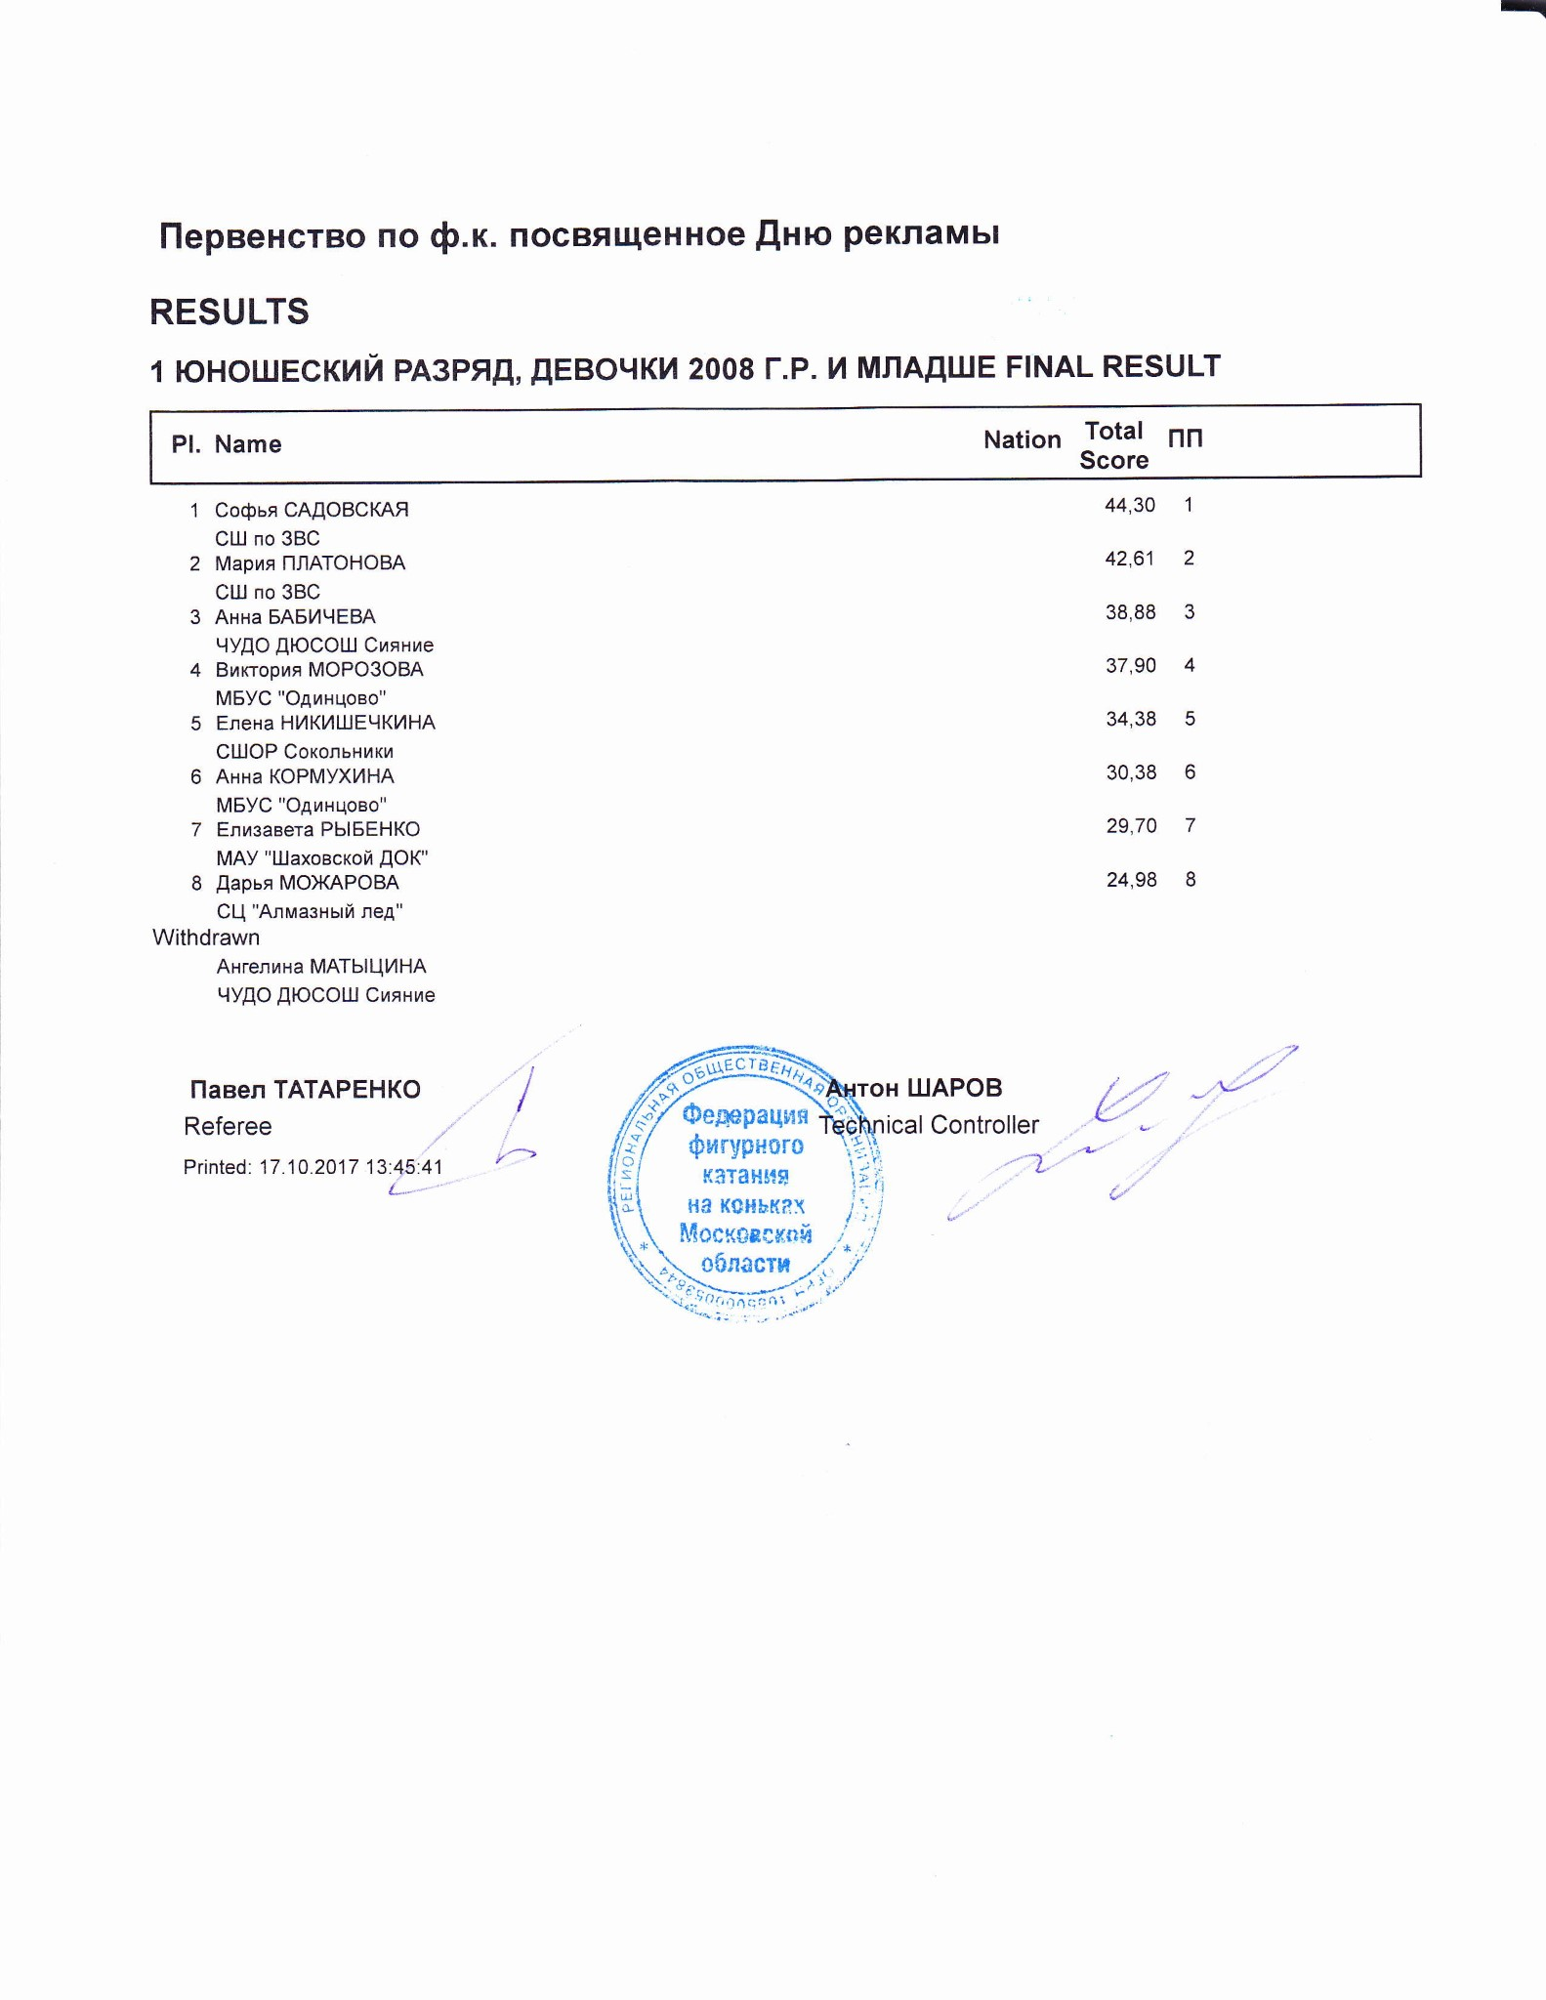

1 ЮНОШЕСКИЙ РАЗРЯД, ДЕВОЧКИ 2008 Г.Р. И МЛАДШЕ
RESULT DETAILS ПРОИЗВОЛЬНАЯ ПРОГРАММА
 | Pl. | Name |  |  | Nation | Total  Segment  Score  = |  | Total  Element  Score  + |  | Tot. Prog.  Comp.  Score *  + |  | SS |  |  |  | PE |  |  |  | IN |  | Deduct.  -
1 Софья САДОВСКАЯ |  |  |  | 44.30 |  |  | 18.64 |  | 25.66 |  | 4.33 |  | 0.00 |  | 4.08 |  | 0.00 |  | 4.42 |  | 0.00
2 Мария ПЛАТОНОВА |  |  |  | 42.61 |  |  | 18.61 |  | 24.00 |  | 4.00 |  | 0.00 |  | 4.00 |  | 0.00 |  | 4.00 |  | 0.00
3 Анна БАБИЧЕВА |  |  |  | 38.88 |  |  | 14.38 |  | 24.50 |  | 3.92 |  | 0.00 |  | 4.08 |  | 0.00 |  | 4.25 |  | 0.00
4 Виктория МОРОЗОВА |  |  |  | 37.90 |  |  | 14.90 |  | 24.00 |  | 3.92 |  | 0.00 |  | 4.00 |  | 0.00 |  | 4.08 |  | 1.00
5 Елена НИКИШЕЧКИНА |  |  |  | 34.38 |  |  | 12.88 |  | 22.50 |  | 3.75 |  | 0.00 |  | 3.58 |  | 0.00 |  | 3.92 |  | 1.00
6 Анна КОРМУХИНА |  |  |  | 30.38 |  |  | 9.88 |  | 20.50 |  | 3.50 |  | 0.00 |  | 3.25 |  | 0.00 |  | 3.50 |  | 0.00
7 Елизавета РЫБЕНКО |  |  |  | 29.70 |  |  | 8.72 |  | 21.98 |  | 3.83 |  | 0.00 |  | 3.58 |  | 0.00 |  | 3.58 |  | 1.00
8 Дарья МОЖАРОВА |  |  |  | 24.98 |  |  | 7.98 |  | 19.00 |  | 3.25 |  | 0.00 |  | 3.00 |  | 0.00 |  | 3.25 |  | 2.00
SS = Навыки скольжения |  |  |  | PE = Представление |  |  |  |  |  |  |  |  |  |  |  |  |  |  | IN = Интерпретация
* = factored score
Printed: 17.10.2017 13:47:22

Rank | Name |  |  |  |  | Nation |  | Starting  Number |  | Total  Segment Score |  | Total  Element Score |  | Total  Program Component  Score (factored) |  |  | Total  Deductions
1 | Софья САДОВСКАЯ |  |  |  |  |  |  | 3 |  | 44.30 |  | 18.64 |  | 25.66 |  |  | 0.00
#  1 | Executed  Elements ChSq1 | Base  Info  Value  2.00 |  | GOE  0.70 |  | J1  1 | J2  2 | J3  1 | J4  1 |  | J5  1 | J6 | J7 | J8 | J9 | Ref | Scores of Panel  2.70
2 | CSSp2 |  | 2.30 |  | 0.67 | 2 | 2 | 1 | 1 |  | 1 |  |  |  |  |  | 2.97
3 | 1A |  | 1.10 |  | 0.27 | 2 | 2 | 1 | 1 |  | 1 |  |  |  |  |  | 1.37
4 | 2Lz+2Lo |  | 4.29 | x | 0.00 | 1 | 0 | 0 | 0 |  | -1 |  |  |  |  |  | 4.29
5 | CCoSp2 |  | 2.50 |  | 0.67 | 2 | 2 | 1 | 1 |  | 0 |  |  |  |  |  | 3.17
6 | 2Lz+2T<< | << | 2.75 | x | -0.90 | -3 | -3 | -3 | -3 |  | -3 |  |  |  |  |  | 1.85
7 | 2F |  | 2.09 | x | 0.20 | -1 | 0 | 1 | 1 |  | 1 |  |  |  |  |  | 2.29
 |  |  | 17.03 |  |  |  |  |  |  |  |  |  |  |  |  |  | 18.64
 | Program Components  Навыки скольжения |  |  |  | Factor  2.00 | 4,50 | 4,50 | 4,25 | 4,25 |  | 4,00 |  |  |  |  |  | 4.33
 | Представление |  |  |  | 2.00 | 4,25 | 4,25 | 4,00 | 4,00 |  | 3,75 |  |  |  |  |  | 4.08
 | Интерпретация |  |  |  | 2.00 | 4,75 | 4,75 | 4,25 | 4,25 |  | 4,00 |  |  |  |  |  | 4.42
 | Judges Total Program Component Score (factored) |  |  |  |  |  |  |  |  |  |  |  |  |  |  |  | 25.66
Deductions
0.00
<< Downgraded jump x Credit for highlight distribution, base value multiplied by 1.1
Rank | Name |  |  |  | Nation |  | Starting  Number |  | Total  Segment Score |  | Total  Element Score |  | Total  Program Component  Score (factored) |  |  | Total  Deductions
2 | Мария ПЛАТОНОВА |  |  |  |  |  | 8 |  | 42.61 |  | 18.61 |  | 24.00 |  |  | 0.00
#  1 | Executed  Elements  1A | Base  Info  Value  1.10 | GOE  0.20 |  | J1  1 | J2  1 | J3  1 | J4  1 |  | J5  1 | J6 | J7 | J8 | J9 | Ref | Scores of Panel  1.30
2 | CCoSp2 | 2.50 |  | 0.00 | 0 | 1 | 0 | 0 |  | 0 |  |  |  |  |  | 2.50
3 | CSSpB | 1.60 |  | 0.50 | 1 | 2 | 1 | 1 |  | 1 |  |  |  |  |  | 2.10
4 | ChSq1 | 2.00 |  | 0.70 | 1 | 0 | 1 | 1 |  | 1 |  |  |  |  |  | 2.70
5 | 2Lo+2Lo | 3.96 | x | 0.00 | 0 | -1 | 0 | 0 |  | 0 |  |  |  |  |  | 3.96
6 | 2Lz+2T | 3.74 | x | 0.00 | 0 | 0 | 0 | 0 |  | 0 |  |  |  |  |  | 3.74
7 | 2Lz | 2.31 | x | 0.00 | -1 | 0 | 0 | 0 |  | 1 |  |  |  |  |  | 2.31
 |  | 17.21 |  |  |  |  |  |  |  |  |  |  |  |  |  | 18.61
 | Program Components  Навыки скольжения |  |  | Factor  2.00 | 4,00 | 4,00 | 4,00 | 4,25 |  | 4,00 |  |  |  |  |  | 4.00
 | Представление |  |  | 2.00 | 3,50 | 3,25 | 4,25 | 4,25 |  | 4,25 |  |  |  |  |  | 4.00
 | Интерпретация |  |  | 2.00 | 3,25 | 3,50 | 4,25 | 4,50 |  | 4,25 |  |  |  |  |  | 4.00
 | Judges Total Program Component Score (factored) |  |  |  |  |  |  |  |  |  |  |  |  |  |  | 24.00
Deductions |  |  |  |  |  |  |  |  |  |  |  |  |  |  |  | 0.00
x Credit for highlight distribution, base value multiplied by 1.1
Rank | Name |  |  |  |  | Nation |  | Starting  Number |  | Total  Segment Score |  | Total  Element Score |  | Total  Program Component  Score (factored) |  |  | Total  Deductions
3 | Анна БАБИЧЕВА |  |  |  |  |  |  | 7 |  | 38.88 |  | 14.38 |  | 24.50 |  |  | 0.00
#  1 | Executed  Elements CCoSp2 | Base  Info  Value  2.50 |  | GOE  0.50 |  | J1  2 | J2  1 | J3  1 | J4  1 |  | J5  1 | J6 | J7 | J8 | J9 | Ref | Scores of Panel  3.00
2 | ChSq1 |  | 2.00 |  | 0.47 | 1 | 1 | 1 | 0 |  | 0 |  |  |  |  |  | 2.47
3 | 1A+2T< | < | 2.20 | x | -0.40 | -3 | -2 | -2 | -2 |  | -2 |  |  |  |  |  | 1.80
4 | 2S+1A+SEQ |  | 2.11 | x | -0.13 | 0 | -1 | 0 | -1 |  | -1 |  |  |  |  |  | 1.98
5 | 2T |  | 1.43 | x | 0.00 | 1 | 0 | 0 | 0 |  | 0 |  |  |  |  |  | 1.43
6 | 2S |  | 1.43 | x | -0.20 | -1 | -1 | -1 | 0 |  | -1 |  |  |  |  |  | 1.23
7 | CSSp2 |  | 2.30 |  | 0.17 | 0 | 1 | 1 | 0 |  | 0 |  |  |  |  |  | 2.47
 |  |  | 13.97 |  |  |  |  |  |  |  |  |  |  |  |  |  | 14.38
 | Program Components  Навыки скольжения |  |  |  | Factor  2.00 | 3,75 | 4,00 | 4,00 | 4,00 |  | 3,75 |  |  |  |  |  | 3.92
 | Представление |  |  |  | 2.00 | 4,25 | 4,25 | 4,00 | 4,00 |  | 3,75 |  |  |  |  |  | 4.08
 | Интерпретация |  |  |  | 2.00 | 4,75 | 4,50 | 4,25 | 4,00 |  | 3,75 |  |  |  |  |  | 4.25
 | Judges Total Program Component Score (factored) |  |  |  |  |  |  |  |  |  |  |  |  |  |  |  | 24.50
Deductions
0.00
< Under-rotated jump x Credit for highlight distribution, base value multiplied by 1.1
Rank | Name |  |  |  |  |  | Nation |  | Starting  Number |  | Total  Segment Score |  | Total  Element Score |  | Total  Program Component  Score (factored) |  |  | Total  Deductions
4 | Виктория МОРОЗОВА |  |  |  |  |  |  |  | 4 |  | 37.90 |  | 14.90 |  | 24.00 |  |  | 1.00
#  1 | Executed  Elements  2Lo+1A+SEQ | Base  Info  Value  2.32 |  |  | GOE  0.10 |  | J1  1 | J2  1 | J3  0 | J4  0 |  | J5  0 | J6 | J7 | J8 | J9 | Ref | Scores of Panel  2.42
2 | 2S+1T |  | 1.70 |  |  | 0.00 | 0 | 1 | 0 | 0 |  | 0 |  |  |  |  |  | 1.70
3 | ChSq1 |  | 2.00 |  |  | 0.70 | 1 | 1 | 1 | 1 |  | 0 |  |  |  |  |  | 2.70
4 | CSSp2 |  | 2.30 |  |  | 0.67 | 2 | 2 | 1 | 1 |  | 0 |  |  |  |  |  | 2.97
5 | 2Lo |  | 1.98 |  | x | 0.00 | 1 | 0 | 0 | 0 |  | 0 |  |  |  |  |  | 1.98
6 | 2S |  | 1.43 |  | x | 0.00 | 1 | 0 | 0 | 0 |  | 0 |  |  |  |  |  | 1.43
7 | CCoSp2V | nC | 2.00 |  |  | -0.30 | -1 | -1 | -1 | -1 |  | 0 |  |  |  |  |  | 1.70
 |  |  | 13.73 |  |  |  |  |  |  |  |  |  |  |  |  |  |  | 14.90
 | Program Components  Навыки скольжения |  |  |  |  | Factor  2.00 | 3,75 | 3,75 | 4,00 | 4,00 |  | 4,00 |  |  |  |  |  | 3.92
 | Представление |  |  |  |  | 2.00 | 4,50 | 4,00 | 4,00 | 4,00 |  | 3,75 |  |  |  |  |  | 4.00
 | Интерпретация |  |  |  |  | 2.00 | 4,25 | 4,00 | 4,25 | 4,00 |  | 4,00 |  |  |  |  |  | 4.08
 | Judges Total Program Component Score (factored) |  |  |  |  |  |  |  |  |  |  |  |  |  |  |  |  | 24.00
Deductions |  |  |  | Falls: |  | -1.00 |  |  |  |  |  |  |  |  |  |  |  | -1.00
x Credit for highlight distribution, base value multiplied by 1.1
Rank | Name |  |  |  |  |  | Nation |  | Starting  Number |  | Total  Segment Score |  | Total  Element Score |  | Total  Program Component  Score (factored) |  |  | Total  Deductions
5 | Елена НИКИШЕЧКИНА |  |  |  |  |  |  |  | 5 |  | 34.38 |  | 12.88 |  | 22.50 |  |  | 1.00
#  1 | Executed  Elements  2S+2Lo< | Base  Info  Value  < 2.60 |  |  | GOE  -0.60 |  | J1  -2 | J2  -2 | J3  -2 | J4  -2 |  | J5  -2 | J6 | J7 | J8 | J9 | Ref | Scores of Panel  2.00
2 | 2F< | < | 1.40 |  |  | -0.50 | -2 | -2 | -2 | -1 |  | -1 |  |  |  |  |  | 0.90
3 | CSSp2 |  | 2.30 |  |  | 0.17 | 0 | 1 | 0 | 0 |  | 1 |  |  |  |  |  | 2.47
4 | ChSq1 |  | 2.00 |  |  | 0.70 | 1 | 1 | 1 | 1 |  | 1 |  |  |  |  |  | 2.70
5 | 2Lo<+2T<< | << | 1.87 |  | x | -0.90 | -3 | -3 | -3 | -3 |  | -3 |  |  |  |  |  | 0.97
6 | CCoSp2 |  | 2.50 |  |  | 0.00 | 0 | 0 | 0 | 0 |  | 0 |  |  |  |  |  | 2.50
7 | 1A |  | 1.21 |  | x | 0.13 | 1 | 1 | 1 | 0 |  | 0 |  |  |  |  |  | 1.34
 |  |  | 13.88 |  |  |  |  |  |  |  |  |  |  |  |  |  |  | 12.88
 | Program Components  Навыки скольжения |  |  |  |  | Factor  2.00 | 4,00 | 3,75 | 3,50 | 3,75 |  | 3,75 |  |  |  |  |  | 3.75
 | Представление |  |  |  |  | 2.00 | 3,50 | 3,50 | 3,50 | 3,75 |  | 3,75 |  |  |  |  |  | 3.58
 | Интерпретация |  |  |  |  | 2.00 | 4,25 | 4,00 | 3,75 | 4,00 |  | 3,75 |  |  |  |  |  | 3.92
 | Judges Total Program Component Score (factored) |  |  |  |  |  |  |  |  |  |  |  |  |  |  |  |  | 22.50
Deductions |  |  |  | Falls: |  | -1.00 |  |  |  |  |  |  |  |  |  |  |  | -1.00
< Under-rotated jump << Downgraded jump x Credit for highlight distribution, base value multiplied by 1.1
Rank |  | Name |  |  |  |  |  |  |  |  | Nation |  |  |  | Starting  Number |  |  | Total  Segment Score |  |  |  | Total  Element Score |  |  |  | Total  Program Component  Score (factored) |  |  |  |  |  | Total  Deductions
6 |  | Анна КОРМУХИНА |  |  |  |  |  |  |  |  |  |  |  |  | 2 |  |  | 30.38 |  |  |  | 9.88 |  |  |  | 20.50 |  |  |  |  |  | 0.00
#  1 | Executed  Elements  2Lo+1A+SEQ |  | Base  Info  Value  2.32 |  |  | GOE  0.00 |  |  |  | J1  1 |  | J2  0 |  | J3  0 |  | J4  0 |  |  | J5  0 |  | J6 |  | J7 |  | J8 |  | J9 |  | Ref |  | Scores of Panel  2.32
2 | 2S<+1T |  | < |  | 1.30 |  |  | -0.20 |  | -1 |  | -1 |  | -1 |  | -1 |  |  | -1 |  |  |  |  |  |  |  |  |  |  |  | 1.10
3 | CSSp2 |  |  |  | 2.30 |  |  | 0.00 |  | 0 |  | 0 |  | 0 |  | 0 |  |  | -1 |  |  |  |  |  |  |  |  |  |  |  | 2.30
4 | ChSq1 |  |  |  | 2.00 |  |  | 0.23 |  | 1 |  | 1 |  | 0 |  | 0 |  |  | 0 |  |  |  |  |  |  |  |  |  |  |  | 2.23
5 | 2S< |  | < |  | 0.99 | x |  | -0.27 |  | -2 |  | -2 |  | -1 |  | -1 |  |  | -1 |  |  |  |  |  |  |  |  |  |  |  | 0.72
6 | 1A |  |  |  | 1.21 | x |  | 0.00 |  | 0 |  | 1 |  | 0 |  | 0 |  |  | 0 |  |  |  |  |  |  |  |  |  |  |  | 1.21
7 | CoSp1V* |  | * |  | 0.00 |  |  | 0.00 |  | - |  | - |  | - |  | - |  |  | - |  |  |  |  |  |  |  |  |  |  |  | 0.00
 |  |  |  |  | 10.12 |  |  |  |  |  |  |  |  |  |  |  |  |  |  |  |  |  |  |  |  |  |  |  |  |  | 9.88
 | Program Components  Навыки скольжения |  |  |  |  |  |  | Factor  2.00 |  | 3,25 |  | 3,50 |  | 3,50 |  | 3,50 |  |  | 3,50 |  |  |  |  |  |  |  |  |  |  |  | 3.50
 | Представление |  |  |  |  |  |  | 2.00 |  | 3,75 |  | 3,25 |  | 3,25 |  | 3,25 |  |  | 3,25 |  |  |  |  |  |  |  |  |  |  |  | 3.25
 | Интерпретация |  |  |  |  |  |  | 2.00 |  | 3,75 |  | 3,50 |  | 3,50 |  | 3,50 |  |  | 3,50 |  |  |  |  |  |  |  |  |  |  |  | 3.50
 | Judges Total Program Component Score (factored) |  |  |  |  |  |  |  |  |  |  |  |  |  |  |  |  |  |  |  |  |  |  |  |  |  |  |  |  |  | 20.50
Deductions |  |  |  |  |  |  |  |  |  |  |  |  |  |  |  |  |  |  |  |  |  |  |  |  |  |  |  |  |  |  |  | 0.00
< Under-rotated jump * Invalid element x Credit for highlight distribution, base value multiplied by 1.1
Rank |  | Name |  |  |  |  |  |  |  |  |  | Nation |  |  |  | Starting  Number |  |  | Total  Segment Score |  |  |  | Total  Element Score |  |  |  | Total  Program Component  Score (factored) |  |  |  |  |  | Total  Deductions
7 |  | Елизавета РЫБЕНКО |  |  |  |  |  |  |  |  |  |  |  |  |  | 1 |  |  | 29.70 |  |  |  | 8.72 |  |  |  | 21.98 |  |  |  |  |  | 1.00
#  1 | Executed  Elements  1A |  | Base  Info  Value  1.10 |  |  |  | GOE  0.07 |  |  |  | J1  1 |  | J2  1 |  | J3  0 |  | J4  0 |  |  | J5  0 |  | J6 |  | J7 |  | J8 |  | J9 |  | Ref |  | Scores of Panel  1.17
2 | FSSp1 |  |  |  | 2.00 |  |  |  | 0.00 |  | 0 |  | 0 |  | 0 |  | 0 |  |  | 1 |  |  |  |  |  |  |  |  |  |  |  | 2.00
3 | 2S+2T<< |  | << |  | 1.70 |  |  |  | -0.40 |  | -2 |  | -2 |  | -2 |  | -2 |  |  | -2 |  |  |  |  |  |  |  |  |  |  |  | 1.30
4 | ChSq1 |  |  |  | 2.00 |  |  |  | 0.00 |  | 0 |  | 1 |  | 0 |  | 0 |  |  | -1 |  |  |  |  |  |  |  |  |  |  |  | 2.00
5 | 2Lz<< |  | << |  | 0.66 |  | x |  | -0.20 |  | -2 |  | -2 |  | -2 |  | -2 |  |  | -2 |  |  |  |  |  |  |  |  |  |  |  | 0.46
6 | 2F |  |  |  | 2.09 |  | x |  | -0.30 |  | -1 |  | -1 |  | -1 |  | -1 |  |  | -1 |  |  |  |  |  |  |  |  |  |  |  | 1.79
7 | 2Lo*+2Lo<<* |  | * |  | 0.00 |  | x |  | 0.00 |  | - |  | - |  | - |  | - |  |  | - |  |  |  |  |  |  |  |  |  |  |  | 0.00
8 | 2Lo*+2Lo<<* |  | * |  | 0.00 |  | x |  | 0.00 |  | - |  | - |  | - |  | - |  |  | - |  |  |  |  |  |  |  |  |  |  |  | 0.00
9 | CSp1* |  | * |  | 0.00 |  |  |  | 0.00 |  | - |  | - |  | - |  | - |  |  | - |  |  |  |  |  |  |  |  |  |  |  | 0.00
 |  |  |  |  | 9.55 |  |  |  |  |  |  |  |  |  |  |  |  |  |  |  |  |  |  |  |  |  |  |  |  |  |  | 8.72
 | Program Components  Навыки скольжения |  |  |  |  |  |  |  | Factor  2.00 |  | 4,25 |  | 4,25 |  | 3,50 |  | 3,50 |  |  | 3,75 |  |  |  |  |  |  |  |  |  |  |  | 3.83
 | Представление |  |  |  |  |  |  |  | 2.00 |  | 3,75 |  | 3,75 |  | 3,25 |  | 3,50 |  |  | 3,50 |  |  |  |  |  |  |  |  |  |  |  | 3.58
 | Интерпретация |  |  |  |  |  |  |  | 2.00 |  | 3,50 |  | 3,50 |  | 3,25 |  | 3,75 |  |  | 3,75 |  |  |  |  |  |  |  |  |  |  |  | 3.58
 | Judges Total Program Component Score (factored) |  |  |  |  |  |  |  |  |  |  |  |  |  |  |  |  |  |  |  |  |  |  |  |  |  |  |  |  |  |  | 21.98
Deductions |  |  |  |  |  | Falls: |  |  |  | -1.00 |  |  |  |  |  |  |  |  |  |  |  |  |  |  |  |  |  |  |  |  |  |  | -1.00
<< Downgraded jump * Invalid element x Credit for highlight distribution, base value multiplied by 1.1
Rank |  | Name |  |  |  |  |  |  |  |  |  | Nation |  |  |  | Starting  Number |  |  | Total  Segment Score |  |  |  | Total  Element Score |  |  |  | Total  Program Component  Score (factored) |  |  |  |  |  | Total  Deductions
8 |  | Дарья МОЖАРОВА |  |  |  |  |  |  |  |  |  |  |  |  |  | 9 |  |  | 24.98 |  |  |  | 7.98 |  |  |  | 19.00 |  |  |  |  |  | 2.00
#  1 | Executed  Elements CSSpB |  | Base  Info  Value  1.60 |  |  |  | GOE  -0.10 |  |  |  | J1  -1 |  | J2  0 |  | J3  -1 |  | J4  0 |  |  | J5  0 |  | J6 |  | J7 |  | J8 |  | J9 |  | Ref |  | Scores of Panel  1.50
2 | 1A |  |  |  | 1.10 |  |  |  | 0.00 |  | -1 |  | 0 |  | 0 |  | 0 |  |  | 0 |  |  |  |  |  |  |  |  |  |  |  | 1.10
3 | 1A+2Lo<< |  | << |  | 1.60 |  |  |  | -0.60 |  | -3 |  | -3 |  | -3 |  | -3 |  |  | -3 |  |  |  |  |  |  |  |  |  |  |  | 1.00
4 | ChSq1 |  |  |  | 2.00 |  |  |  | 0.00 |  | 0 |  | -1 |  | 0 |  | 0 |  |  | 0 |  |  |  |  |  |  |  |  |  |  |  | 2.00
5 | 2F<< |  | << |  | 0.55 |  | x |  | -0.30 |  | -3 |  | -3 |  | -3 |  | -3 |  |  | -3 |  |  |  |  |  |  |  |  |  |  |  | 0.25
6 | 2S |  |  |  | 1.43 |  | x |  | -0.60 |  | -3 |  | -3 |  | -3 |  | -3 |  |  | -3 |  |  |  |  |  |  |  |  |  |  |  | 0.83
7 | CCoSp1V |  | nC |  | 1.70 |  |  |  | -0.40 |  | -2 |  | -2 |  | -1 |  | -1 |  |  | -1 |  |  |  |  |  |  |  |  |  |  |  | 1.30
 |  |  |  |  | 9.98 |  |  |  |  |  |  |  |  |  |  |  |  |  |  |  |  |  |  |  |  |  |  |  |  |  |  | 7.98
 | Program Components  Навыки скольжения |  |  |  |  |  |  |  | Factor  2.00 |  | 3,25 |  | 3,25 |  | 3,25 |  | 3,25 |  |  | 3,25 |  |  |  |  |  |  |  |  |  |  |  | 3.25
 | Представление |  |  |  |  |  |  |  | 2.00 |  | 3,00 |  | 2,75 |  | 3,00 |  | 3,00 |  |  | 3,00 |  |  |  |  |  |  |  |  |  |  |  | 3.00
 | Интерпретация |  |  |  |  |  |  |  | 2.00 |  | 3,50 |  | 3,50 |  | 3,00 |  | 3,00 |  |  | 3,25 |  |  |  |  |  |  |  |  |  |  |  | 3.25
 | Judges Total Program Component Score (factored) |  |  |  |  |  |  |  |  |  |  |  |  |  |  |  |  |  |  |  |  |  |  |  |  |  |  |  |  |  |  | 19.00
Deductions |  |  |  |  |  | Falls: |  |  |  | -2.00 |  |  |  |  |  |  |  |  |  |  |  |  |  |  |  |  |  |  |  |  |  |  | -2.00
<< Downgraded jump x Credit for highlight distribution, base value multiplied by 1.1 printed: 17.10.2017 13:47:28

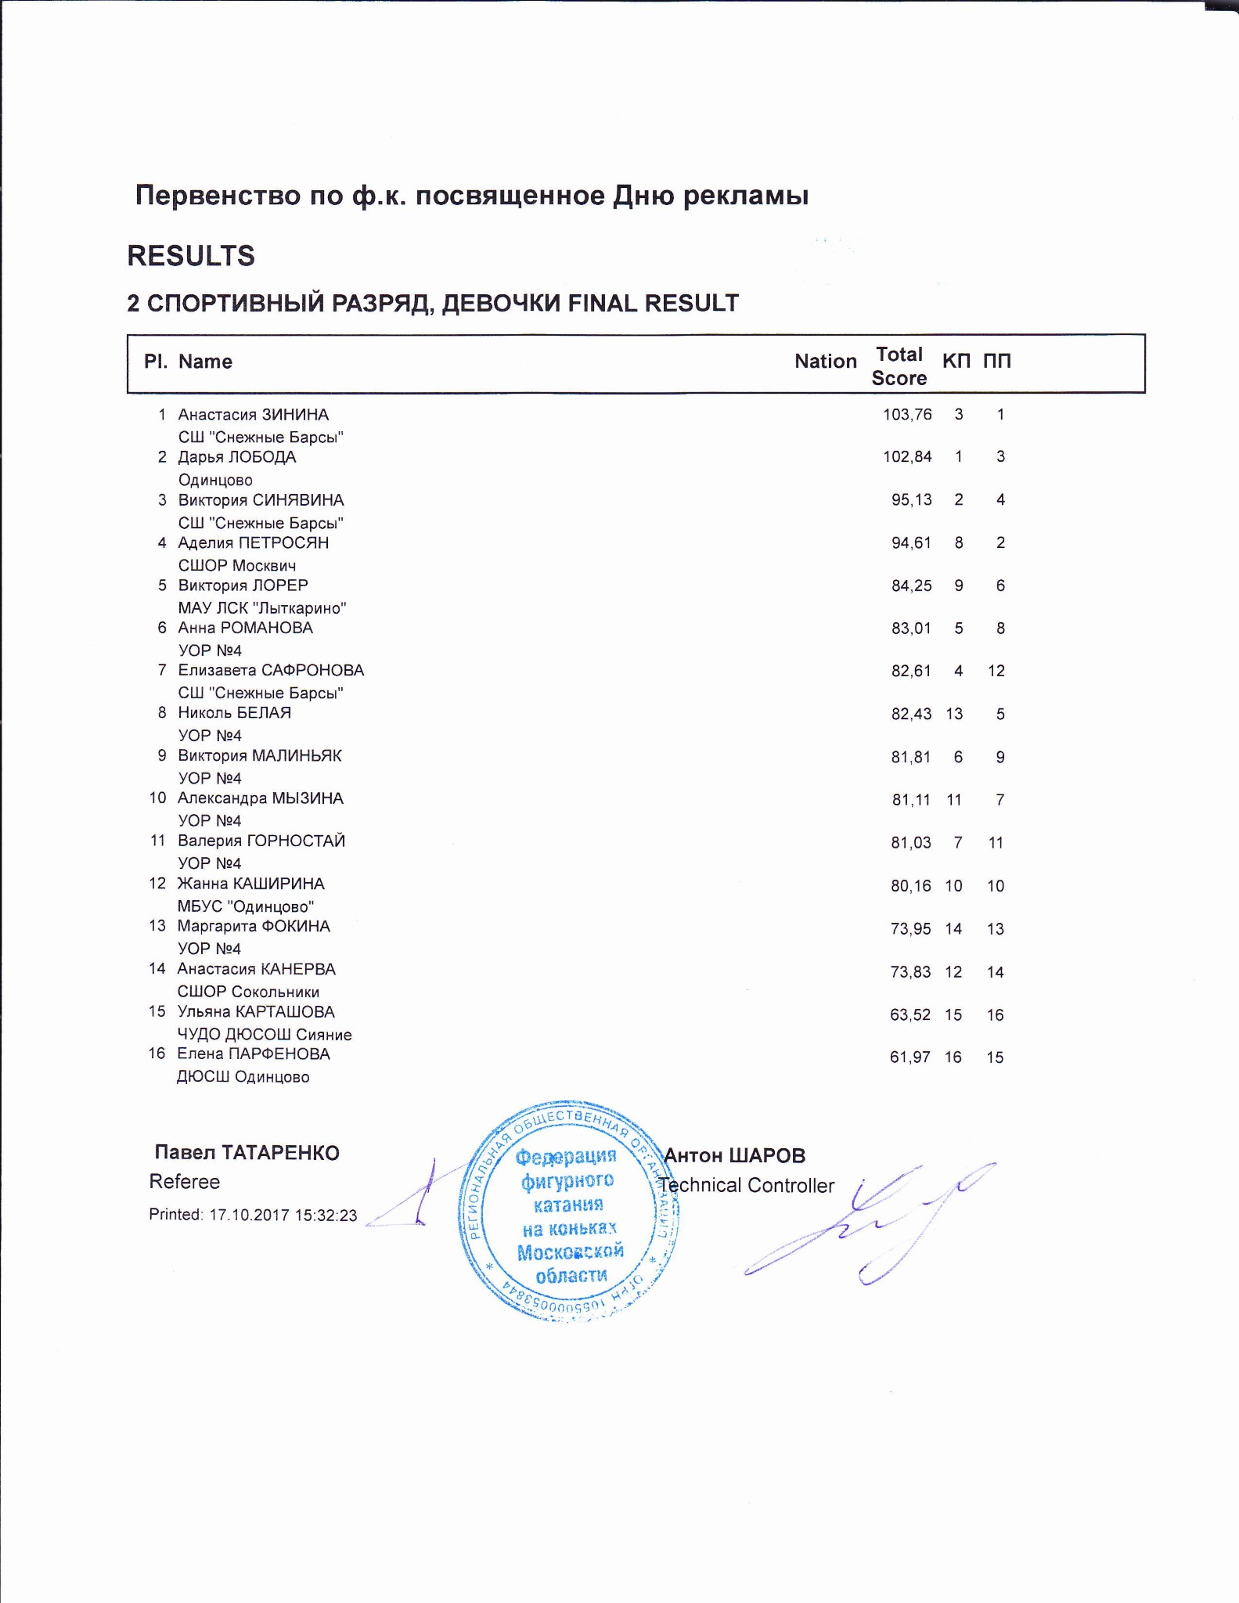

2 СПОРТИВНЫЙ РАЗРЯД, ДЕВОЧКИ
RESULT DETAILS ПРОИЗВОЛЬНАЯ ПРОГРАММА
 | Pl. |  | Name |  |  |  |  | Nation | Total  Segment  Score  = |  | Total  Element  Score  + |  | Tot. Prog.  Comp.  Score *  + |  | SS |  | TR |  | PE |  |  |  | IN |  | Deduct.  -
1 |  | Анастасия ЗИНИНА |  |  |  |  | 66.73 |  |  | 31.73 |  | 36.00 |  | 5.25 |  | 4.75 |  | 4.83 |  | 0.00 |  | 5.17 |  | 1.00
2 |  | Аделия ПЕТРОСЯН |  |  |  |  | 63.52 |  |  | 26.93 |  | 36.59 |  | 5.00 |  | 4.83 |  | 5.17 |  | 0.00 |  | 5.33 |  | 0.00
3 |  | Дарья ЛОБОДА |  |  |  |  | 60.51 |  |  | 30.42 |  | 32.09 |  | 4.75 |  | 4.33 |  | 4.25 |  | 0.00 |  | 4.50 |  | 2.00
4 |  | Виктория СИНЯВИНА |  |  |  |  | 57.67 |  |  | 28.17 |  | 31.50 |  | 4.50 |  | 4.25 |  | 4.25 |  | 0.00 |  | 4.50 |  | 2.00
5 |  | Николь БЕЛАЯ |  |  |  |  | 55.16 |  |  | 24.66 |  | 31.50 |  | 4.58 |  | 4.17 |  | 4.33 |  | 0.00 |  | 4.42 |  | 1.00
6 |  | Виктория ЛОРЕР |  |  |  |  | 53.43 |  |  | 21.17 |  | 32.26 |  | 4.50 |  | 4.17 |  | 4.58 |  | 0.00 |  | 4.67 |  | 0.00
7 |  | Александра МЫЗИНА |  |  |  |  | 51.16 |  |  | 20.73 |  | 30.43 |  | 4.08 |  | 4.08 |  | 4.33 |  | 0.00 |  | 4.42 |  | 0.00
8 |  | Анна РОМАНОВА |  |  |  |  | 50.37 |  |  | 20.81 |  | 29.56 |  | 4.25 |  | 3.92 |  | 4.00 |  | 0.00 |  | 4.25 |  | 0.00
9 |  | Виктория МАЛИНЬЯК |  |  |  |  | 49.98 |  |  | 19.52 |  | 30.46 |  | 4.25 |  | 4.08 |  | 4.17 |  | 0.00 |  | 4.42 |  | 0.00
10 |  | Жанна КАШИРИНА |  |  |  |  | 49.82 |  |  | 21.64 |  | 28.18 |  | 4.00 |  | 3.83 |  | 3.83 |  | 0.00 |  | 4.00 |  | 0.00
11 |  | Валерия ГОРНОСТАЙ |  |  |  |  | 49.39 |  |  | 19.69 |  | 29.70 |  | 4.00 |  | 4.00 |  | 4.17 |  | 0.00 |  | 4.33 |  | 0.00
12 |  | Елизавета САФРОНОВА |  |  |  |  | 47.75 |  |  | 17.90 |  | 32.85 |  | 4.83 |  | 4.42 |  | 4.25 |  | 0.00 |  | 4.75 |  | 3.00
13 |  | Маргарита ФОКИНА |  |  |  |  | 47.41 |  |  | 18.58 |  | 28.83 |  | 4.17 |  | 3.75 |  | 3.92 |  | 0.00 |  | 4.17 |  | 0.00
14 |  | Анастасия КАНЕРВА |  |  |  |  | 44.62 |  |  | 16.55 |  | 28.07 |  | 3.92 |  | 3.92 |  | 3.75 |  | 0.00 |  | 4.00 |  | 0.00
15 |  | Елена ПАРФЕНОВА |  |  |  |  | 39.27 |  |  | 13.86 |  | 26.41 |  | 3.75 |  | 3.42 |  | 3.58 |  | 0.00 |  | 3.92 |  | 1.00
16 |  | Ульяна КАРТАШОВА |  |  |  |  | 38.92 |  |  | 13.86 |  | 25.06 |  | 3.50 |  | 3.33 |  | 3.42 |  | 0.00 |  | 3.67 |  | 0.00
SS = Навыки скольжения |  |  |  | TR = Переходы |  |  | PE = Представление |  |  |  |  |  |  |  |  |  |  |  |  |  |  | IN = Интерпретация
* = factored score
Printed: 17.10.2017 15:35:21

#  1 | Executed  Elements  3F<< | Base  Info  Value  << 1.90 |  | GOE  -0.90 |  | J1  -3 | J2  -3 | J3  -3 | J4  -3 | J5  -3 | J6 | J7 | J8 | J9 | Ref | Scores of Panel  1.00
2 | 3Lo< | < | 3.60 |  | -0.70 | 0 | -1 | -1 | -1 | -1 |  |  |  |  |  | 2.90
3 | 2A<+3T< | < | 5.30 |  | -1.40 | -1 | -2 | -2 | -2 | -2 |  |  |  |  |  | 3.90
4 | StSq3 |  | 3.30 |  | 0.50 | 2 | 1 | 1 | 1 | 1 |  |  |  |  |  | 3.80
5 | 3S+2T |  | 6.27 | x | 0.70 | 1 | 2 | 1 | 1 | 1 |  |  |  |  |  | 6.97
6 | 3T |  | 4.73 | x | 1.17 | 2 | 2 | 2 | 1 | 1 |  |  |  |  |  | 5.90
7 | 3S<< | << | 1.43 | x | -0.60 | -3 | -3 | -3 | -3 | -3 |  |  |  |  |  | 0.83
8 | CCoSp3 |  | 3.00 |  | 0.33 | 0 | 0 | 1 | 1 | 1 |  |  |  |  |  | 3.33
9 | FSSp3 |  | 2.60 |  | 0.50 | 1 | 1 | 1 | 1 | 1 |  |  |  |  |  | 3.10
 |  |  | 32.13 |  |  |  |  |  |  |  |  |  |  |  |  | 31.73
 | Program Components  Навыки скольжения |  |  |  | Factor  1.80 | 5,25 | 5,25 | 5,25 | 5,25 | 5,00 |  |  |  |  |  | 5.25
 | Переходы |  |  |  | 1.80 | 4,50 | 4,75 | 4,75 | 5,00 | 4,75 |  |  |  |  |  | 4.75
 | Представление |  |  |  | 1.80 | 4,25 | 4,50 | 5,00 | 5,00 | 5,25 |  |  |  |  |  | 4.83
 | Интерпретация |  |  |  | 1.80 | 5,00 | 5,00 | 5,25 | 5,25 | 5,25 |  |  |  |  |  | 5.17
 | Judges Total Program Component Score (factored) |  |  |  |  |  |  |  |  |  |  |  |  |  |  | 36.00
Rank | Name |  |  | Nation | Starting  Number | Total  Segment Score | Total  Element Score | Total  Program Component  Score (factored) | Total  Deductions
1 | Анастасия ЗИНИНА |  |  |  | 15 | 66.73 | 31.73 | 36.00 | 1.00
Deductions | Falls: | -1.00 |  |  |  |  |  |  |  |  |  |  |  | -1.00
< Under-rotated jump << Downgraded jump x Credit for highlight distribution, base value multiplied by 1.1
Rank |  | Name |  |  |  |  |  |  |  | Nation |  |  | Starting  Number |  | Total  Segment Score |  |  | Total  Element Score |  |  | Total  Program Component  Score (factored) |  |  |  | Total  Deductions
2 |  | Аделия ПЕТРОСЯН |  |  |  |  |  |  |  |  |  |  | 2 |  | 63.52 |  |  | 26.93 |  |  | 36.59 |  |  |  | 0.00
#  1 | Executed  Elements  2A+2T |  | Base  Info  Value  4.60 |  |  | GOE  0.33 |  |  | J1  1 |  | J2  1 | J3  1 |  | J4  0 |  | J5  0 | J6 |  | J7 | J8 |  | J9 | Ref | Scores of Panel  4.93
2 | FCCoSp3 |  |  |  | 3.00 |  |  | 0.50 | 1 |  | 2 | 1 |  | 1 |  | 1 |  |  |  |  |  |  |  | 3.50
3 | StSq1 |  |  |  | 1.80 |  |  | 0.50 | 1 |  | 1 | 1 |  | 1 |  | 1 |  |  |  |  |  |  |  | 2.30
4 | 3T<< |  | << |  | 1.43 | x |  | -0.60 | -3 |  | -3 | -3 |  | -3 |  | -3 |  |  |  |  |  |  |  | 0.83
5 | 3S<+2T |  | < |  | 4.84 | x |  | -0.70 | -1 |  | -2 | -1 |  | -1 |  | -1 |  |  |  |  |  |  |  | 4.14
6 | 2A |  |  |  | 3.63 | x |  | 0.50 | 2 |  | 2 | 0 |  | 1 |  | 0 |  |  |  |  |  |  |  | 4.13
7 | 2Lze |  | e |  | 1.65 | x |  | -0.30 | 0 |  | -1 | -1 |  | -1 |  | -2 |  |  |  |  |  |  |  | 1.35
8 | 2Lo |  |  |  | 1.98 | x |  | 0.10 | 0 |  | -1 | 1 |  | 1 |  | 0 |  |  |  |  |  |  |  | 2.08
9 | CCoSp3 |  |  |  | 3.00 |  |  | 0.67 | 3 |  | 2 | 1 |  | 1 |  | 1 |  |  |  |  |  |  |  | 3.67
 |  |  |  |  | 25.93 |  |  |  |  |  |  |  |  |  |  |  |  |  |  |  |  |  |  | 26.93
 | Program Components  Навыки скольжения |  |  |  |  |  |  | Factor  1.80 | 5,00 |  | 5,00 | 5,00 |  | 5,00 |  | 4,75 |  |  |  |  |  |  |  | 5.00
 | Переходы |  |  |  |  |  |  | 1.80 | 4,75 |  | 4,75 | 5,25 |  | 5,00 |  | 4,50 |  |  |  |  |  |  |  | 4.83
 | Представление |  |  |  |  |  |  | 1.80 | 5,25 |  | 5,25 | 5,25 |  | 5,00 |  | 4,75 |  |  |  |  |  |  |  | 5.17
 | Интерпретация |  |  |  |  |  |  | 1.80 | 5,50 |  | 5,50 | 5,50 |  | 5,00 |  | 4,75 |  |  |  |  |  |  |  | 5.33
 | Judges Total Program Component Score (factored) |  |  |  |  |  |  |  |  |  |  |  |  |  |  |  |  |  |  |  |  |  |  | 36.59

Deductions
< Under-rotated jump << Downgraded jump x Credit for highlight distribution, base value multiplied by 1.1 e Wrong edge
#  1 | Executed  Elements  3T | Base  Info  Value  4.30 |  | GOE  -2.10 |  | J1  -3 | J2  -3 | J3  -3 | J4  -3 | J5  -3 | J6 | J7 | J8 | J9 | Ref | Scores of Panel  2.20
2 | StSq2 |  | 2.60 |  | 0.17 | 1 | 1 | 0 | 0 | 0 |  |  |  |  |  | 2.77
3 | 2A |  | 3.30 |  | 0.17 | 1 | 1 | 0 | 0 | 0 |  |  |  |  |  | 3.47
4 | 3Lz |  | 6.00 |  | -1.40 | -1 | -2 | -2 | -2 | -2 |  |  |  |  |  | 4.60
5 | CCoSp3 |  | 3.00 |  | 1.00 | 2 | 2 | 2 | 2 | 1 |  |  |  |  |  | 4.00
6 | 3S+2T |  | 6.27 | x | -1.63 | -2 | -2 | -3 | -2 | -3 |  |  |  |  |  | 4.64
7 | 3T<<+REP | << | 1.00 | x | -0.60 | -3 | -3 | -3 | -3 | -3 |  |  |  |  |  | 0.40
8 | 3S |  | 4.84 | x | 0.00 | 0 | 0 | 0 | 0 | 0 |  |  |  |  |  | 4.84
9 | FCCoSp3 |  | 3.00 |  | 0.50 | 1 | 1 | 1 | 1 | 1 |  |  |  |  |  | 3.50
 |  |  | 34.31 |  |  |  |  |  |  |  |  |  |  |  |  | 30.42
 | Program Components  Навыки скольжения |  |  |  | Factor  1.80 | 5,50 | 4,75 | 4,25 | 4,75 | 4,75 |  |  |  |  |  | 4.75
 | Переходы |  |  |  | 1.80 | 4,50 | 4,00 | 4,00 | 4,50 | 4,50 |  |  |  |  |  | 4.33
 | Представление |  |  |  | 1.80 | 4,75 | 4,00 | 4,00 | 4,25 | 4,50 |  |  |  |  |  | 4.25
 | Интерпретация |  |  |  | 1.80 | 5,00 | 4,25 | 4,50 | 4,50 | 4,50 |  |  |  |  |  | 4.50
 | Judges Total Program Component Score (factored) |  |  |  |  |  |  |  |  |  |  |  |  |  |  | 32.09
Rank | Name |  |  | Nation | Starting  Number | Total  Segment Score | Total  Element Score | Total  Program Component  Score (factored) | Total  Deductions
3 | Дарья ЛОБОДА |  |  |  | 16 | 60.51 | 30.42 | 32.09 | 2.00
Deductions | Falls: | -2.00 |  |  |  |  |  |  |  |  |  |  |  | -2.00
<< Downgraded jump x Credit for highlight distribution, base value multiplied by 1.1 REP Jump repetition
Rank |  | Name |  |  |  |  |  |  |  |  |  | Nation |  |  |  | Starting  Number |  |  | Total  Segment Score |  |  |  | Total  Element Score |  |  |  | Total  Program Component  Score (factored) |  |  |  |  |  | Total  Deductions
4 |  | Виктория СИНЯВИНА |  |  |  |  |  |  |  |  |  |  |  |  |  | 14 |  |  | 57.67 |  |  |  | 28.17 |  |  |  | 31.50 |  |  |  |  |  | 2.00
#  1 | Executed  Elements  3F< |  | Base  Info  Value  < 3.70 |  |  |  | GOE  -2.10 |  |  |  | J1  -3 |  | J2  -3 |  | J3  -3 |  | J4  -3 |  |  | J5  -3 |  | J6 |  | J7 |  | J8 |  | J9 |  | Ref |  | Scores of Panel  1.60
2 | 3Lo< |  | < |  | 3.60 |  |  |  | -2.10 |  | -3 |  | -3 |  | -3 |  | -3 |  |  | -3 |  |  |  |  |  |  |  |  |  |  |  | 1.50
3 | 3S+2T |  |  |  | 5.70 |  |  |  | 0.23 |  | 1 |  | 1 |  | 0 |  | 0 |  |  | 0 |  |  |  |  |  |  |  |  |  |  |  | 5.93
4 | FSSp1 |  |  |  | 2.00 |  |  |  | 0.50 |  | 1 |  | 2 |  | 1 |  | 1 |  |  | 1 |  |  |  |  |  |  |  |  |  |  |  | 2.50
5 | StSq1 |  |  |  | 1.80 |  |  |  | 0.00 |  | 0 |  | 0 |  | 0 |  | 0 |  |  | 0 |  |  |  |  |  |  |  |  |  |  |  | 1.80
6 | 3S+2T |  |  |  | 6.27 |  | x |  | 0.00 |  | 0 |  | 1 |  | 0 |  | 0 |  |  | 0 |  |  |  |  |  |  |  |  |  |  |  | 6.27
7 | 2A< |  | < |  | 2.53 |  | x |  | -0.33 |  | 0 |  | 0 |  | -1 |  | -1 |  |  | -1 |  |  |  |  |  |  |  |  |  |  |  | 2.20
8 | 2A+REP |  | * |  | 2.54 |  | x |  | 0.33 |  | 1 |  | 1 |  | 1 |  | 0 |  |  | 0 |  |  |  |  |  |  |  |  |  |  |  | 2.87
9 | CCoSp3 |  |  |  | 3.00 |  |  |  | 0.50 |  | 1 |  | 1 |  | 0 |  | 1 |  |  | 1 |  |  |  |  |  |  |  |  |  |  |  | 3.50
 |  |  |  |  | 31.14 |  |  |  |  |  |  |  |  |  |  |  |  |  |  |  |  |  |  |  |  |  |  |  |  |  |  | 28.17
 | Program Components  Навыки скольжения |  |  |  |  |  |  |  | Factor  1.80 |  | 4,50 |  | 4,50 |  | 4,50 |  | 4,50 |  |  | 4,50 |  |  |  |  |  |  |  |  |  |  |  | 4.50
 | Переходы |  |  |  |  |  |  |  | 1.80 |  | 4,00 |  | 4,25 |  | 4,50 |  | 4,25 |  |  | 4,25 |  |  |  |  |  |  |  |  |  |  |  | 4.25
 | Представление |  |  |  |  |  |  |  | 1.80 |  | 4,00 |  | 4,25 |  | 4,25 |  | 4,25 |  |  | 4,50 |  |  |  |  |  |  |  |  |  |  |  | 4.25
 | Интерпретация |  |  |  |  |  |  |  | 1.80 |  | 4,25 |  | 4,50 |  | 4,75 |  | 4,50 |  |  | 4,50 |  |  |  |  |  |  |  |  |  |  |  | 4.50
 | Judges Total Program Component Score (factored) |  |  |  |  |  |  |  |  |  |  |  |  |  |  |  |  |  |  |  |  |  |  |  |  |  |  |  |  |  |  | 31.50
Deductions |  |  |  |  |  | Falls: |  |  |  | -2.00 |  |  |  |  |  |  |  |  |  |  |  |  |  |  |  |  |  |  |  |  |  |  | -2.00
< Under-rotated jump x Credit for highlight distribution, base value multiplied by 1.1 REP Jump repetition
#  1 | Executed  Elements  2A+2T | Base  Info  Value  4.60 |  | GOE  0.00 |  | J1  1 | J2  0 | J3  0 | J4  0 | J5  0 | J6 | J7 | J8 | J9 | Ref | Scores of Panel  4.60
2 | 3S< | < | 3.10 |  | -2.10 | -3 | -3 | -3 | -3 | -3 |  |  |  |  |  | 1.00
3 | FSSp2 |  | 2.30 |  | 0.50 | 1 | 1 | 0 | 1 | 1 |  |  |  |  |  | 2.80
4 | StSq1 |  | 1.80 |  | 0.50 | 0 | 1 | 1 | 1 | 1 |  |  |  |  |  | 2.30
5 | 2A |  | 3.63 | x | 0.17 | 1 | 1 | 0 | 0 | 0 |  |  |  |  |  | 3.80
6 | 2Lz+2T |  | 3.74 | x | 0.30 | 1 | 1 | 1 | 1 | 0 |  |  |  |  |  | 4.04
7 | 2Fe | e | 1.54 | x | -0.90 | -3 | -3 | -3 | -3 | -2 |  |  |  |  |  | 0.64
8 | 2Lo |  | 1.98 | x | 0.00 | 0 | 0 | 0 | 0 | 0 |  |  |  |  |  | 1.98
9 | CCoSp3 |  | 3.00 |  | 0.50 | 1 | 1 | 1 | 1 | 1 |  |  |  |  |  | 3.50
 |  |  | 25.69 |  |  |  |  |  |  |  |  |  |  |  |  | 24.66
 | Program Components  Навыки скольжения |  |  |  | Factor  1.80 | 4,75 | 4,75 | 4,50 | 4,50 | 4,50 |  |  |  |  |  | 4.58
 | Переходы |  |  |  | 1.80 | 4,00 | 4,00 | 4,25 | 4,25 | 4,25 |  |  |  |  |  | 4.17
 | Представление |  |  |  | 1.80 | 4,25 | 4,25 | 4,50 | 4,25 | 4,50 |  |  |  |  |  | 4.33
 | Интерпретация |  |  |  | 1.80 | 4,00 | 4,50 | 4,25 | 4,50 | 4,75 |  |  |  |  |  | 4.42
 | Judges Total Program Component Score (factored) |  |  |  |  |  |  |  |  |  |  |  |  |  |  | 31.50
Rank | Name |  |  | Nation | Starting  Number | Total  Segment Score | Total  Element Score | Total  Program Component  Score (factored) | Total  Deductions
5 | Николь БЕЛАЯ |  |  |  | 10 | 55.16 | 24.66 | 31.50 | 1.00
Deductions | Falls: | -1.00 |  |  |  |  |  |  |  |  |  |  |  | -1.00
< Under-rotated jump x Credit for highlight distribution, base value multiplied by 1.1 e Wrong edge
Rank |  | Name |  |  |  |  |  |  |  | Nation |  |  | Starting  Number |  | Total  Segment Score |  |  | Total  Element Score |  |  | Total  Program Component  Score (factored) |  |  |  | Total  Deductions
6 |  | Виктория ЛОРЕР |  |  |  |  |  |  |  |  |  |  | 3 |  | 53.43 |  |  | 21.17 |  |  | 32.26 |  |  |  | 0.00
#  1 | Executed  Elements FSSp2 |  | Base  Info  Value  2.30 |  |  | GOE  0.17 |  |  | J1  1 |  | J2  1 | J3  0 |  | J4  0 |  | J5  0 | J6 |  | J7 | J8 |  | J9 | Ref | Scores of Panel  2.47
2 | 1A |  |  |  | 1.10 |  |  | 0.13 | 1 |  | 1 | 1 |  | 0 |  | 0 |  |  |  |  |  |  |  | 1.23
3 | 2F+2Lo< |  | ! |  | 3.20 |  |  | -0.50 | -2 |  | -2 | -2 |  | -1 |  | -1 |  |  |  |  |  |  |  | 2.70
4 | StSq1 |  |  |  | 1.80 |  |  | 0.50 | 1 |  | 1 | 1 |  | 1 |  | 1 |  |  |  |  |  |  |  | 2.30
5 | CCoSp3 |  |  |  | 3.00 |  |  | 0.17 | 0 |  | 0 | 0 |  | 1 |  | 1 |  |  |  |  |  |  |  | 3.17
6 | 2Lz |  |  |  | 2.31 | x |  | 0.00 | 0 |  | 0 | 0 |  | 0 |  | 0 |  |  |  |  |  |  |  | 2.31
7 | 2S |  |  |  | 1.43 | x |  | -0.07 | -1 |  | -1 | 0 |  | 0 |  | 0 |  |  |  |  |  |  |  | 1.36
8 | 2Lz |  |  |  | 2.31 | x |  | 0.10 | 1 |  | 0 | 0 |  | 0 |  | 1 |  |  |  |  |  |  |  | 2.41
9 | 2F+2Lo< |  | < |  | 3.52 | x |  | -0.30 | -2 |  | -1 | -1 |  | -1 |  | -1 |  |  |  |  |  |  |  | 3.22
 |  |  |  |  | 20.97 |  |  |  |  |  |  |  |  |  |  |  |  |  |  |  |  |  |  | 21.17
 | Program Components  Навыки скольжения |  |  |  |  |  |  | Factor  1.80 | 4,25 |  | 4,50 | 4,50 |  | 4,50 |  | 4,50 |  |  |  |  |  |  |  | 4.50
 | Переходы |  |  |  |  |  |  | 1.80 | 4,00 |  | 4,00 | 4,50 |  | 4,25 |  | 4,25 |  |  |  |  |  |  |  | 4.17
 | Представление |  |  |  |  |  |  | 1.80 | 4,50 |  | 4,75 | 4,75 |  | 4,50 |  | 4,50 |  |  |  |  |  |  |  | 4.58
 | Интерпретация |  |  |  |  |  |  | 1.80 | 4,75 |  | 5,00 | 4,75 |  | 4,50 |  | 4,50 |  |  |  |  |  |  |  | 4.67
 | Judges Total Program Component Score (factored) |  |  |  |  |  |  |  |  |  |  |  |  |  |  |  |  |  |  |  |  |  |  | 32.26

Deductions
< Under-rotated jump x Credit for highlight distribution, base value multiplied by 1.1 ! Not clear edge

#  1 | Executed  Elements  1A+2T | Base  Info  Value  2.40 |  | GOE  0.00 |  | J1  0 | J2  0 | J3  0 | J4  0 | J5  0 | J6 | J7 | J8 | J9 | Ref | Scores of Panel  2.40
2 | 2Lz+2T |  | 3.40 |  | 0.00 | 0 | 1 | 0 | 0 | 0 |  |  |  |  |  | 3.40
3 | 2Lo |  | 1.80 |  | 0.00 | 0 | 0 | 0 | 0 | 0 |  |  |  |  |  | 1.80
4 | FSSp1 |  | 2.00 |  | -0.20 | -1 | -1 | -1 | 0 | 0 |  |  |  |  |  | 1.80
5 | StSq1 |  | 1.80 |  | 0.33 | 1 | 1 | 0 | 0 | 1 |  |  |  |  |  | 2.13
6 | 2F | ! | 2.09 | x | -0.30 | -1 | -1 | -1 | -1 | -1 |  |  |  |  |  | 1.79
7 | 2S |  | 1.43 | x | 0.07 | 1 | 1 | 0 | 0 | 0 |  |  |  |  |  | 1.50
8 | 2Lz |  | 2.31 | x | 0.10 | 1 | 1 | 0 | 0 | 0 |  |  |  |  |  | 2.41
9 | CCoSp3 |  | 3.00 |  | 0.50 | 1 | 1 | 0 | 1 | 1 |  |  |  |  |  | 3.50
 |  |  | 20.23 |  |  |  |  |  |  |  |  |  |  |  |  | 20.73
 | Program Components  Навыки скольжения |  |  |  | Factor  1.80 | 4,25 | 4,00 | 3,75 | 4,00 | 4,50 |  |  |  |  |  | 4.08
 | Переходы |  |  |  | 1.80 | 4,25 | 3,75 | 4,00 | 4,00 | 4,25 |  |  |  |  |  | 4.08
 | Представление |  |  |  | 1.80 | 4,75 | 4,25 | 4,25 | 4,00 | 4,50 |  |  |  |  |  | 4.33
 | Интерпретация |  |  |  | 1.80 | 4,75 | 4,50 | 4,25 | 4,25 | 4,50 |  |  |  |  |  | 4.42
 | Judges Total Program Component Score (factored) |  |  |  |  |  |  |  |  |  |  |  |  |  |  | 30.43
Rank | Name |  |  | Nation | Starting  Number | Total  Segment Score | Total  Element Score | Total  Program Component  Score (factored) | Total  Deductions
7 | Александра МЫЗИНА |  |  |  | 8 | 51.16 | 20.73 | 30.43 | 0.00
x Credit for highlight distribution, base value multiplied by 1.1 ! Not clear edge
Deductions
0.00
Rank |  | Name |  |  |  |  |  |  | Nation |  |  | Starting  Number |  | Total  Segment Score |  |  | Total  Element Score |  |  | Total  Program Component  Score (factored) |  |  |  | Total  Deductions
8 |  | Анна РОМАНОВА |  |  |  |  |  |  |  |  |  | 12 |  | 50.37 |  |  | 20.81 |  |  | 29.56 |  |  |  | 0.00
#  1 | Executed  Elements  1A |  | Base  Info  Value  1.10 |  | GOE  0.20 |  |  | J1  1 |  | J2  1 | J3  1 |  | J4  1 |  | J5  1 | J6 |  | J7 | J8 |  | J9 | Ref | Scores of Panel  1.30
2 | 2F+2Lo |  | 3.70 |  |  |  | -0.10 | -1 |  | -1 | 0 |  | 0 |  | 0 |  |  |  |  |  |  |  | 3.60
3 | FSSp3 |  | 2.60 |  |  |  | 0.17 | 1 |  | 0 | 0 |  | 0 |  | 1 |  |  |  |  |  |  |  | 2.77
4 | StSq1 |  | 1.80 |  |  |  | 0.00 | 0 |  | 0 | 0 |  | 0 |  | 0 |  |  |  |  |  |  |  | 1.80
5 | 2S |  | 1.43 |  | x |  | 0.00 | 0 |  | 1 | 0 |  | 0 |  | 0 |  |  |  |  |  |  |  | 1.43
6 | 2Lz |  | 2.31 |  | x |  | -0.50 | -1 |  | -2 | -2 |  | -2 |  | -1 |  |  |  |  |  |  |  | 1.81
7 | 2F |  | 2.09 |  | x |  | -0.10 | -1 |  | 0 | 0 |  | 0 |  | -1 |  |  |  |  |  |  |  | 1.99
8 | 2Lz+2T |  | 3.74 |  | x |  | -0.30 | -1 |  | -1 | -1 |  | 0 |  | -1 |  |  |  |  |  |  |  | 3.44
9 | CCoSp2 |  | 2.50 |  |  |  | 0.17 | 2 |  | 1 | 0 |  | 0 |  | 0 |  |  |  |  |  |  |  | 2.67
 |  |  | 21.27 |  |  |  |  |  |  |  |  |  |  |  |  |  |  |  |  |  |  |  | 20.81
 | Program Components  Навыки скольжения |  |  |  |  |  | Factor  1.80 | 4,25 |  | 4,25 | 4,25 |  | 4,25 |  | 4,00 |  |  |  |  |  |  |  | 4.25
 | Переходы |  |  |  |  |  | 1.80 | 4,00 |  | 4,00 | 4,00 |  | 3,75 |  | 3,75 |  |  |  |  |  |  |  | 3.92
 | Представление |  |  |  |  |  | 1.80 | 4,00 |  | 4,00 | 4,25 |  | 4,00 |  | 4,00 |  |  |  |  |  |  |  | 4.00
 | Интерпретация |  |  |  |  |  | 1.80 | 4,25 |  | 4,50 | 4,50 |  | 4,00 |  | 4,00 |  |  |  |  |  |  |  | 4.25
 | Judges Total Program Component Score (factored) |  |  |  |  |  |  |  |  |  |  |  |  |  |  |  |  |  |  |  |  |  | 29.56

Deductions
x Credit for highlight distribution, base value multiplied by 1.1
#  1 | Executed  Elements  2A<< | Base  Info  Value  << 1.10 |  | GOE  -0.53 |  | J1  -3 | J2  -3 | J3  -3 | J4  -2 | J5  -2 | J6 | J7 | J8 | J9 | Ref | Scores of Panel  0.57
2 | 2F+2T |  | 3.20 |  | 0.20 | 1 | 1 | 1 | 0 | 0 |  |  |  |  |  | 3.40
3 | 2S+2T |  | 2.60 |  | 0.20 | 2 | 1 | 1 | 1 | 0 |  |  |  |  |  | 2.80
4 | FSSp2 |  | 2.30 |  | 0.67 | 2 | 2 | 1 | 1 | 1 |  |  |  |  |  | 2.97
5 | StSqB |  | 1.50 |  | 0.33 | -1 | 1 | 1 | 1 | 0 |  |  |  |  |  | 1.83
6 | 2Lz< | ! | 1.65 | x | -0.60 | -2 | -2 | -2 | -2 | -2 |  |  |  |  |  | 1.05
7 | 2Lo |  | 1.98 | x | 0.00 | 1 | 0 | 0 | 0 | 0 |  |  |  |  |  | 1.98
8 | 2F |  | 2.09 | x | 0.00 | 0 | 0 | 0 | 0 | 0 |  |  |  |  |  | 2.09
9 | CCoSp2 |  | 2.50 |  | 0.33 | 0 | 0 | 1 | 1 | 1 |  |  |  |  |  | 2.83
 |  |  | 18.92 |  |  |  |  |  |  |  |  |  |  |  |  | 19.52
 | Program Components  Навыки скольжения |  |  |  | Factor  1.80 | 4,00 | 4,25 | 4,25 | 4,50 | 4,25 |  |  |  |  |  | 4.25
 | Переходы |  |  |  | 1.80 | 4,00 | 3,75 | 4,25 | 4,25 | 4,00 |  |  |  |  |  | 4.08
 | Представление |  |  |  | 1.80 | 4,00 | 4,00 | 4,50 | 4,25 | 4,25 |  |  |  |  |  | 4.17
 | Интерпретация |  |  |  | 1.80 | 4,25 | 4,50 | 4,50 | 4,50 | 4,25 |  |  |  |  |  | 4.42
 | Judges Total Program Component Score (factored) |  |  |  |  |  |  |  |  |  |  |  |  |  |  | 30.46
Rank | Name |  |  | Nation | Starting  Number | Total  Segment Score | Total  Element Score | Total  Program Component  Score (factored) | Total  Deductions
9 | Виктория МАЛИНЬЯК |  |  |  | 6 | 49.98 | 19.52 | 30.46 | 0.00
Deductions |  |  |  |  |  |  |  |  |  |  |  | 0.00
< Under-rotated jump << Downgraded jump x Credit for highlight distribution, base value multiplied by 1.1 ! Not clear edge
Rank |  | Name |  |  |  |  |  |  | Nation |  |  | Starting  Number |  | Total  Segment Score |  |  | Total  Element Score |  |  | Total  Program Component  Score (factored) |  |  |  | Total  Deductions
10 |  | Жанна КАШИРИНА |  |  |  |  |  |  |  |  |  | 11 |  | 49.82 |  |  | 21.64 |  |  | 28.18 |  |  |  | 0.00
#  1 | Executed  Elements  1A |  | Base  Info  Value  1.10 |  | GOE  0.07 |  |  | J1  0 |  | J2  1 | J3  1 |  | J4  0 |  | J5  0 | J6 |  | J7 | J8 |  | J9 | Ref | Scores of Panel  1.17
2 | 2S |  | 1.30 |  |  |  | -0.07 | -1 |  | -1 | 0 |  | 0 |  | 0 |  |  |  |  |  |  |  | 1.23
3 | CCoSp3 |  | 3.00 |  |  |  | 0.50 | 0 |  | 1 | 1 |  | 1 |  | 1 |  |  |  |  |  |  |  | 3.50
4 | 2F |  | 1.90 |  |  |  | -0.10 | -1 |  | -1 | 0 |  | 0 |  | 0 |  |  |  |  |  |  |  | 1.80
5 | 2Lz+2T |  | 3.74 |  | x |  | 0.00 | -1 |  | 0 | 0 |  | 0 |  | 0 |  |  |  |  |  |  |  | 3.74
6 | 2F+2T |  | 3.52 |  | x |  | -0.10 | -1 |  | -1 | 0 |  | 0 |  | 0 |  |  |  |  |  |  |  | 3.42
7 | 2Lo |  | 1.98 |  | x |  | 0.00 | 0 |  | 0 | 0 |  | 1 |  | 0 |  |  |  |  |  |  |  | 1.98
8 | FCCoSp3 |  | 3.00 |  |  |  | 0.00 | 0 |  | 0 | 0 |  | 0 |  | 0 |  |  |  |  |  |  |  | 3.00
9 | StSq1 |  | 1.80 |  |  |  | 0.00 | 0 |  | 0 | 0 |  | 0 |  | 0 |  |  |  |  |  |  |  | 1.80
 |  |  | 21.34 |  |  |  |  |  |  |  |  |  |  |  |  |  |  |  |  |  |  |  | 21.64
 | Program Components  Навыки скольжения |  |  |  |  |  | Factor  1.80 | 4,00 |  | 4,00 | 4,00 |  | 4,25 |  | 3,75 |  |  |  |  |  |  |  | 4.00
 | Переходы |  |  |  |  |  | 1.80 | 3,50 |  | 3,75 | 4,25 |  | 4,00 |  | 3,75 |  |  |  |  |  |  |  | 3.83
 | Представление |  |  |  |  |  | 1.80 | 3,50 |  | 3,75 | 4,25 |  | 4,00 |  | 3,75 |  |  |  |  |  |  |  | 3.83
 | Интерпретация |  |  |  |  |  | 1.80 | 3,50 |  | 4,00 | 4,50 |  | 4,25 |  | 3,75 |  |  |  |  |  |  |  | 4.00
 | Judges Total Program Component Score (factored) |  |  |  |  |  |  |  |  |  |  |  |  |  |  |  |  |  |  |  |  |  | 28.18

Deductions
x Credit for highlight distribution, base value multiplied by 1.1
#  1 | Executed  Elements  1A | Base  Info  Value  1.10 | GOE  -0.20 |  | J1  -1 | J2  -1 | J3  -2 | J4  -1 | J5  0 | J6 | J7 | J8 | J9 | Ref | Scores of Panel  0.90
2 | 2Lo | 1.80 |  | 0.10 | 1 | 1 | 0 | 0 | 0 |  |  |  |  |  | 1.90
3 | FSSp | 0.00 |  | 0.00 | - | - | - | - | - |  |  |  |  |  | 0.00
4 | StSqB | 1.50 |  | 0.00 | 0 | -1 | 0 | 0 | 0 |  |  |  |  |  | 1.50
5 | 2S | 1.43 | x | 0.07 | 1 | 1 | 0 | 0 | 0 |  |  |  |  |  | 1.50
6 | 2Lz+2T | 3.74 | x | 0.00 | 1 | 0 | 0 | 0 | 0 |  |  |  |  |  | 3.74
7 | 2F | 2.09 | x | 0.10 | 0 | 0 | 1 | 1 | 0 |  |  |  |  |  | 2.19
8 | 2Lz+2Lo | 4.29 | x | 0.00 | 1 | 0 | 0 | 0 | 0 |  |  |  |  |  | 4.29
9 | CCoSp3 | 3.00 |  | 0.67 | 2 | 2 | 1 | 1 | 1 |  |  |  |  |  | 3.67
 |  | 18.95 |  |  |  |  |  |  |  |  |  |  |  |  | 19.69
 | Program Components  Навыки скольжения |  |  | Factor  1.80 | 4,00 | 4,00 | 3,75 | 4,00 | 4,25 |  |  |  |  |  | 4.00
 | Переходы |  |  | 1.80 | 4,00 | 3,75 | 4,00 | 4,00 | 4,25 |  |  |  |  |  | 4.00
 | Представление |  |  | 1.80 | 4,25 | 4,00 | 4,25 | 3,75 | 4,25 |  |  |  |  |  | 4.17
 | Интерпретация |  |  | 1.80 | 4,50 | 4,50 | 4,25 | 4,25 | 4,00 |  |  |  |  |  | 4.33
 | Judges Total Program Component Score (factored) |  |  |  |  |  |  |  |  |  |  |  |  |  | 29.70
Rank | Name |  |  | Nation | Starting  Number | Total  Segment Score | Total  Element Score | Total  Program Component  Score (factored) | Total  Deductions
11 | Валерия ГОРНОСТАЙ |  |  |  | 9 | 49.39 | 19.69 | 29.70 | 0.00
x Credit for highlight distribution, base value multiplied by 1.1
Deductions
0.00
Rank |  | Name |  |  |  |  |  |  |  |  |  | Nation |  |  |  | Starting  Number |  |  | Total  Segment Score |  |  |  | Total  Element Score |  |  |  | Total  Program Component  Score (factored) |  |  |  |  |  | Total  Deductions
12 |  | Елизавета САФРОНОВА |  |  |  |  |  |  |  |  |  |  |  |  |  | 7 |  |  | 47.75 |  |  |  | 17.90 |  |  |  | 32.85 |  |  |  |  |  | 3.00
#  1 | Executed  Elements  3S< |  | Base  Info  Value  < 3.10 |  |  |  | GOE  -2.10 |  |  |  | J1  -3 |  | J2  -3 |  | J3  -3 |  | J4  -3 |  |  | J5  -3 |  | J6 |  | J7 |  | J8 |  | J9 |  | Ref |  | Scores of Panel  1.00
2 | FCCoSp3V |  | nC |  | 2.50 |  |  |  | 0.00 |  | 0 |  | 0 |  | -1 |  | 0 |  |  | 0 |  |  |  |  |  |  |  |  |  |  |  | 2.50
3 | 2A< |  | < |  | 2.30 |  |  |  | -1.00 |  | -3 |  | -2 |  | -2 |  | -2 |  |  | -2 |  |  |  |  |  |  |  |  |  |  |  | 1.30
4 | 3Lo<< |  | << |  | 1.80 |  |  |  | -0.90 |  | -3 |  | -3 |  | -3 |  | -3 |  |  | -3 |  |  |  |  |  |  |  |  |  |  |  | 0.90
5 | StSq3 |  |  |  | 3.30 |  |  |  | 0.50 |  | 2 |  | 1 |  | 0 |  | 1 |  |  | 1 |  |  |  |  |  |  |  |  |  |  |  | 3.80
6 | 2A<+REP |  | < |  | 1.77 |  | x |  | -1.50 |  | -3 |  | -3 |  | -3 |  | -3 |  |  | -3 |  |  |  |  |  |  |  |  |  |  |  | 0.27
7 | 3S<+2T |  | < |  | 4.84 |  | x |  | -0.70 |  | -1 |  | -1 |  | -1 |  | -1 |  |  | -1 |  |  |  |  |  |  |  |  |  |  |  | 4.14
8 | 2Lz+2Lo |  | ! |  | 4.29 |  | x |  | -0.30 |  | -1 |  | -1 |  | -1 |  | -1 |  |  | 0 |  |  |  |  |  |  |  |  |  |  |  | 3.99
9 | CSp2* |  |  |  | 0.00 |  |  |  | 0.00 |  | - |  | - |  | - |  | - |  |  | - |  |  |  |  |  |  |  |  |  |  |  | 0.00
 |  |  |  |  | 23.90 |  |  |  |  |  |  |  |  |  |  |  |  |  |  |  |  |  |  |  |  |  |  |  |  |  |  | 17.90
 | Program Components  Навыки скольжения |  |  |  |  |  |  |  | Factor  1.80 |  | 5,50 |  | 5,00 |  | 4,50 |  | 4,75 |  |  | 4,75 |  |  |  |  |  |  |  |  |  |  |  | 4.83
 | Переходы |  |  |  |  |  |  |  | 1.80 |  | 4,50 |  | 4,25 |  | 4,25 |  | 4,75 |  |  | 4,50 |  |  |  |  |  |  |  |  |  |  |  | 4.42
 | Представление |  |  |  |  |  |  |  | 1.80 |  | 4,50 |  | 4,00 |  | 4,00 |  | 4,25 |  |  | 4,75 |  |  |  |  |  |  |  |  |  |  |  | 4.25
 | Интерпретация |  |  |  |  |  |  |  | 1.80 |  | 4,75 |  | 4,75 |  | 4,25 |  | 4,75 |  |  | 4,75 |  |  |  |  |  |  |  |  |  |  |  | 4.75
 | Judges Total Program Component Score (factored) |  |  |  |  |  |  |  |  |  |  |  |  |  |  |  |  |  |  |  |  |  |  |  |  |  |  |  |  |  |  | 32.85
Deductions |  |  |  |  |  | Falls: |  |  |  | -3.00 |  |  |  |  |  |  |  |  |  |  |  |  |  |  |  |  |  |  |  |  |  |  | -3.00
< Under-rotated jump << Downgraded jump * Invalid element x Credit for highlight distribution, base value multiplied by 1.1 ! Not clear edge REP Jump repetition

Rank |  | Name |  |  |  |  |  |  | Nation |  |  | Starting  Number |  | Total  Segment Score |  |  | Total  Element Score |  |  | Total  Program Component  Score (factored) |  |  |  | Total  Deductions
13 |  | Маргарита ФОКИНА |  |  |  |  |  |  |  |  |  | 5 |  | 47.41 |  |  | 18.58 |  |  | 28.83 |  |  |  | 0.00
#  1 | Executed  Elements  1A |  | Base  Info  Value  1.10 |  | GOE  0.20 |  |  | J1  1 |  | J2  1 | J3  1 |  | J4  0 |  | J5  1 | J6 |  | J7 | J8 |  | J9 | Ref | Scores of Panel  1.30
2 | 2F+SEQ+2T* |  | 1.52 |  |  |  | -0.50 | -3 |  | -2 | -2 |  | -1 |  | -1 |  |  |  |  |  |  |  | 1.02
3 | 2Lz |  | 2.10 |  |  |  | 0.00 | 1 |  | 0 | 0 |  | 0 |  | 0 |  |  |  |  |  |  |  | 2.10
4 | FSSp2 |  | 2.30 |  |  |  | 0.50 | 2 |  | 1 | 1 |  | 1 |  | 1 |  |  |  |  |  |  |  | 2.80
5 | StSqB |  | 1.50 |  |  |  | 0.00 | -1 |  | 0 | 0 |  | 0 |  | 0 |  |  |  |  |  |  |  | 1.50
6 | 2S |  | 1.43 |  | x |  | 0.07 | 1 |  | 1 | 0 |  | 0 |  | 0 |  |  |  |  |  |  |  | 1.50
7 | 2Lz+2T |  | 3.74 |  | x |  | -0.30 | -1 |  | -1 | -1 |  | -1 |  | -1 |  |  |  |  |  |  |  | 3.44
8 | 2F |  | 2.09 |  | x |  | 0.00 | 0 |  | 0 | 0 |  | 0 |  | 0 |  |  |  |  |  |  |  | 2.09
9 | CCoSp2 |  | 2.50 |  |  |  | 0.33 | 0 |  | 0 | 1 |  | 1 |  | 1 |  |  |  |  |  |  |  | 2.83
 |  |  | 18.28 |  |  |  |  |  |  |  |  |  |  |  |  |  |  |  |  |  |  |  | 18.58
 | Program Components  Навыки скольжения |  |  |  |  |  | Factor  1.80 | 4,00 |  | 4,25 | 4,00 |  | 4,25 |  | 4,25 |  |  |  |  |  |  |  | 4.17
 | Переходы |  |  |  |  |  | 1.80 | 3,50 |  | 3,75 | 3,75 |  | 3,75 |  | 4,00 |  |  |  |  |  |  |  | 3.75
 | Представление |  |  |  |  |  | 1.80 | 3,75 |  | 3,75 | 4,00 |  | 4,00 |  | 4,25 |  |  |  |  |  |  |  | 3.92
 | Интерпретация |  |  |  |  |  | 1.80 | 4,00 |  | 4,25 | 4,25 |  | 4,00 |  | 4,25 |  |  |  |  |  |  |  | 4.17
 | Judges Total Program Component Score (factored) |  |  |  |  |  |  |  |  |  |  |  |  |  |  |  |  |  |  |  |  |  | 28.83
Deductions
0.00
* Invalid element x Credit for highlight distribution, base value multiplied by 1.1
Rank |  | Name |  |  |  |  |  |  |  | Nation |  |  | Starting  Number |  | Total  Segment Score |  |  | Total  Element Score |  |  | Total  Program Component  Score (factored) |  |  |  |  | Total  Deductions
14 |  | Анастасия КАНЕРВА |  |  |  |  |  |  |  |  |  |  | 1 |  | 44.62 |  |  | 16.55 |  |  | 28.07 |  |  |  |  | 0.00
#  1 | Executed  Elements  1A |  | Base  Info  Value  1.10 |  |  | GOE  0.00 |  |  | J1  0 |  | J2  0 | J3  0 |  | J4  0 |  | J5  0 | J6 |  | J7 | J8 |  | J9 |  | Ref | Scores of Panel  1.10
2 | 2F |  | ! |  | 1.90 |  |  | -0.30 | -2 |  | -1 | -1 |  | -1 |  | -1 |  |  |  |  |  |  |  |  | 1.60
3 | 2Fe+2Lo<< |  | e |  | 1.90 |  |  | -0.90 | -3 |  | -3 | -3 |  | -3 |  | -3 |  |  |  |  |  |  |  |  | 1.00
4 | StSq2 |  |  |  | 2.60 |  |  | 0.00 | 1 |  | 0 | 0 |  | 0 |  | 0 |  |  |  |  |  |  |  |  | 2.60
5 | FSSp3 |  |  |  | 2.60 |  |  | 0.50 | 1 |  | 1 | 1 |  | 1 |  | 1 |  |  |  |  |  |  |  |  | 3.10
6 | 2Lz+1Lo |  |  |  | 2.86 | x |  | -0.30 | -1 |  | -1 | -1 |  | -1 |  | 0 |  |  |  |  |  |  |  |  | 2.56
7 | 2S |  |  |  | 1.43 | x |  | -0.40 | -2 |  | -2 | -2 |  | -2 |  | -2 |  |  |  |  |  |  |  |  | 1.03
8 | 2Lz<+2Lo<*+REP |  | * |  | 1.16 | x |  | -0.60 | -2 |  | -2 | -2 |  | -1 |  | -3 |  |  |  |  |  |  |  |  | 0.56
9 | CCoSp3 |  |  |  | 3.00 |  |  | 0.00 | 0 |  | 0 | 1 |  | 0 |  | 0 |  |  |  |  |  |  |  |  | 3.00
 |  |  |  |  | 18.55 |  |  |  |  |  |  |  |  |  |  |  |  |  |  |  |  |  |  |  | 16.55
 | Program Components  Навыки скольжения |  |  |  |  |  |  | Factor  1.80 | 4,25 |  | 4,25 | 3,75 |  | 3,75 |  | 3,75 |  |  |  |  |  |  |  |  | 3.92
 | Переходы |  |  |  |  |  |  | 1.80 | 4,25 |  | 4,00 | 4,00 |  | 3,75 |  | 3,75 |  |  |  |  |  |  |  |  | 3.92
 | Представление |  |  |  |  |  |  | 1.80 | 4,00 |  | 3,75 | 3,75 |  | 3,75 |  | 3,75 |  |  |  |  |  |  |  |  | 3.75
 | Интерпретация |  |  |  |  |  |  | 1.80 | 4,25 |  | 4,00 | 4,00 |  | 4,00 |  | 3,75 |  |  |  |  |  |  |  |  | 4.00
 | Judges Total Program Component Score (factored) |  |  |  |  |  |  |  |  |  |  |  |  |  |  |  |  |  |  |  |  |  |  |  | 28.07

Deductions
< Under-rotated jump << Downgraded jump * Invalid element x Credit for highlight distribution, base value multiplied by 1.1 e Wrong edge ! Not clear edge REP Jump repetition
Rank |  | Name |  |  |  |  |  |  |  |  |  | Nation |  |  |  | Starting  Number |  |  | Total  Segment Score |  |  |  | Total  Element Score |  |  |  | Total  Program Component  Score (factored) |  |  |  |  |  | Total  Deductions
15 |  | Елена ПАРФЕНОВА |  |  |  |  |  |  |  |  |  |  |  |  |  | 4 |  |  | 39.27 |  |  |  | 13.86 |  |  |  | 26.41 |  |  |  |  |  | 1.00
#  1 | Executed  Elements  1A |  | Base  Info  Value  1.10 |  |  |  | GOE  0.13 |  |  |  | J1  1 |  | J2  1 |  | J3  1 |  | J4  0 |  |  | J5  0 |  | J6 |  | J7 |  | J8 |  | J9 |  | Ref |  | Scores of Panel  1.23
2 | 2Lz<+2T< |  | < |  |  | 2.40 |  |  | -0.60 |  | -3 |  | -2 |  | -2 |  | -2 |  |  | -2 |  |  |  |  |  |  |  |  |  |  |  | 1.80
3 | 2Lo< |  | < |  |  | 1.30 |  |  | -0.30 |  | -1 |  | -1 |  | -1 |  | -1 |  |  | -1 |  |  |  |  |  |  |  |  |  |  |  | 1.00
4 | CCoSp3 |  |  |  |  | 3.00 |  |  | 0.00 |  | 0 |  | 0 |  | 0 |  | 0 |  |  | 1 |  |  |  |  |  |  |  |  |  |  |  | 3.00
5 | StSqB |  |  |  |  | 1.50 |  |  | 0.00 |  | -1 |  | 0 |  | 0 |  | 0 |  |  | 0 |  |  |  |  |  |  |  |  |  |  |  | 1.50
6 | 2Lz< |  | < |  |  | 1.65 | x |  | -0.30 |  | -1 |  | -1 |  | -1 |  | -1 |  |  | -1 |  |  |  |  |  |  |  |  |  |  |  | 1.35
7 | 2S<+2Lo<< |  | << |  |  | 1.54 | x |  | -0.60 |  | -3 |  | -3 |  | -3 |  | -3 |  |  | -3 |  |  |  |  |  |  |  |  |  |  |  | 0.94
8 | FCCoSp1 |  |  |  |  | 2.00 |  |  | -0.20 |  | -1 |  | -1 |  | -1 |  | 0 |  |  | 0 |  |  |  |  |  |  |  |  |  |  |  | 1.80
9 | 2F< |  | < |  |  | 1.54 | x |  | -0.30 |  | -2 |  | -1 |  | -1 |  | -1 |  |  | -1 |  |  |  |  |  |  |  |  |  |  |  | 1.24
 |  |  |  |  |  | 16.03 |  |  |  |  |  |  |  |  |  |  |  |  |  |  |  |  |  |  |  |  |  |  |  |  |  | 13.86
 | Program Components  Навыки скольжения |  |  |  |  |  |  |  | Factor  1.80 |  | 3,75 |  | 3,75 |  | 3,75 |  | 3,75 |  |  | 3,75 |  |  |  |  |  |  |  |  |  |  |  | 3.75
 | Переходы |  |  |  |  |  |  |  | 1.80 |  | 3,25 |  | 3,25 |  | 3,50 |  | 3,50 |  |  | 3,50 |  |  |  |  |  |  |  |  |  |  |  | 3.42
 | Представление |  |  |  |  |  |  |  | 1.80 |  | 3,50 |  | 3,75 |  | 3,75 |  | 3,50 |  |  | 3,50 |  |  |  |  |  |  |  |  |  |  |  | 3.58
 | Интерпретация |  |  |  |  |  |  |  | 1.80 |  | 4,00 |  | 4,00 |  | 4,00 |  | 3,75 |  |  | 3,50 |  |  |  |  |  |  |  |  |  |  |  | 3.92
 | Judges Total Program Component Score (factored) |  |  |  |  |  |  |  |  |  |  |  |  |  |  |  |  |  |  |  |  |  |  |  |  |  |  |  |  |  |  | 26.41
Deductions |  |  |  |  | Time violation: |  |  |  |  | -1.00 |  |  |  |  |  |  |  |  |  |  |  |  |  |  |  |  |  |  |  |  |  |  | -1.00
< Under-rotated jump << Downgraded jump x Credit for highlight distribution, base value multiplied by 1.1
Rank |  | Name |  |  |  |  |  |  |  |  | Nation |  |  |  | Starting  Number |  |  | Total  Segment Score |  |  |  | Total  Element Score |  |  |  | Total  Program Component  Score (factored) |  |  |  |  |  | Total  Deductions
16 |  | Ульяна КАРТАШОВА |  |  |  |  |  |  |  |  |  |  |  |  | 13 |  |  | 38.92 |  |  |  | 13.86 |  |  |  | 25.06 |  |  |  |  |  | 0.00
#  1 | Executed  Elements  2S+2T<< |  | Base  Info  Value  << 1.70 |  |  | GOE  -0.60 |  |  |  | J1  -3 |  | J2  -3 |  | J3  -3 |  | J4  -3 |  |  | J5  -3 |  | J6 |  | J7 |  | J8 |  | J9 |  | Ref |  | Scores of Panel  1.10
2 | 2F |  |  |  | 1.90 |  |  | -0.30 |  | 0 |  | -1 |  | -1 |  | -1 |  |  | -1 |  |  |  |  |  |  |  |  |  |  |  | 1.60
3 | 2Lo |  |  |  | 1.80 |  |  | 0.00 |  | -1 |  | 0 |  | 0 |  | 0 |  |  | 0 |  |  |  |  |  |  |  |  |  |  |  | 1.80
4 | StSqB |  |  |  | 1.50 |  |  | -0.10 |  | -1 |  | -1 |  | 0 |  | 0 |  |  | 0 |  |  |  |  |  |  |  |  |  |  |  | 1.40
5 | FCCoSp1V |  | nC |  | 1.70 |  |  | -0.30 |  | -1 |  | -1 |  | -1 |  | -1 |  |  | -1 |  |  |  |  |  |  |  |  |  |  |  | 1.40
6 | 2Lze+2Lo |  | e |  | 3.63 | x |  | -0.60 |  | -2 |  | -2 |  | -2 |  | -2 |  |  | -2 |  |  |  |  |  |  |  |  |  |  |  | 3.03
7 | 1A |  |  |  | 1.21 | x |  | 0.07 |  | 1 |  | 1 |  | 0 |  | 0 |  |  | 0 |  |  |  |  |  |  |  |  |  |  |  | 1.28
8 | 2Lze |  | e |  | 1.65 | x |  | -0.60 |  | -2 |  | -2 |  | -2 |  | -2 |  |  | -2 |  |  |  |  |  |  |  |  |  |  |  | 1.05
9 | CCoSpBV |  | nC |  | 1.50 |  |  | -0.30 |  | -1 |  | -1 |  | -1 |  | -1 |  |  | -1 |  |  |  |  |  |  |  |  |  |  |  | 1.20
 |  |  |  |  | 16.59 |  |  |  |  |  |  |  |  |  |  |  |  |  |  |  |  |  |  |  |  |  |  |  |  |  | 13.86
 | Program Components  Навыки скольжения |  |  |  |  |  |  | Factor  1.80 |  | 3,50 |  | 3,25 |  | 3,50 |  | 3,50 |  |  | 3,50 |  |  |  |  |  |  |  |  |  |  |  | 3.50
 | Переходы |  |  |  |  |  |  | 1.80 |  | 3,75 |  | 3,25 |  | 3,25 |  | 3,25 |  |  | 3,50 |  |  |  |  |  |  |  |  |  |  |  | 3.33
 | Представление |  |  |  |  |  |  | 1.80 |  | 3,75 |  | 3,50 |  | 3,50 |  | 3,25 |  |  | 3,25 |  |  |  |  |  |  |  |  |  |  |  | 3.42
 | Интерпретация |  |  |  |  |  |  | 1.80 |  | 4,00 |  | 3,75 |  | 3,75 |  | 3,50 |  |  | 3,50 |  |  |  |  |  |  |  |  |  |  |  | 3.67
 | Judges Total Program Component Score (factored) |  |  |  |  |  |  |  |  |  |  |  |  |  |  |  |  |  |  |  |  |  |  |  |  |  |  |  |  |  | 25.06
Deductions |  |  |  |  |  |  |  |  |  |  |  |  |  |  |  |  |  |  |  |  |  |  |  |  |  |  |  |  |  |  |  | 0.00
<< Downgraded jump x Credit for highlight distribution, base value multiplied by 1.1 e Wrong edge printed: 17.10.2017 15:35:27
Первенство по ф.к. посвященное Дню рекламы

RESULTS
2 СПОРТИВНЫЙ РАЗРЯД, ДЕВОЧКИ КОРОТКАЯ ПРОГРАММА
Pl. |  | Name |  |  | Nation | Total Segment  Score
 | 1 Дарья ЛОБОДА |  |  | 42.33
 | 2 Виктория СИНЯВИНА |  |  | 37.46
 | 3 Анастасия ЗИНИНА |  |  | 37.03
 | 4 Елизавета САФРОНОВА |  |  | 34.86
 | 5 Анна РОМАНОВА |  |  | 32.64
 | 6 Виктория МАЛИНЬЯК |  |  | 31.83
 | 7 Валерия ГОРНОСТАЙ |  |  | 31.64
 | 8 Аделия ПЕТРОСЯН |  |  | 31.09
 | 9 Виктория ЛОРЕР |  |  | 30.82
 | 10 Жанна КАШИРИНА |  |  | 30.34
 | 11 Александра МЫЗИНА |  |  | 29.95
 | 12 Анастасия КАНЕРВА |  |  | 29.21
 | 13 Николь БЕЛАЯ |  |  | 27.27
 | 14 Маргарита ФОКИНА |  |  | 26.54
 | 15 Ульяна КАРТАШОВА |  |  | 24.60
 | 16 Елена ПАРФЕНОВА |  |  | 22.70
Printed: 17.10.2017 11:05:24

Rank |  | Name |  |  |  |  |  |  |  |  |  | Nation |  |  |  | Starting  Number |  |  | Total  Segment Score |  |  |  | Total  Element Score |  |  |  | Total  Program Component  Score (factored) |  |  |  |  |  | Total  Deductions
1 |  | Дарья ЛОБОДА |  |  |  |  |  |  |  |  |  |  |  |  |  | 16 |  |  | 42.33 |  |  |  | 22.74 |  |  |  | 20.59 |  |  |  |  |  | 1.00
#  1 | Executed  Elements  3Lz+2T |  | Base  Info  Value  7.30 |  |  |  | GOE  0.00 |  |  |  | J1  0 |  | J2  0 |  | J3  0 |  | J4  0 |  |  | J5  0 |  | J6 |  | J7 |  | J8 |  | J9 |  | Ref |  | Scores of Panel  7.30
2 | StSq2 |  |  |  | 2.60 |  |  |  | 0.50 |  | 1 |  | 1 |  | 1 |  | 1 |  |  | 1 |  |  |  |  |  |  |  |  |  |  |  | 3.10
3 | LSp3 |  |  |  | 2.40 |  |  |  | 1.00 |  | 2 |  | 2 |  | 2 |  | 2 |  |  | 2 |  |  |  |  |  |  |  |  |  |  |  | 3.40
4 | 2A |  |  |  | 3.63 |  | x |  | 0.50 |  | 1 |  | 1 |  | 1 |  | 1 |  |  | 0 |  |  |  |  |  |  |  |  |  |  |  | 4.13
5 | 3S< |  | < |  | 3.41 |  | x |  | -2.10 |  | -3 |  | -3 |  | -3 |  | -3 |  |  | -3 |  |  |  |  |  |  |  |  |  |  |  | 1.31
6 | CCoSp3 |  |  |  | 3.00 |  |  |  | 0.50 |  | 0 |  | 1 |  | 1 |  | 1 |  |  | 1 |  |  |  |  |  |  |  |  |  |  |  | 3.50
 |  |  |  |  | 22.34 |  |  |  |  |  |  |  |  |  |  |  |  |  |  |  |  |  |  |  |  |  |  |  |  |  |  | 22.74
 | Program Components  Навыки скольжения |  |  |  |  |  |  |  | Factor  1.00 |  | 5,25 |  | 5,50 |  | 5,00 |  | 5,25 |  |  | 4,75 |  |  |  |  |  |  |  |  |  |  |  | 5.17
 | Переходы |  |  |  |  |  |  |  | 1.00 |  | 5,00 |  | 5,00 |  | 5,25 |  | 5,00 |  |  | 4,50 |  |  |  |  |  |  |  |  |  |  |  | 5.00
 | Представление |  |  |  |  |  |  |  | 1.00 |  | 5,25 |  | 5,00 |  | 5,00 |  | 5,00 |  |  | 4,75 |  |  |  |  |  |  |  |  |  |  |  | 5.00
 | Интерпретация |  |  |  |  |  |  |  | 1.00 |  | 5,75 |  | 5,75 |  | 5,25 |  | 5,25 |  |  | 4,75 |  |  |  |  |  |  |  |  |  |  |  | 5.42
 | Judges Total Program Component Score (factored) |  |  |  |  |  |  |  |  |  |  |  |  |  |  |  |  |  |  |  |  |  |  |  |  |  |  |  |  |  |  | 20.59
Deductions |  |  |  |  |  | Falls: |  |  |  | -1.00 |  |  |  |  |  |  |  |  |  |  |  |  |  |  |  |  |  |  |  |  |  |  | -1.00
< Under-rotated jump x Credit for highlight distribution, base value multiplied by 1.1
Rank |  | Name |  |  |  |  |  |  |  | Nation |  |  | Starting  Number |  | Total  Segment Score |  |  | Total  Element Score |  |  | Total  Program Component  Score (factored) |  |  |  | Total  Deductions
2 |  | Виктория СИНЯВИНА |  |  |  |  |  |  |  |  |  |  | 14 |  | 37.46 |  |  | 19.47 |  |  | 17.99 |  |  |  | 0.00
#  1 | Executed  Elements  3Lo<+2T |  | Base  Info  Value  < 4.90 |  |  | GOE  -0.70 |  |  | J1  -1 |  | J2  -1 | J3  -1 |  | J4  -1 |  | J5  -1 | J6 |  | J7 | J8 |  | J9 | Ref | Scores of Panel  4.20
2 | StSq2 |  |  |  | 2.60 |  |  | 0.17 | 1 |  | 1 | 0 |  | 0 |  | 0 |  |  |  |  |  |  |  | 2.77
3 | 3F< |  | < |  | 4.07 | x |  | -0.70 | -1 |  | -1 | -1 |  | -1 |  | -1 |  |  |  |  |  |  |  | 3.37
4 | LSp1 |  |  |  | 1.50 |  |  | 0.50 | 1 |  | 1 | 0 |  | 1 |  | 1 |  |  |  |  |  |  |  | 2.00
5 | 2A |  |  |  | 3.63 | x |  | 0.33 | 0 |  | 1 | 0 |  | 1 |  | 1 |  |  |  |  |  |  |  | 3.96
6 | CCoSp3 |  |  |  | 3.00 |  |  | 0.17 | 0 |  | 0 | 0 |  | 1 |  | 1 |  |  |  |  |  |  |  | 3.17
 |  |  |  |  | 19.70 |  |  |  |  |  |  |  |  |  |  |  |  |  |  |  |  |  |  | 19.47
 | Program Components  Навыки скольжения |  |  |  |  |  |  | Factor  1.00 | 4,75 |  | 4,50 | 4,25 |  | 4,75 |  | 4,50 |  |  |  |  |  |  |  | 4.58
 | Переходы |  |  |  |  |  |  | 1.00 | 4,50 |  | 4,25 | 4,25 |  | 4,50 |  | 4,25 |  |  |  |  |  |  |  | 4.33
 | Представление |  |  |  |  |  |  | 1.00 | 4,25 |  | 4,50 | 4,50 |  | 4,50 |  | 4,50 |  |  |  |  |  |  |  | 4.50
 | Интерпретация |  |  |  |  |  |  | 1.00 | 4,25 |  | 4,75 | 4,50 |  | 4,75 |  | 4,50 |  |  |  |  |  |  |  | 4.58
 | Judges Total Program Component Score (factored) |  |  |  |  |  |  |  |  |  |  |  |  |  |  |  |  |  |  |  |  |  |  | 17.99

Deductions
< Under-rotated jump x Credit for highlight distribution, base value multiplied by 1.1
Rank |  | Name |  |  |  |  |  |  |  |  |  | Nation |  |  |  | Starting  Number |  |  | Total  Segment Score |  |  |  | Total  Element Score |  |  |  | Total  Program Component  Score (factored) |  |  |  |  |  | Total  Deductions
3 |  | Анастасия ЗИНИНА |  |  |  |  |  |  |  |  |  |  |  |  |  | 15 |  |  | 37.03 |  |  |  | 19.37 |  |  |  | 18.66 |  |  |  |  |  | 1.00
#  1 | Executed  Elements  LSp3 |  | Base  Info  Value  2.40 |  |  |  | GOE  0.67 |  |  |  | J1  2 |  | J2  2 |  | J3  1 |  | J4  1 |  |  | J5  1 |  | J6 |  | J7 |  | J8 |  | J9 |  | Ref |  | Scores of Panel  3.07
2 | 2A |  |  |  |  | 3.30 |  |  | -1.00 |  | -2 |  | -2 |  | -2 |  | -2 |  |  | -2 |  |  |  |  |  |  |  |  |  |  |  | 2.30
3 | StSq2 |  |  |  |  | 2.60 |  |  | 0.50 |  | 1 |  | 1 |  | 0 |  | 1 |  |  | 1 |  |  |  |  |  |  |  |  |  |  |  | 3.10
4 | 3Lo<+2T |  | < |  |  | 5.39 | x |  | -0.70 |  | -1 |  | -1 |  | -1 |  | -1 |  |  | -1 |  |  |  |  |  |  |  |  |  |  |  | 4.69
5 | 3S< |  | < |  |  | 3.41 | x |  | -0.70 |  | -2 |  | -1 |  | -1 |  | -1 |  |  | -1 |  |  |  |  |  |  |  |  |  |  |  | 2.71
6 | CCoSp3 |  |  |  |  | 3.00 |  |  | 0.50 |  | 1 |  | 2 |  | 0 |  | 1 |  |  | 1 |  |  |  |  |  |  |  |  |  |  |  | 3.50
 |  |  |  |  |  | 20.10 |  |  |  |  |  |  |  |  |  |  |  |  |  |  |  |  |  |  |  |  |  |  |  |  |  | 19.37
 | Program Components  Навыки скольжения |  |  |  |  |  |  |  | Factor  1.00 |  | 5,00 |  | 4,75 |  | 4,75 |  | 4,75 |  |  | 4,75 |  |  |  |  |  |  |  |  |  |  |  | 4.75
 | Переходы |  |  |  |  |  |  |  | 1.00 |  | 4,50 |  | 4,25 |  | 4,50 |  | 4,75 |  |  | 4,50 |  |  |  |  |  |  |  |  |  |  |  | 4.50
 | Представление |  |  |  |  |  |  |  | 1.00 |  | 4,75 |  | 4,50 |  | 4,50 |  | 4,50 |  |  | 4,75 |  |  |  |  |  |  |  |  |  |  |  | 4.58
 | Интерпретация |  |  |  |  |  |  |  | 1.00 |  | 5,00 |  | 5,00 |  | 4,75 |  | 4,75 |  |  | 4,75 |  |  |  |  |  |  |  |  |  |  |  | 4.83
 | Judges Total Program Component Score (factored) |  |  |  |  |  |  |  |  |  |  |  |  |  |  |  |  |  |  |  |  |  |  |  |  |  |  |  |  |  |  | 18.66
Deductions |  |  |  |  | Time violation: |  |  |  |  | -1.00 |  |  |  |  |  |  |  |  |  |  |  |  |  |  |  |  |  |  |  |  |  |  | -1.00
< Under-rotated jump x Credit for highlight distribution, base value multiplied by 1.1
Rank |  | Name |  |  |  |  |  |  |  |  |  |  |  | Nation |  |  |  | Starting  Number |  |  |  | Total  Segment Score |  |  |  | Total  Element Score |  |  |  | Total  Program Component  Score (factored) |  |  |  |  |  | Total  Deductions
4 |  | Елизавета САФРОНОВА |  |  |  |  |  |  |  |  |  |  |  |  |  |  |  | 7 |  |  |  | 34.86 |  |  |  | 16.69 |  |  |  | 19.17 |  |  |  |  |  | 1.00
#  1 | Executed  Elements  3S<< |  | Base  Info  Value  << 1.30 |  |  |  |  |  | GOE  -0.60 |  |  |  | J1  -3 |  | J2  -3 |  | J3  -3 |  |  | J4  -3 |  |  | J5  -3 |  | J6 |  | J7 |  | J8 |  | J9 |  | Ref |  | Scores of Panel  0.70
2 | 2A |  |  |  |  |  | 3.30 |  |  |  | 0.00 |  | 0 |  | 0 |  | 0 |  |  | 0 |  |  | -1 |  |  |  |  |  |  |  |  |  |  |  | 3.30
3 | CCoSp3 |  |  |  |  |  | 3.00 |  |  |  | 0.17 |  | 0 |  | 0 |  | 1 |  |  | 1 |  |  | 0 |  |  |  |  |  |  |  |  |  |  |  | 3.17
4 | StSq2 |  |  |  |  |  | 2.60 |  |  |  | 0.50 |  | 2 |  | 1 |  | 0 |  |  | 1 |  |  | 1 |  |  |  |  |  |  |  |  |  |  |  | 3.10
5 | 2Lz+2Lo |  |  |  |  |  | 4.29 x |  |  |  | 0.30 |  | 1 |  | 1 |  | 1 |  |  | 1 |  |  | 0 |  |  |  |  |  |  |  |  |  |  |  | 4.59
6 | LSp1 |  |  |  |  |  | 1.50 |  |  |  | 0.33 |  | 2 |  | 1 |  | 0 |  |  | 1 |  |  | 0 |  |  |  |  |  |  |  |  |  |  |  | 1.83
 |  |  |  |  |  |  | 15.99 |  |  |  |  |  |  |  |  |  |  |  |  |  |  |  |  |  |  |  |  |  |  |  |  |  |  |  | 16.69
 | Program Components  Навыки скольжения |  |  |  |  |  |  |  |  |  | Factor  1.00 |  | 5,25 |  | 5,25 |  | 4,75 |  |  | 4,75 |  |  | 4,50 |  |  |  |  |  |  |  |  |  |  |  | 4.92
 | Переходы |  |  |  |  |  |  |  |  |  | 1.00 |  | 5,25 |  | 5,00 |  | 4,50 |  |  | 4,50 |  |  | 4,25 |  |  |  |  |  |  |  |  |  |  |  | 4.67
 | Представление |  |  |  |  |  |  |  |  |  | 1.00 |  | 5,50 |  | 4,75 |  | 4,50 |  |  | 4,50 |  |  | 4,50 |  |  |  |  |  |  |  |  |  |  |  | 4.58
 | Интерпретация |  |  |  |  |  |  |  |  |  | 1.00 |  | 5,50 |  | 5,25 |  | 5,00 |  |  | 4,75 |  |  | 4,50 |  |  |  |  |  |  |  |  |  |  |  | 5.00
 | Judges Total Program Component Score (factored) |  |  |  |  |  |  |  |  |  |  |  |  |  |  |  |  |  |  |  |  |  |  |  |  |  |  |  |  |  |  |  |  |  | 19.17
Deductions |  |  |  |  |  |  |  | Falls: |  |  |  | -1.00 |  |  |  |  |  |  |  |  |  |  |  |  |  |  |  |  |  |  |  |  |  |  |  | -1.00
Rank |  | Name |  |  |  |  |  |  |  |  |  |  |  | Nation |  |  |  | Starting  Number |  |  |  | Total  Segment Score |  |  |  | Total  Element Score |  |  |  | Total  Program Component  Score (factored) |  |  |  |  |  | Total  Deductions
5 |  | Анна РОМАНОВА |  |  |  |  |  |  |  |  |  |  |  |  |  |  |  | 12 |  |  |  | 32.64 |  |  |  | 16.15 |  |  |  | 16.49 |  |  |  |  |  | 0.00
#  1 | Executed  Elements  1A |  |  |  | Base  Info  Value  1.10 |  |  |  | GOE  0.20 |  |  |  | J1  1 |  | J2  2 |  | J3  1 |  | J4  0 |  |  |  | J5  1 |  | J6 |  | J7 |  | J8 |  | J9 |  | Ref |  | Scores of Panel  1.30
2 | LSp3 |  |  |  | 2.40 |  |  |  |  |  | 0.50 |  | 2 |  | 2 |  | 0 |  | 1 |  |  |  | 0 |  |  |  |  |  |  |  |  |  |  |  | 2.90
3 | StSq2 |  |  |  | 2.60 |  |  |  |  |  | 0.00 |  | 1 |  | 0 |  | 0 |  | 0 |  |  |  | 0 |  |  |  |  |  |  |  |  |  |  |  | 2.60
4 | 2Lz+2Lo |  |  |  | 4.29 |  |  |  | x |  | 0.00 |  | 1 |  | 0 |  | 0 |  | 0 |  |  |  | 0 |  |  |  |  |  |  |  |  |  |  |  | 4.29
5 | 2F |  |  |  | 2.09 |  |  |  | x |  | -0.20 |  | -1 |  | -1 |  | 0 |  | 0 |  |  |  | -1 |  |  |  |  |  |  |  |  |  |  |  | 1.89
6 | CCoSp3 |  |  |  | 3.00 |  |  |  |  |  | 0.17 |  | 2 |  | 1 |  | 0 |  | 0 |  |  |  | 0 |  |  |  |  |  |  |  |  |  |  |  | 3.17
 |  |  |  |  | 15.48 |  |  |  |  |  |  |  |  |  |  |  |  |  |  |  |  |  |  |  |  |  |  |  |  |  |  |  |  |  | 16.15
 | Program Components  Навыки скольжения |  |  |  |  |  |  |  |  |  | Factor  1.00 |  | 4,50 |  | 4,25 |  | 4,00 |  | 4,00 |  |  |  | 3,75 |  |  |  |  |  |  |  |  |  |  |  | 4.08
 | Переходы |  |  |  |  |  |  |  |  |  | 1.00 |  | 4,25 |  | 4,00 |  | 4,25 |  | 4,00 |  |  |  | 3,75 |  |  |  |  |  |  |  |  |  |  |  | 4.08
 | Представление |  |  |  |  |  |  |  |  |  | 1.00 |  | 4,00 |  | 3,75 |  | 4,00 |  | 4,00 |  |  |  | 4,00 |  |  |  |  |  |  |  |  |  |  |  | 4.00
 | Интерпретация |  |  |  |  |  |  |  |  |  | 1.00 |  | 4,50 |  | 4,50 |  | 4,25 |  | 4,25 |  |  |  | 4,00 |  |  |  |  |  |  |  |  |  |  |  | 4.33
 | Judges Total Program Component Score (factored) |  |  |  |  |  |  |  |  |  |  |  |  |  |  |  |  |  |  |  |  |  |  |  |  |  |  |  |  |  |  |  |  |  | 16.49
Deductions
0.00
x Credit for highlight distribution, base value multiplied by 1.1
Rank |  | Name |  |  |  |  |  |  |  |  | Nation |  |  | Starting  Number |  | Total  Segment Score |  |  | Total  Element Score |  |  | Total  Program Component  Score (factored) |  |  |  | Total  Deductions
6 |  | Виктория МАЛИНЬЯК |  |  |  |  |  |  |  |  |  |  |  | 6 |  | 31.83 |  |  | 14.99 |  |  | 16.84 |  |  |  | 0.00
#  1 | Executed  Elements  2A<< |  | Base  Info  Value  << 1.10 |  |  | GOE  -0.40 |  |  |  | J1  -2 |  | J2  -2 | J3  -2 |  | J4  -2 |  | J5  -2 | J6 |  | J7 | J8 |  | J9 | Ref | Scores of Panel  0.70
2 | 2Lo+2Lo |  |  |  | 3.60 |  |  | 0.10 |  | 1 |  | 1 | 0 |  | 0 |  | 0 |  |  |  |  |  |  |  | 3.70
3 | CCoSp3 |  |  |  | 3.00 |  |  | 0.50 |  | 0 |  | 1 | 1 |  | 1 |  | 1 |  |  |  |  |  |  |  | 3.50
4 | StSqB |  |  |  | 1.50 |  |  | 0.33 |  | 0 |  | 0 | 1 |  | 1 |  | 1 |  |  |  |  |  |  |  | 1.83
5 | 2F |  |  |  | 2.09 x |  |  | 0.10 |  | 1 |  | 1 | 0 |  | 0 |  | 0 |  |  |  |  |  |  |  | 2.19
6 | LSp3 |  |  |  | 2.40 |  |  | 0.67 |  | 2 |  | 2 | 1 |  | 1 |  | 1 |  |  |  |  |  |  |  | 3.07
 |  |  |  |  | 13.69 |  |  |  |  |  |  |  |  |  |  |  |  |  |  |  |  |  |  |  | 14.99
 | Program Components  Навыки скольжения |  |  |  |  |  |  | Factor  1.00 |  | 4,50 |  | 4,00 | 4,50 |  | 4,25 |  | 4,00 |  |  |  |  |  |  |  | 4.25
 | Переходы |  |  |  |  |  |  | 1.00 |  | 4,25 |  | 3,75 | 4,25 |  | 4,00 |  | 3,75 |  |  |  |  |  |  |  | 4.00
 | Представление |  |  |  |  |  |  | 1.00 |  | 4,75 |  | 4,25 | 4,25 |  | 4,00 |  | 4,00 |  |  |  |  |  |  |  | 4.17
 | Интерпретация |  |  |  |  |  |  | 1.00 |  | 4,75 |  | 4,25 | 4,50 |  | 4,50 |  | 4,00 |  |  |  |  |  |  |  | 4.42
 | Judges Total Program Component Score (factored) |  |  |  |  |  |  |  |  |  |  |  |  |  |  |  |  |  |  |  |  |  |  |  | 16.84

Deductions
Rank |  | Name |  |  |  |  |  |  | Nation |  |  | Starting  Number |  | Total  Segment Score |  |  | Total  Element Score |  |  | Total  Program Component  Score (factored) |  |  |  | Total  Deductions
7 |  | Валерия ГОРНОСТАЙ |  |  |  |  |  |  |  |  |  | 9 |  | 31.64 |  |  | 14.88 |  |  | 16.76 |  |  |  | 0.00
#  1 | Executed  Elements  1A |  | Base  Info  Value  1.10 |  | GOE  0.20 |  |  | J1  1 |  | J2  1 | J3  1 |  | J4  1 |  | J5  0 | J6 |  | J7 | J8 |  | J9 | Ref | Scores of Panel  1.30
2 | CCoSp3 |  | 3.00 |  |  |  | 0.67 | 2 |  | 2 | 1 |  | 1 |  | 1 |  |  |  |  |  |  |  | 3.67
3 | StSq1 |  | 1.80 |  |  |  | -0.10 | 0 |  | 0 | -1 |  | -1 |  | 0 |  |  |  |  |  |  |  | 1.70
4 | 2Lz+2Lo |  | 4.29 |  | x |  | 0.00 | 0 |  | 0 | 0 |  | 0 |  | 0 |  |  |  |  |  |  |  | 4.29
5 | 2F |  | 2.09 |  | x |  | 0.00 | 0 |  | 1 | 0 |  | 0 |  | 0 |  |  |  |  |  |  |  | 2.09
6 | LSp1 |  | 1.50 |  |  |  | 0.33 | 1 |  | 1 | 0 |  | 1 |  | 0 |  |  |  |  |  |  |  | 1.83
 |  |  | 13.78 |  |  |  |  |  |  |  |  |  |  |  |  |  |  |  |  |  |  |  | 14.88
 | Program Components  Навыки скольжения |  |  |  |  |  | Factor  1.00 | 4,25 |  | 4,25 | 3,75 |  | 4,25 |  | 4,00 |  |  |  |  |  |  |  | 4.17
 | Переходы |  |  |  |  |  | 1.00 | 3,75 |  | 4,00 | 4,00 |  | 4,00 |  | 4,00 |  |  |  |  |  |  |  | 4.00
 | Представление |  |  |  |  |  | 1.00 | 4,50 |  | 4,25 | 4,00 |  | 4,00 |  | 4,25 |  |  |  |  |  |  |  | 4.17
 | Интерпретация |  |  |  |  |  | 1.00 | 4,50 |  | 4,50 | 4,25 |  | 4,50 |  | 4,25 |  |  |  |  |  |  |  | 4.42
 | Judges Total Program Component Score (factored) |  |  |  |  |  |  |  |  |  |  |  |  |  |  |  |  |  |  |  |  |  | 16.76
Deductions
0.00
x Credit for highlight distribution, base value multiplied by 1.1
Rank |  | Name |  |  |  |  |  |  |  |  |  | Nation |  |  |  | Starting  Number |  |  | Total  Segment Score |  |  |  | Total  Element Score |  |  |  | Total  Program Component  Score (factored) |  |  |  |  |  | Total  Deductions
8 |  | Аделия ПЕТРОСЯН |  |  |  |  |  |  |  |  |  |  |  |  |  | 2 |  |  | 31.09 |  |  |  | 14.91 |  |  |  | 18.18 |  |  |  |  |  | 2.00
#  1 | Executed  Elements  2A |  | Base  Info  Value  3.30 |  |  |  | GOE  0.50 |  |  |  | J1  0 |  | J2  1 |  | J3  1 |  | J4  1 |  |  | J5  1 |  | J6 |  | J7 |  | J8 |  | J9 |  | Ref |  | Scores of Panel  3.80
2 | CCoSp3 |  |  |  |  | 3.00 |  |  | 0.83 |  | 1 |  | 2 |  | 1 |  | 2 |  |  | 2 |  |  |  |  |  |  |  |  |  |  |  | 3.83
3 | StSq1 |  |  |  |  | 1.80 |  |  | 0.50 |  | 2 |  | 1 |  | 1 |  | 1 |  |  | 1 |  |  |  |  |  |  |  |  |  |  |  | 2.30
4 | 3S<< |  | << |  |  | 1.43 | x |  | -0.60 |  | -3 |  | -3 |  | -3 |  | -3 |  |  | -3 |  |  |  |  |  |  |  |  |  |  |  | 0.83
5 | 3Lo<<+COMBO |  | << |  |  | 1.98 | x |  | -0.90 |  | -3 |  | -3 |  | -3 |  | -3 |  |  | -3 |  |  |  |  |  |  |  |  |  |  |  | 1.08
6 | LSp3 |  |  |  |  | 2.40 |  |  | 0.67 |  | 2 |  | 1 |  | 1 |  | 2 |  |  | 1 |  |  |  |  |  |  |  |  |  |  |  | 3.07
 |  |  |  |  |  | 13.91 |  |  |  |  |  |  |  |  |  |  |  |  |  |  |  |  |  |  |  |  |  |  |  |  |  | 14.91
 | Program Components  Навыки скольжения |  |  |  |  |  |  |  | Factor  1.00 |  | 5,00 |  | 5,00 |  | 4,25 |  | 4,50 |  |  | 4,50 |  |  |  |  |  |  |  |  |  |  |  | 4.67
 | Переходы |  |  |  |  |  |  |  | 1.00 |  | 5,00 |  | 4,50 |  | 4,50 |  | 4,25 |  |  | 4,25 |  |  |  |  |  |  |  |  |  |  |  | 4.42
 | Представление |  |  |  |  |  |  |  | 1.00 |  | 5,50 |  | 4,75 |  | 4,25 |  | 4,00 |  |  | 4,25 |  |  |  |  |  |  |  |  |  |  |  | 4.42
 | Интерпретация |  |  |  |  |  |  |  | 1.00 |  | 5,25 |  | 4,75 |  | 4,75 |  | 4,50 |  |  | 4,50 |  |  |  |  |  |  |  |  |  |  |  | 4.67
 | Judges Total Program Component Score (factored) |  |  |  |  |  |  |  |  |  |  |  |  |  |  |  |  |  |  |  |  |  |  |  |  |  |  |  |  |  |  | 18.18
Deductions |  |  |  |  | Time violation: |  |  |  |  | -1.00 |  |  |  |  |  |  |  | Falls: |  |  | -1.00 |  |  |  |  |  |  |  |  |  |  |  | -2.00

Rank |  | Name |  |  |  |  |  |  | Nation |  |  | Starting  Number |  | Total  Segment Score |  |  | Total  Element Score |  |  | Total  Program Component  Score (factored) |  |  |  | Total  Deductions
9 |  | Виктория ЛОРЕР |  |  |  |  |  |  |  |  |  | 3 |  | 30.82 |  |  | 14.75 |  |  | 16.07 |  |  |  | 0.00
#  1 | Executed  Elements StSq2 |  | Base  Info  Value  2.60 |  | GOE  0.00 |  |  | J1  1 |  | J2  0 | J3  -1 |  | J4  0 |  | J5  0 | J6 |  | J7 | J8 |  | J9 | Ref | Scores of Panel  2.60
2 | 1A |  | 1.10 |  |  |  | 0.00 | 0 |  | 1 | 0 |  | 0 |  | 0 |  |  |  |  |  |  |  | 1.10
3 | LSp1 |  | 1.50 |  |  |  | 0.17 | 1 |  | 1 | 0 |  | 0 |  | 0 |  |  |  |  |  |  |  | 1.67
4 | 2Lz+2Lo |  | 4.29 |  | x |  | 0.10 | 1 |  | 1 | 0 |  | 0 |  | 0 |  |  |  |  |  |  |  | 4.39
5 | CCoSp3 |  | 3.00 |  |  |  | 0.00 | 0 |  | 0 | 0 |  | 1 |  | 0 |  |  |  |  |  |  |  | 3.00
6 | 2F |  | 2.09 |  | x |  | -0.10 | -1 |  | -1 | 0 |  | 0 |  | 0 |  |  |  |  |  |  |  | 1.99
 |  |  | 14.58 |  |  |  |  |  |  |  |  |  |  |  |  |  |  |  |  |  |  |  | 14.75
 | Program Components  Навыки скольжения |  |  |  |  |  | Factor  1.00 | 4,25 |  | 4,25 | 3,75 |  | 4,00 |  | 4,00 |  |  |  |  |  |  |  | 4.08
 | Переходы |  |  |  |  |  | 1.00 | 4,25 |  | 3,75 | 4,00 |  | 3,75 |  | 3,75 |  |  |  |  |  |  |  | 3.83
 | Представление |  |  |  |  |  | 1.00 | 4,50 |  | 4,25 | 4,00 |  | 3,75 |  | 4,00 |  |  |  |  |  |  |  | 4.08
 | Интерпретация |  |  |  |  |  | 1.00 | 4,75 |  | 4,00 | 4,25 |  | 4,00 |  | 3,75 |  |  |  |  |  |  |  | 4.08
 | Judges Total Program Component Score (factored) |  |  |  |  |  |  |  |  |  |  |  |  |  |  |  |  |  |  |  |  |  | 16.07
Deductions
0.00
x Credit for highlight distribution, base value multiplied by 1.1
Rank |  | Name |  |  |  |  |  |  | Nation |  |  | Starting  Number |  | Total  Segment Score |  |  | Total  Element Score |  |  | Total  Program Component  Score (factored) |  |  |  | Total  Deductions
10 |  | Жанна КАШИРИНА |  |  |  |  |  |  |  |  |  | 11 |  | 30.34 |  |  | 14.59 |  |  | 15.75 |  |  |  | 0.00
#  1 | Executed  Elements  1A |  | Base  Info  Value  1.10 |  | GOE  -0.20 |  |  | J1  -1 |  | J2  -1 | J3  -1 |  | J4  -1 |  | J5  -1 | J6 |  | J7 | J8 |  | J9 | Ref | Scores of Panel  0.90
2 | 2Lz+2T |  | 3.40 |  | -0.30 |  |  | -1 |  | -1 | -1 |  | -1 |  | 0 |  |  |  |  |  |  |  | 3.10
3 | CCoSp3 |  | 3.00 |  | 0.00 |  |  | 0 |  | 0 | 0 |  | 0 |  | 0 |  |  |  |  |  |  |  | 3.00
4 | 2F |  | 2.09 |  | x 0.00 |  |  | 0 |  | 0 | 0 |  | 0 |  | 0 |  |  |  |  |  |  |  | 2.09
5 | StSq2 |  | 2.60 |  | 0.00 |  |  | 0 |  | 0 | 0 |  | 0 |  | 0 |  |  |  |  |  |  |  | 2.60
6 | LSp3 |  | 2.40 |  | 0.50 |  |  | 1 |  | 1 | 1 |  | 1 |  | 1 |  |  |  |  |  |  |  | 2.90
 |  |  | 14.59 |  |  |  |  |  |  |  |  |  |  |  |  |  |  |  |  |  |  |  | 14.59
 | Program Components  Навыки скольжения |  |  |  | Factor  1.00 |  |  | 4,00 |  | 4,00 | 4,00 |  | 4,00 |  | 3,75 |  |  |  |  |  |  |  | 4.00
 | Переходы |  |  |  | 1.00 |  |  | 4,00 |  | 4,00 | 3,75 |  | 3,75 |  | 3,75 |  |  |  |  |  |  |  | 3.83
 | Представление |  |  |  | 1.00 |  |  | 4,25 |  | 3,75 | 4,00 |  | 3,75 |  | 4,00 |  |  |  |  |  |  |  | 3.92
 | Интерпретация |  |  |  | 1.00 |  |  | 4,50 |  | 4,25 | 3,75 |  | 4,00 |  | 3,75 |  |  |  |  |  |  |  | 4.00
 | Judges Total Program Component Score (factored) |  |  |  |  |  |  |  |  |  |  |  |  |  |  |  |  |  |  |  |  |  | 15.75

Deductions
x Credit for highlight distribution, base value multiplied by 1.1
Rank |  | Name |  |  |  |  |  |  | Nation |  |  | Starting  Number |  | Total  Segment Score |  |  | Total  Element Score |  |  | Total  Program Component  Score (factored) |  |  |  | Total  Deductions
11 |  | Александра МЫЗИНА |  |  |  |  |  |  |  |  |  | 8 |  | 29.95 |  |  | 14.20 |  |  | 15.75 |  |  |  | 0.00
#  1 | Executed  Elements  1A |  | Base  Info  Value  1.10 |  | GOE  0.20 |  |  | J1  1 |  | J2  1 | J3  1 |  | J4  1 |  | J5  0 | J6 |  | J7 | J8 |  | J9 | Ref | Scores of Panel  1.30
2 | CCoSp3 |  | 3.00 |  |  |  | 0.00 | 0 |  | 0 | -1 |  | 0 |  | 0 |  |  |  |  |  |  |  | 3.00
3 | 2F+2T |  | 3.52 |  | x |  | 0.00 | 0 |  | 0 | 0 |  | 0 |  | 0 |  |  |  |  |  |  |  | 3.52
4 | 2Lz |  | 2.31 |  | x |  | -0.30 | -1 |  | -1 | -1 |  | -1 |  | -2 |  |  |  |  |  |  |  | 2.01
5 | StSq1 |  | 1.80 |  |  |  | 0.00 | 0 |  | 0 | 0 |  | 0 |  | 0 |  |  |  |  |  |  |  | 1.80
6 | LSp3 |  | 2.40 |  |  |  | 0.17 | 1 |  | 1 | 0 |  | 0 |  | 0 |  |  |  |  |  |  |  | 2.57
 |  |  | 14.13 |  |  |  |  |  |  |  |  |  |  |  |  |  |  |  |  |  |  |  | 14.20
 | Program Components  Навыки скольжения |  |  |  |  |  | Factor  1.00 | 4,00 |  | 4,50 | 3,75 |  | 3,75 |  | 4,00 |  |  |  |  |  |  |  | 3.92
 | Переходы |  |  |  |  |  | 1.00 | 3,75 |  | 4,00 | 3,75 |  | 3,75 |  | 3,75 |  |  |  |  |  |  |  | 3.75
 | Представление |  |  |  |  |  | 1.00 | 4,25 |  | 4,50 | 4,00 |  | 3,75 |  | 4,00 |  |  |  |  |  |  |  | 4.08
 | Интерпретация |  |  |  |  |  | 1.00 | 4,25 |  | 4,75 | 4,00 |  | 3,75 |  | 3,75 |  |  |  |  |  |  |  | 4.00
 | Judges Total Program Component Score (factored) |  |  |  |  |  |  |  |  |  |  |  |  |  |  |  |  |  |  |  |  |  | 15.75
Deductions
0.00
x Credit for highlight distribution, base value multiplied by 1.1
Rank |  | Name |  |  |  |  |  |  |  |  | Nation |  |  | Starting  Number |  | Total  Segment Score |  |  | Total  Element Score |  |  | Total  Program Component  Score (factored) |  |  |  | Total  Deductions
12 |  | Анастасия КАНЕРВА |  |  |  |  |  |  |  |  |  |  |  | 1 |  | 29.21 |  |  | 13.63 |  |  | 15.58 |  |  |  | 0.00
#  1 | Executed  Elements  1A |  | Base  Info  Value  1.10 |  |  | GOE  0.13 |  |  |  | J1  0 |  | J2  1 | J3  1 |  | J4  1 |  | J5  0 | J6 |  | J7 | J8 |  | J9 | Ref | Scores of Panel  1.23
2 | LSp3 |  |  |  | 2.40 |  |  | 0.67 |  | 2 |  | 2 | 1 |  | 1 |  | 1 |  |  |  |  |  |  |  | 3.07
3 | StSq1 |  |  |  | 1.80 |  |  | 0.00 |  | 1 |  | 0 | -1 |  | 0 |  | 0 |  |  |  |  |  |  |  | 1.80
4 | 2Lz<+2T< |  | < |  | 2.64 | x |  | -0.60 |  | -1 |  | -2 | -2 |  | -2 |  | -2 |  |  |  |  |  |  |  | 2.04
5 | 2F |  |  |  | 2.09 | x |  | -0.10 |  | -1 |  | -1 | 0 |  | 0 |  | 0 |  |  |  |  |  |  |  | 1.99
6 | CCoSp3 |  |  |  | 3.00 |  |  | 0.50 |  | 1 |  | 2 | 1 |  | 1 |  | 1 |  |  |  |  |  |  |  | 3.50
 |  |  |  |  | 13.03 |  |  |  |  |  |  |  |  |  |  |  |  |  |  |  |  |  |  |  | 13.63
 | Program Components  Навыки скольжения |  |  |  |  |  |  | Factor  1.00 |  | 4,25 |  | 4,00 | 3,75 |  | 3,75 |  | 4,00 |  |  |  |  |  |  |  | 3.92
 | Переходы |  |  |  |  |  |  | 1.00 |  | 4,00 |  | 3,75 | 4,00 |  | 3,75 |  | 3,75 |  |  |  |  |  |  |  | 3.83
 | Представление |  |  |  |  |  |  | 1.00 |  | 4,50 |  | 3,75 | 3,50 |  | 3,75 |  | 4,00 |  |  |  |  |  |  |  | 3.83
 | Интерпретация |  |  |  |  |  |  | 1.00 |  | 4,50 |  | 4,00 | 3,75 |  | 4,00 |  | 4,00 |  |  |  |  |  |  |  | 4.00
 | Judges Total Program Component Score (factored) |  |  |  |  |  |  |  |  |  |  |  |  |  |  |  |  |  |  |  |  |  |  |  | 15.58

Deductions
< Under-rotated jump x Credit for highlight distribution, base value multiplied by 1.1
Rank |  | Name |  |  |  |  |  |  |  |  |  | Nation |  |  |  | Starting  Number |  |  | Total  Segment Score |  |  |  | Total  Element Score |  |  |  | Total  Program Component  Score (factored) |  |  |  |  |  | Total  Deductions
13 |  | Николь БЕЛАЯ |  |  |  |  |  |  |  |  |  |  |  |  |  | 10 |  |  | 27.27 |  |  |  | 12.53 |  |  |  | 15.74 |  |  |  |  |  | 1.00
#  1 | Executed  Elements  3S< |  | Base  Info  Value  < 3.10 |  |  |  | GOE  -2.10 |  |  |  | J1  -3 |  | J2  -3 |  | J3  -3 |  | J4  -3 |  |  | J5  -3 |  | J6 |  | J7 |  | J8 |  | J9 |  | Ref |  | Scores of Panel  1.00
2 | 2Lz+2T |  |  |  |  | 3.40 |  |  | -0.30 |  | 0 |  | -2 |  | -1 |  | -1 |  |  | -1 |  |  |  |  |  |  |  |  |  |  |  | 3.10
3 | LSp2 |  |  |  |  | 1.90 |  |  | -0.30 |  | -1 |  | -1 |  | -1 |  | -1 |  |  | 0 |  |  |  |  |  |  |  |  |  |  |  | 1.60
4 | StSq1 |  |  |  |  | 1.80 |  |  | 0.00 |  | 0 |  | 0 |  | 0 |  | 0 |  |  | 0 |  |  |  |  |  |  |  |  |  |  |  | 1.80
5 | 2A< |  | < |  |  | 2.53 x |  |  | -0.50 |  | -1 |  | -1 |  | -1 |  | 0 |  |  | -1 |  |  |  |  |  |  |  |  |  |  |  | 2.03
6 | CCoSp3 |  |  |  |  | 3.00 |  |  | 0.00 |  | 0 |  | 1 |  | 0 |  | 0 |  |  | 0 |  |  |  |  |  |  |  |  |  |  |  | 3.00
 |  |  |  |  |  | 15.73 |  |  |  |  |  |  |  |  |  |  |  |  |  |  |  |  |  |  |  |  |  |  |  |  |  | 12.53
 | Program Components  Навыки скольжения |  |  |  |  |  |  |  | Factor  1.00 |  | 4,00 |  | 4,25 |  | 4,00 |  | 4,00 |  |  | 4,25 |  |  |  |  |  |  |  |  |  |  |  | 4.08
 | Переходы |  |  |  |  |  |  |  | 1.00 |  | 3,75 |  | 3,75 |  | 3,75 |  | 3,75 |  |  | 4,00 |  |  |  |  |  |  |  |  |  |  |  | 3.75
 | Представление |  |  |  |  |  |  |  | 1.00 |  | 4,00 |  | 3,50 |  | 3,75 |  | 3,75 |  |  | 4,25 |  |  |  |  |  |  |  |  |  |  |  | 3.83
 | Интерпретация |  |  |  |  |  |  |  | 1.00 |  | 4,25 |  | 4,25 |  | 4,00 |  | 4,00 |  |  | 4,00 |  |  |  |  |  |  |  |  |  |  |  | 4.08
 | Judges Total Program Component Score (factored) |  |  |  |  |  |  |  |  |  |  |  |  |  |  |  |  |  |  |  |  |  |  |  |  |  |  |  |  |  |  | 15.74
Deductions |  |  |  |  | Time violation: |  |  |  |  | -1.00 |  |  |  |  |  |  |  |  |  |  |  |  |  |  |  |  |  |  |  |  |  |  | -1.00
< Under-rotated jump x Credit for highlight distribution, base value multiplied by 1.1
Rank |  | Name |  |  |  |  |  |  |  | Nation |  |  | Starting  Number |  | Total  Segment Score |  |  | Total  Element Score |  |  | Total  Program Component  Score (factored) |  |  |  | Total  Deductions
14 |  | Маргарита ФОКИНА |  |  |  |  |  |  |  |  |  |  | 5 |  | 26.54 |  |  | 11.38 |  |  | 15.16 |  |  |  | 0.00
#  1 | Executed  Elements  LSp1 |  | Base  Info  Value  1.50 |  |  | GOE  0.00 |  |  | J1  1 |  | J2  0 | J3  0 |  | J4  0 |  | J5  0 | J6 |  | J7 | J8 |  | J9 | Ref | Scores of Panel  1.50
2 | StSq1 |  |  |  | 1.80 |  |  | 0.00 | 0 |  | 0 | -1 |  | 0 |  | 0 |  |  |  |  |  |  |  | 1.80
3 | 2F+2T |  |  |  | 3.52 | x |  | -0.50 | -1 |  | -1 | -2 |  | -2 |  | -2 |  |  |  |  |  |  |  | 3.02
4 | 2Lz< |  | < |  | 1.65 | x |  | -0.80 | -3 |  | -3 | -3 |  | -2 |  | -2 |  |  |  |  |  |  |  | 0.85
5 | 1A |  |  |  | 1.21 | x |  | 0.00 | 0 |  | 0 | 0 |  | 0 |  | 0 |  |  |  |  |  |  |  | 1.21
6 | CCoSp3 |  |  |  | 3.00 |  |  | 0.00 | 0 |  | 0 | 0 |  | 0 |  | 0 |  |  |  |  |  |  |  | 3.00
 |  |  |  |  | 12.68 |  |  |  |  |  |  |  |  |  |  |  |  |  |  |  |  |  |  | 11.38
 | Program Components  Навыки скольжения |  |  |  |  |  |  | Factor  1.00 | 4,00 |  | 4,00 | 3,75 |  | 3,75 |  | 3,50 |  |  |  |  |  |  |  | 3.83
 | Переходы |  |  |  |  |  |  | 1.00 | 4,00 |  | 3,50 | 3,75 |  | 3,50 |  | 3,25 |  |  |  |  |  |  |  | 3.58
 | Представление |  |  |  |  |  |  | 1.00 | 4,00 |  | 3,75 | 4,00 |  | 3,50 |  | 3,50 |  |  |  |  |  |  |  | 3.75
 | Интерпретация |  |  |  |  |  |  | 1.00 | 4,25 |  | 4,25 | 4,00 |  | 3,75 |  | 3,50 |  |  |  |  |  |  |  | 4.00
 | Judges Total Program Component Score (factored) |  |  |  |  |  |  |  |  |  |  |  |  |  |  |  |  |  |  |  |  |  |  | 15.16

Deductions
< Under-rotated jump x Credit for highlight distribution, base value multiplied by 1.1
Rank |  | Name |  |  |  |  |  |  | Nation |  |  | Starting  Number |  | Total  Segment Score |  |  | Total  Element Score |  |  | Total  Program Component  Score (factored) |  |  |  | Total  Deductions
15 |  | Ульяна КАРТАШОВА |  |  |  |  |  |  |  |  |  | 13 |  | 24.60 |  |  | 10.43 |  |  | 14.17 |  |  |  | 0.00
#  1 | Executed  Elements LSpB |  | Base  Info  Value  1.20 |  | GOE  -0.30 |  |  | J1  -1 |  | J2  -1 | J3  -1 |  | J4  -1 |  | J5  -1 | J6 |  | J7 | J8 |  | J9 | Ref | Scores of Panel  0.90
2 | StSqB |  | 1.50 |  |  |  | -0.20 | -1 |  | -1 | -1 |  | 0 |  | 0 |  |  |  |  |  |  |  | 1.30
3 | 2Lze |  | e 1.65 |  | x |  | -0.60 | -2 |  | -2 | -2 |  | -2 |  | -2 |  |  |  |  |  |  |  | 1.05
4 | 1A |  | 1.21 |  | x |  | 0.00 | 0 |  | 0 | 0 |  | 0 |  | 0 |  |  |  |  |  |  |  | 1.21
5 | 2F+2Lo |  | 4.07 |  | x |  | -0.30 | -1 |  | -2 | -1 |  | -1 |  | -1 |  |  |  |  |  |  |  | 3.77
6 | CCoSp2 |  | 2.50 |  |  |  | -0.30 | -1 |  | -1 | -1 |  | 0 |  | -1 |  |  |  |  |  |  |  | 2.20
 |  |  | 12.13 |  |  |  |  |  |  |  |  |  |  |  |  |  |  |  |  |  |  |  | 10.43
 | Program Components  Навыки скольжения |  |  |  |  |  | Factor  1.00 | 3,25 |  | 3,50 | 3,50 |  | 3,50 |  | 3,50 |  |  |  |  |  |  |  | 3.50
 | Переходы |  |  |  |  |  | 1.00 | 3,25 |  | 3,25 | 3,75 |  | 3,50 |  | 3,25 |  |  |  |  |  |  |  | 3.33
 | Представление |  |  |  |  |  | 1.00 | 3,50 |  | 3,75 | 3,75 |  | 3,75 |  | 3,50 |  |  |  |  |  |  |  | 3.67
 | Интерпретация |  |  |  |  |  | 1.00 | 3,75 |  | 3,75 | 3,50 |  | 3,75 |  | 3,50 |  |  |  |  |  |  |  | 3.67
 | Judges Total Program Component Score (factored) |  |  |  |  |  |  |  |  |  |  |  |  |  |  |  |  |  |  |  |  |  | 14.17
Deductions
0.00
x Credit for highlight distribution, base value multiplied by 1.1 e Wrong edge
Rank |  | Name |  |  |  |  |  |  |  | Nation |  |  | Starting  Number |  | Total  Segment Score |  |  | Total  Element Score |  |  | Total  Program Component  Score (factored) |  |  |  | Total  Deductions
16 |  | Елена ПАРФЕНОВА |  |  |  |  |  |  |  |  |  |  | 4 |  | 22.70 |  |  | 9.04 |  |  | 13.66 |  |  |  | 0.00
#  1 | Executed  Elements  LSp1 |  | Base  Info  Value  1.50 |  |  | GOE  -0.60 |  |  | J1  -2 |  | J2  -2 | J3  -2 |  | J4  -2 |  | J5  -1 | J6 |  | J7 | J8 |  | J9 | Ref | Scores of Panel  0.90
2 | StSqB |  |  |  | 1.50 |  |  | -0.10 | -1 |  | 0 | -1 |  | 0 |  | 0 |  |  |  |  |  |  |  | 1.40
3 | 1A |  |  |  | 1.21 | x |  | 0.00 | 1 |  | 0 | 0 |  | 0 |  | 0 |  |  |  |  |  |  |  | 1.21
4 | 2Lz<+2T<< |  | << |  | 2.09 | x |  | -0.80 | -3 |  | -3 | -3 |  | -2 |  | -2 |  |  |  |  |  |  |  | 1.29
5 | CCoSp3 |  |  |  | 3.00 |  |  | 0.00 | 0 |  | 0 | 0 |  | 0 |  | 0 |  |  |  |  |  |  |  | 3.00
6 | 2F< |  | < |  | 1.54 | x |  | -0.30 | -1 |  | -1 | -1 |  | -1 |  | -1 |  |  |  |  |  |  |  | 1.24
 |  |  |  |  | 10.84 |  |  |  |  |  |  |  |  |  |  |  |  |  |  |  |  |  |  | 9.04
 | Program Components  Навыки скольжения |  |  |  |  |  |  | Factor  1.00 | 3,50 |  | 3,75 | 3,50 |  | 3,50 |  | 3,50 |  |  |  |  |  |  |  | 3.50
 | Переходы |  |  |  |  |  |  | 1.00 | 3,50 |  | 3,00 | 3,50 |  | 3,25 |  | 3,25 |  |  |  |  |  |  |  | 3.33
 | Представление |  |  |  |  |  |  | 1.00 | 3,50 |  | 3,25 | 3,25 |  | 3,25 |  | 3,50 |  |  |  |  |  |  |  | 3.33
 | Интерпретация |  |  |  |  |  |  | 1.00 | 3,75 |  | 3,50 | 3,25 |  | 3,50 |  | 3,50 |  |  |  |  |  |  |  | 3.50
 | Judges Total Program Component Score (factored) |  |  |  |  |  |  |  |  |  |  |  |  |  |  |  |  |  |  |  |  |  |  | 13.66

Deductions
< Under-rotated jump << Downgraded jump x Credit for highlight distribution, base value multiplied by 1.1 printed: 17.10.2017 11:05:39

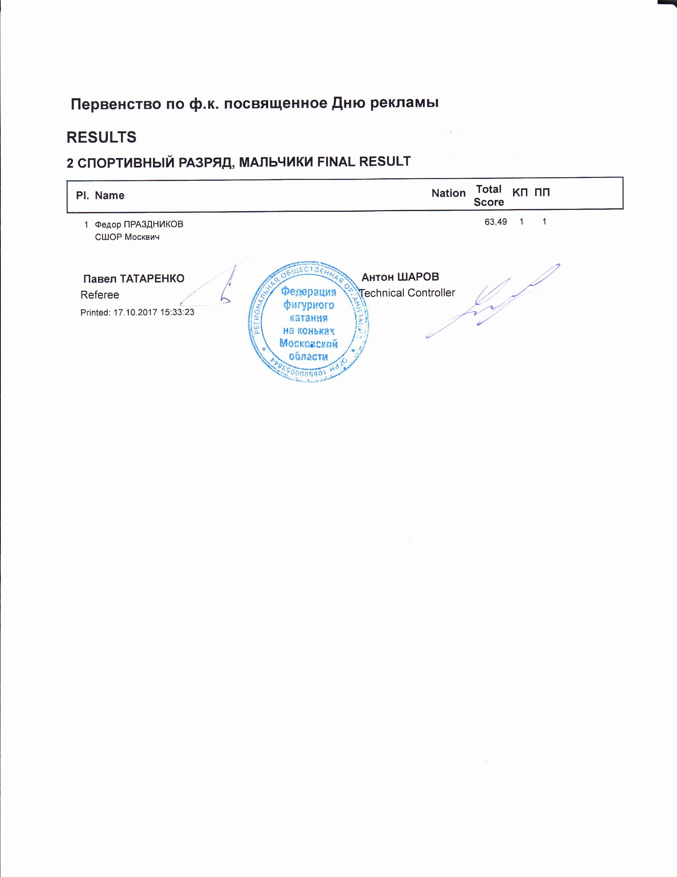

2 СПОРТИВНЫЙ РАЗРЯД, МАЛЬЧИКИ
RESULT DETAILS КОРОТКАЯ ПРОГРАММА
Pl. | Name |  |  | Nation | Total  Segment  Score  = | Total  Element  Score  + | Tot. Prog.  Comp.  Score *  + | SS | TR | PE |  | IN | Deduct.  -
1 Федор ПРАЗДНИКОВ 25.08 9.49 15.59 3.92 3.83 3.92 0.00 3.92 0.00

SS = Навыки скольжения
* = factored score
Printed: 17.10.2017 15:34:34

TR = Переходы PE = Представление IN = Интерпретация

Первенство по ф.к. посвященное Дню рекламы
2 СПОРТИВНЫЙ РАЗРЯД, МАЛЬЧИКИ КОРОТКАЯ ПРОГРАММА JUDGES DETAILS PER SKATER
Rank |  | Name |  |  |  |  | Nation |  | Starting  Number |  | Total  Segment Score |  | Total  Element Score |  | Total  Program Component  Score (factored) |  |  | Total  Deductions
1 |  | Федор ПРАЗДНИКОВ |  |  |  |  |  |  | 1 |  | 25.08 |  | 9.49 |  | 15.59 |  |  | 0.00
 | #  1 | Executed  Elements  1A | Base  Info  Value  1.10 |  | GOE  0.20 |  | J1  1 | J2  1 | J3  1 | J4  1 |  | J5  0 | J6 | J7 | J8 | J9 | Ref | Scores of Panel  1.30
 | 2 | 2Lz+2T |  | 3.40 |  | 0.00 | 0 | 0 | 0 | 0 |  | 0 |  |  |  |  |  | 3.40
 | 3 | CCoSp1V | nS | 1.70 |  | -0.10 | 1 | 0 | -1 | -1 |  | 0 |  |  |  |  |  | 1.60
 | 4 | 2F | ! | 2.09 x |  | -0.30 | -1 | -1 | -1 | -1 |  | -1 |  |  |  |  |  | 1.79
 | 5 | CSSp |  | 0.00 |  | 0.00 | - | - | - | - |  | - |  |  |  |  |  | 0.00
 | 6 | StSqB |  | 1.50 |  | -0.10 | -1 | -1 | 0 | 0 |  | 0 |  |  |  |  |  | 1.40
 |  |  |  | 9.79 |  |  |  |  |  |  |  |  |  |  |  |  |  | 9.49
 |  | Program Components  Навыки скольжения |  |  |  | Factor  1.00 | 3,75 | 4,00 | 4,25 | 4,00 |  | 3,75 |  |  |  |  |  | 3.92
 |  | Переходы |  |  |  | 1.00 | 3,75 | 3,75 | 4,00 | 4,00 |  | 3,50 |  |  |  |  |  | 3.83
 |  | Представление |  |  |  | 1.00 | 4,00 | 4,25 | 4,00 | 3,75 |  | 3,75 |  |  |  |  |  | 3.92
 |  | Интерпретация |  |  |  | 1.00 | 4,25 | 4,25 | 3,75 | 3,75 |  | 3,75 |  |  |  |  |  | 3.92
 |  | Judges Total Program Component Score (factored) |  |  |  |  |  |  |  |  |  |  |  |  |  |  |  | 15.59
Deductions |  |  |  |  |  |  |  |  |  |  |  |  |  |  |  |  |  | 0.00
x Credit for highlight distribution, base value multiplied by 1.1 ! Not clear edge printed: 17.10.2017 15:34:37
Первенство по ф.к. посвященное Дню рекламы

RESULTS
2 СПОРТИВНЫЙ РАЗРЯД, МАЛЬЧИКИ КОРОТКАЯ ПРОГРАММА
Pl. | Name |  | Nation | Total Segment  Score
1 Федор ПРАЗДНИКОВ 25.08
Printed: 17.10.2017 11:06:14

Первенство по ф.к. посвященное Дню рекламы
2 СПОРТИВНЫЙ РАЗРЯД, МАЛЬЧИКИ КОРОТКАЯ ПРОГРАММА JUDGES DETAILS PER SKATER
Rank |  | Name |  |  |  |  | Nation |  | Starting  Number |  | Total  Segment Score |  | Total  Element Score |  | Total  Program Component  Score (factored) |  |  | Total  Deductions
1 |  | Федор ПРАЗДНИКОВ |  |  |  |  |  |  | 1 |  | 25.08 |  | 9.49 |  | 15.59 |  |  | 0.00
 | #  1 | Executed  Elements  1A | Base  Info  Value  1.10 |  | GOE  0.20 |  | J1  1 | J2  1 | J3  1 | J4  1 |  | J5  0 | J6 | J7 | J8 | J9 | Ref | Scores of Panel  1.30
 | 2 | 2Lz+2T |  | 3.40 |  | 0.00 | 0 | 0 | 0 | 0 |  | 0 |  |  |  |  |  | 3.40
 | 3 | CCoSp1V | nS | 1.70 |  | -0.10 | 1 | 0 | -1 | -1 |  | 0 |  |  |  |  |  | 1.60
 | 4 | 2F | ! | 2.09 x |  | -0.30 | -1 | -1 | -1 | -1 |  | -1 |  |  |  |  |  | 1.79
 | 5 | CSSp |  | 0.00 |  | 0.00 | - | - | - | - |  | - |  |  |  |  |  | 0.00
 | 6 | StSqB |  | 1.50 |  | -0.10 | -1 | -1 | 0 | 0 |  | 0 |  |  |  |  |  | 1.40
 |  |  |  | 9.79 |  |  |  |  |  |  |  |  |  |  |  |  |  | 9.49
 |  | Program Components  Навыки скольжения |  |  |  | Factor  1.00 | 3,75 | 4,00 | 4,25 | 4,00 |  | 3,75 |  |  |  |  |  | 3.92
 |  | Переходы |  |  |  | 1.00 | 3,75 | 3,75 | 4,00 | 4,00 |  | 3,50 |  |  |  |  |  | 3.83
 |  | Представление |  |  |  | 1.00 | 4,00 | 4,25 | 4,00 | 3,75 |  | 3,75 |  |  |  |  |  | 3.92
 |  | Интерпретация |  |  |  | 1.00 | 4,25 | 4,25 | 3,75 | 3,75 |  | 3,75 |  |  |  |  |  | 3.92
 |  | Judges Total Program Component Score (factored) |  |  |  |  |  |  |  |  |  |  |  |  |  |  |  | 15.59
Deductions |  |  |  |  |  |  |  |  |  |  |  |  |  |  |  |  |  | 0.00
x Credit for highlight distribution, base value multiplied by 1.1 ! Not clear edge printed: 17.10.2017 11:06:26

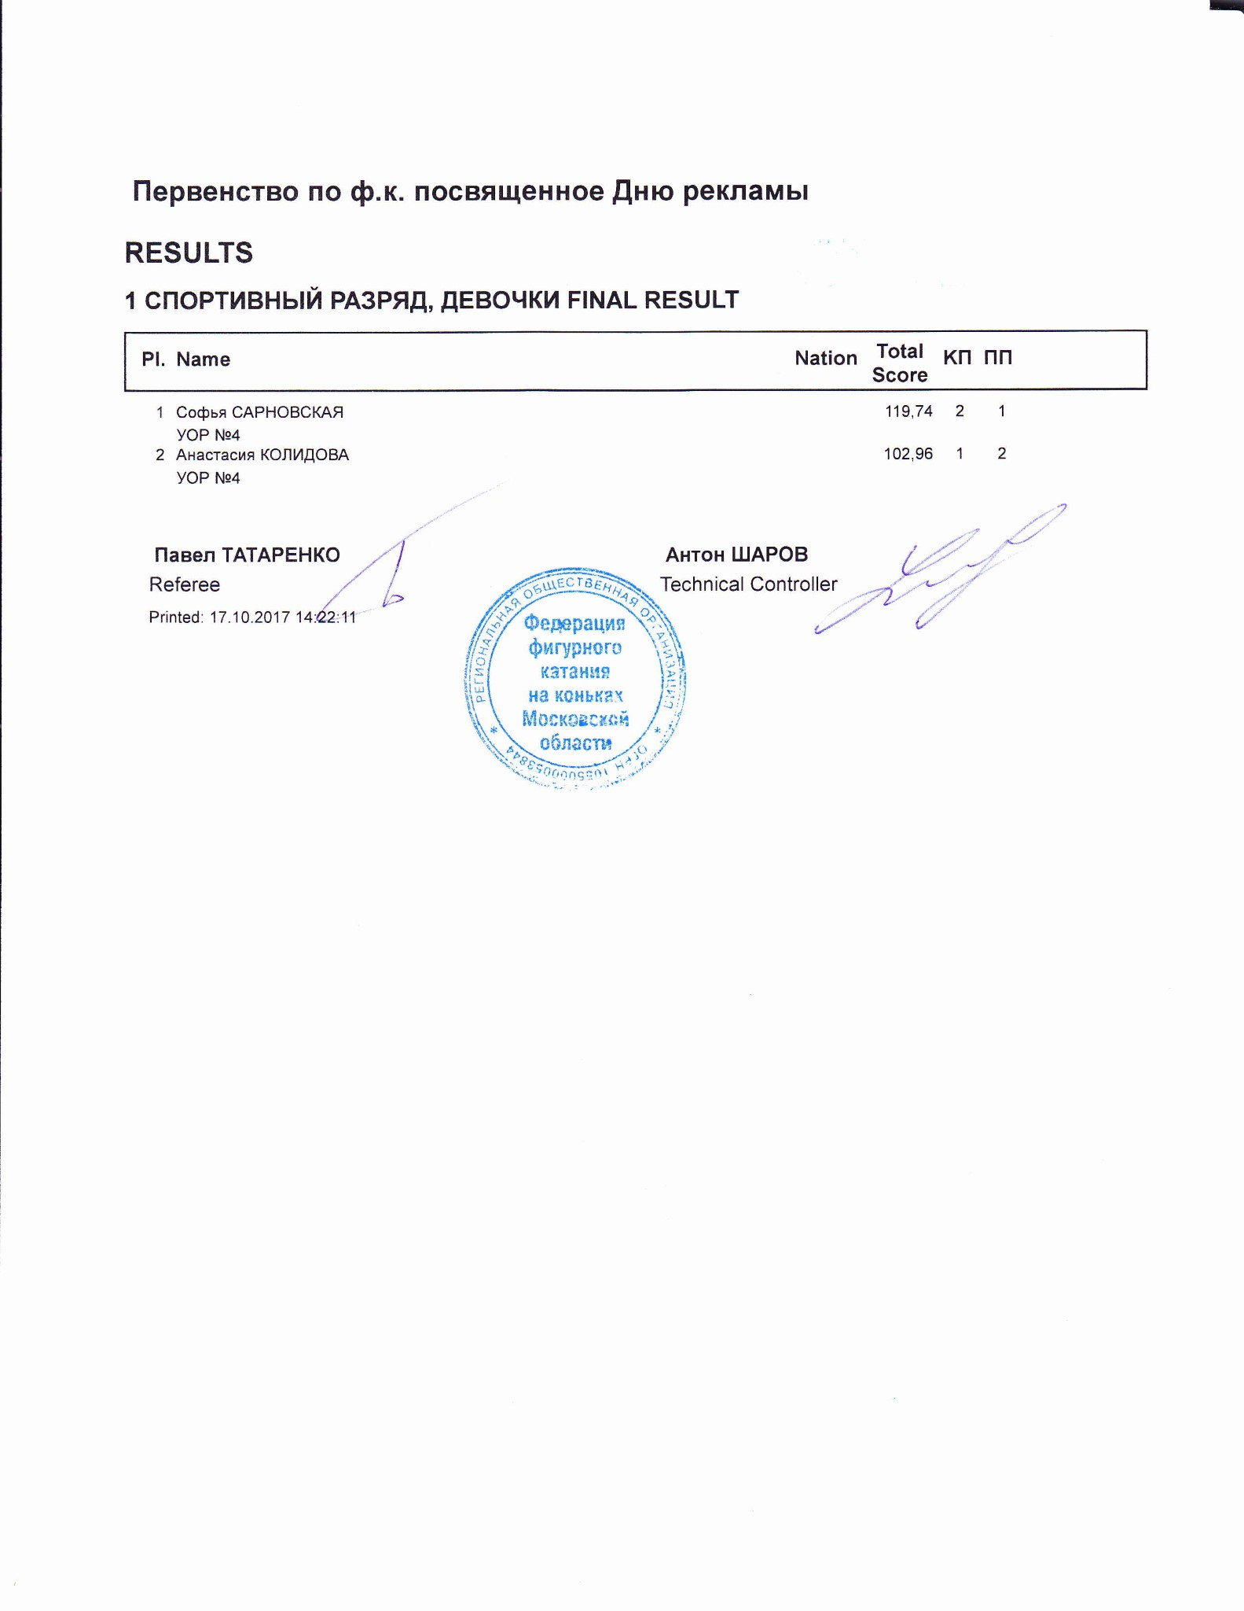

1 СПОРТИВНЫЙ РАЗРЯД, ДЕВОЧКИ
RESULT DETAILS ПРОИЗВОЛЬНАЯ ПРОГРАММА
Pl. | Name |  | Nation | Total  Segment  Score  = | Total  Element  Score  + | Tot. Prog.  Comp.  Score *  + | SS | TR | PE | CO | IN | Deduct.  -
- Софья САРНОВСКАЯ 80.39 42.60 38.79 5.00 4.58 4.75 4.83 5.08 1.00
- Анастасия КОЛИДОВА 63.40 28.20 35.20 4.50 4.17 4.33 4.33 4.67 0.00
SS = Навыки скольжения TR = Переходы PE = Представление CO = Композиция IN = Интерпретация
* = factored score
Printed: 17.10.2017 14:23:36

Первенство по ф.к. посвященное Дню рекламы
1 СПОРТИВНЫЙ РАЗРЯД, ДЕВОЧКИ ПРОИЗВОЛЬНАЯ ПРОГРАММА JUDGES DETAILS PER SKA
Rank |  | Name |  |  |  |  |  | Nation |  | Starting  Number |  | Total  Segment Score |  | Total  Element Score |  | Total  Program Component  Score (factored) |  |  | Total  Deductions
1 |  | Софья САРНОВСКАЯ |  |  |  |  |  |  |  | 2 |  | 80.39 |  | 42.60 |  | 38.79 |  |  | 1.00
 | #  1 | Executed  Elements  2A+3T | Base  Info  Value  7.60 |  |  | GOE  1.17 |  | J1  2 | J2  2 | J3  2 | J4  1 |  | J5  1 | J6 | J7 | J8 | J9 | Ref | Scores of Panel  8.77
 | 2 | 3F |  | 5.30 |  |  | 0.23 | 0 | 1 | 0 | 1 |  | 0 |  |  |  |  |  | 5.53
 | 3 | CCoSp4 |  | 3.50 |  |  | 0.50 | 1 | 1 | 1 | 1 |  | 1 |  |  |  |  |  | 4.00
 | 4 | StSq2 |  | 2.60 |  |  | 0.50 | 1 | 1 | 1 | 1 |  | 1 |  |  |  |  |  | 3.10
 | 5 | 3Lo<+2T | < | 5.39 |  | x | -0.70 | -1 | -1 | -1 | -1 |  | -1 |  |  |  |  |  | 4.69
 | 6 | 3S+2T |  | 6.27 |  | x | 0.47 | 1 | 1 | 0 | 1 |  | 0 |  |  |  |  |  | 6.74
 | 7 | 3Lo< | < | 3.96 |  | x | -0.70 | -1 | -1 | -1 | -1 |  | -1 |  |  |  |  |  | 3.26
 | 8 | 3S< | < | 3.41 |  | x | -2.10 | -3 | -3 | -3 | -3 |  | -3 |  |  |  |  |  | 1.31
 | 9 | FSSp2 |  | 2.30 |  |  | 0.50 | 1 | 1 | 0 | 1 |  | 1 |  |  |  |  |  | 2.80
 | 10 | LSp2 |  | 1.90 |  |  | 0.50 | 1 | 1 | 0 | 1 |  | 1 |  |  |  |  |  | 2.40
 |  |  |  | 42.23 |  |  |  |  |  |  |  |  |  |  |  |  |  |  | 42.60
 |  | Program Components  Навыки скольжения |  |  |  |  | Factor  1.60 | 5,00 | 5,25 | 5,00 | 5,00 |  | 4,75 |  |  |  |  |  | 5.00
 |  | Переходы |  |  |  |  | 1.60 | 4,25 | 4,50 | 4,50 | 5,00 |  | 4,75 |  |  |  |  |  | 4.58
 |  | Представление |  |  |  |  | 1.60 | 4,50 | 4,50 | 4,75 | 5,00 |  | 5,25 |  |  |  |  |  | 4.75
 |  | Композиция |  |  |  |  | 1.60 | 4,50 | 4,75 | 4,75 | 5,00 |  | 5,00 |  |  |  |  |  | 4.83
 |  | Интерпретация |  |  |  |  | 1.60 | 4,75 | 5,00 | 5,00 | 5,25 |  | 5,25 |  |  |  |  |  | 5.08
 |  | Judges Total Program Component Score (factored) |  |  |  |  |  |  |  |  |  |  |  |  |  |  |  |  | 38.79
Deductions |  |  |  |  | Falls: |  | -1.00 |  |  |  |  |  |  |  |  |  |  |  | -1.00
< Under-rotated jump x Credit for highlight distribution, base value multiplied by 1.1
Rank |  | Name |  |  |  |  | Nation |  | Starting  Number |  | Total  Segment Score |  | Total  Element Score |  | Total  Program Component  Score (factored) |  |  | Total  Deductions
2 |  | Анастасия КОЛИДОВА |  |  |  |  |  |  | 1 |  | 63.40 |  | 28.20 |  | 35.20 |  |  | 0.00
 | #  1 | Executed  Elements  3S< | Base  Info  Value  < 3.10 |  | GOE  -0.70 |  | J1  -2 | J2  -1 | J3  -1 | J4  -1 |  | J5  -1 | J6 | J7 | J8 | J9 | Ref | Scores of Panel  2.40
 | 2 | 2F+2T | ! | 3.20 |  | 0.00 | 0 | 0 | 0 | 0 |  | -1 |  |  |  |  |  | 3.20
 | 3 | FSSp4 |  | 3.00 |  | 0.83 | 2 | 2 | 2 | 1 |  | 1 |  |  |  |  |  | 3.83
 | 4 | LSp1 |  | 1.50 |  | 0.33 | 1 | 1 | 1 | 0 |  | 0 |  |  |  |  |  | 1.83
 | 5 | StSq1 |  | 1.80 |  | 0.00 | 1 | 0 | 0 | 0 |  | 0 |  |  |  |  |  | 1.80
 | 6 | 2A |  | 3.63 | x | 0.00 | 0 | 0 | 0 | 0 |  | 0 |  |  |  |  |  | 3.63
 | 7 | 2A+2T |  | 5.06 | x | 0.50 | 1 | 1 | 1 | 1 |  | 0 |  |  |  |  |  | 5.56
 | 8 | 1Lz |  | 0.66 | x | 0.00 | 0 | 0 | 0 | 0 |  | 0 |  |  |  |  |  | 0.66
 | 9 | 2F | ! | 2.09 | x | -0.30 | 0 | -1 | -1 | -1 |  | -1 |  |  |  |  |  | 1.79
 | 10 | CCoSp4 |  | 3.50 |  | 0.00 | 0 | 0 | 0 | 0 |  | 0 |  |  |  |  |  | 3.50
 |  |  |  | 27.54 |  |  |  |  |  |  |  |  |  |  |  |  |  | 28.20
 |  | Program Components  Навыки скольжения |  |  |  | Factor  1.60 | 4,50 | 4,50 | 4,50 | 4,50 |  | 4,25 |  |  |  |  |  | 4.50
 |  | Переходы |  |  |  | 1.60 | 4,00 | 4,25 | 4,25 | 4,25 |  | 4,00 |  |  |  |  |  | 4.17
 |  | Представление |  |  |  | 1.60 | 4,25 | 4,25 | 4,75 | 4,25 |  | 4,50 |  |  |  |  |  | 4.33
 |  | Композиция |  |  |  | 1.60 | 4,25 | 4,75 | 4,25 | 4,50 |  | 4,25 |  |  |  |  |  | 4.33
 |  | Интерпретация |  |  |  | 1.60 | 5,00 | 5,00 | 4,50 | 4,50 |  | 4,50 |  |  |  |  |  | 4.67
 |  | Judges Total Program Component Score (factored) |  |  |  |  |  |  |  |  |  |  |  |  |  |  |  | 35.20
Deductions |  |  |  |  |  |  |  |  |  |  |  |  |  |  |  |  |  | 0.00
< Under-rotated jump x Credit for highlight distribution, base value multiplied by 1.1 ! Not clear edge printed: 17.10.2017 14:23:42
Первенство по ф.к. посвященное Дню рекламы

RESULTS
1 СПОРТИВНЫЙ РАЗРЯД, ДЕВОЧКИ КОРОТКАЯ ПРОГРАММА
Pl. |  | Name | Nation |  | Total Segment  Score
 | 1 Анастасия КОЛИДОВА |  |  | 39.56
 | 2 Софья САРНОВСКАЯ |  |  | 39.35
Printed: 17.10.2017 10:41:08

Первенство по ф.к. посвященное Дню рекламы
1 СПОРТИВНЫЙ РАЗРЯД, ДЕВОЧКИ КОРОТКАЯ ПРОГРАММА JUDGES DETAILS PER SKATER
Rank |  | Name |  |  |  | Nation |  | Starting  Number |  | Total  Segment Score |  | Total  Element Score |  | Total  Program Component  Score (factored) |  |  | Total  Deductions
1 |  | Анастасия КОЛИДОВА |  |  |  |  |  | 1 |  | 39.56 |  | 19.57 |  | 19.99 |  |  | 0.00
 | #  1 | Executed  Elements  3S | Base  Info  Value  4.40 | GOE  -0.47 |  | J1  -1 | J2  -1 | J3  -1 | J4  0 |  | J5  0 | J6 | J7 | J8 | J9 | Ref | Scores of Panel  3.93
 | 2 | LSp3 | 2.40 |  | 0.33 | 2 | 1 | 0 | 0 |  | 1 |  |  |  |  |  | 2.73
 | 3 | FSSp3 | 2.60 |  | -0.20 | 0 | 0 | -1 | -1 |  | -1 |  |  |  |  |  | 2.40
 | 4 | StSq1 | 1.80 |  | 0.00 | 1 | 0 | 0 | 0 |  | 0 |  |  |  |  |  | 1.80
 | 5 | 2Lz+COMBO | 2.31 | x | -0.90 | -3 | -3 | -3 | -3 |  | -3 |  |  |  |  |  | 1.41
 | 6 | 2A+2T* | * 3.63 | x | 0.00 | 1 | 0 | 0 | 0 |  | 0 |  |  |  |  |  | 3.63
 | 7 | CCoSp4 | 3.50 |  | 0.17 | 1 | 1 | 0 | 0 |  | 0 |  |  |  |  |  | 3.67
 |  |  | 20.64 |  |  |  |  |  |  |  |  |  |  |  |  |  | 19.57
 |  | Program Components  Навыки скольжения |  |  | Factor  1.00 | 4,50 | 4,25 | 4,00 | 4,00 |  | 4,00 |  |  |  |  |  | 4.08
 |  | Переходы |  |  | 1.00 | 4,25 | 3,75 | 4,00 | 3,75 |  | 3,75 |  |  |  |  |  | 3.83
 |  | Представление |  |  | 1.00 | 4,25 | 4,00 | 3,75 | 3,75 |  | 4,00 |  |  |  |  |  | 3.92
 |  | Композиция |  |  | 1.00 | 4,75 | 4,25 | 3,50 | 4,00 |  | 4,00 |  |  |  |  |  | 4.08
 |  | Интерпретация |  |  | 1.00 | 4,25 | 4,25 | 3,75 | 4,00 |  | 4,00 |  |  |  |  |  | 4.08
 |  | Judges Total Program Component Score (factored) |  |  |  |  |  |  |  |  |  |  |  |  |  |  | 19.99
Deductions
0.00
* Invalid element x Credit for highlight distribution, base value multiplied by 1.1
Rank |  | Name |  |  |  |  |  | Nation |  | Starting  Number |  | Total  Segment Score |  | Total  Element Score |  | Total  Program Component  Score (factored) |  |  | Total  Deductions
2 |  | Софья САРНОВСКАЯ |  |  |  |  |  |  |  | 2 |  | 39.35 |  | 19.11 |  | 21.24 |  |  | 1.00
 | #  1 | Executed  Elements  3Lo< | Base  Info  Value  < 3.60 |  |  | GOE  -2.10 |  | J1  -3 | J2  -3 | J3  -3 | J4  -3 |  | J5  -2 | J6 | J7 | J8 | J9 | Ref | Scores of Panel  1.50
 | 2 | CCoSp4 |  | 3.50 |  |  | 0.33 | 1 | 1 | 0 | 0 |  | 1 |  |  |  |  |  | 3.83
 | 3 | LSp4 |  | 2.70 |  |  | 0.50 | 1 | 1 | 1 | 1 |  | 1 |  |  |  |  |  | 3.20
 | 4 | StSqB |  | 1.50 |  |  | 0.17 | 0 | 1 | 1 | 0 |  | 0 |  |  |  |  |  | 1.67
 | 5 | 3S+2T |  | 6.27 |  | x | -0.47 | -1 | -1 | 0 | 0 |  | -1 |  |  |  |  |  | 5.80
 | 6 | 2A<< | << | 1.21 |  | x | -0.60 | -3 | -3 | -3 | -3 |  | -3 |  |  |  |  |  | 0.61
 | 7 | FSSp3 |  | 2.60 |  |  | -0.10 | 0 | -1 | -1 | 1 |  | 0 |  |  |  |  |  | 2.50
 |  |  |  | 21.38 |  |  |  |  |  |  |  |  |  |  |  |  |  |  | 19.11
 |  | Program Components  Навыки скольжения |  |  |  |  | Factor  1.00 | 4,50 | 4,75 | 4,50 | 4,25 |  | 4,25 |  |  |  |  |  | 4.42
 |  | Переходы |  |  |  |  | 1.00 | 4,00 | 4,50 | 4,25 | 4,00 |  | 4,00 |  |  |  |  |  | 4.08
 |  | Представление |  |  |  |  | 1.00 | 4,00 | 4,50 | 4,00 | 4,00 |  | 4,25 |  |  |  |  |  | 4.08
 |  | Композиция |  |  |  |  | 1.00 | 4,50 | 4,75 | 4,25 | 4,25 |  | 4,25 |  |  |  |  |  | 4.33
 |  | Интерпретация |  |  |  |  | 1.00 | 4,25 | 4,75 | 4,50 | 4,25 |  | 4,25 |  |  |  |  |  | 4.33
 |  | Judges Total Program Component Score (factored) |  |  |  |  |  |  |  |  |  |  |  |  |  |  |  |  | 21.24
Deductions |  |  |  |  | Falls: |  | -1.00 |  |  |  |  |  |  |  |  |  |  |  | -1.00
< Under-rotated jump << Downgraded jump x Credit for highlight distribution, base value multiplied by 1.1 printed: 17.10.2017 10:41:21

